IMPLEMENTATION OF E-LEARNING SCHOOLOGY TO IMPROVE THE CHARACTER BASED ON ANEKA
F. Shoufika Hilyana¹, M. Malik Hakim²
^{1,2} Universitas Muria Kudus
1farah.hilyana@umk.ac.id, 2malik.hakim@umk.ac.id
Abstract
Through character education and e-learning schoology, students have the ability to know, understand, and interact with the world of information and communication technology. Based on PP. Republic of Indonesia No. 37 of 2009, lecturers are said to be professional educators and scientists with the primary task. Given the importance of lecturers' duties, it is expected that lecturers can actualize of the ASN profession incorporated in ANEKA (Accountability, Nationalism, Public Ethics, Quality Commitment and Anti-Corruption). This research is expected to internalize of ANEKA character to students applied through e-learning Schoology in Physics course. The research method used is pre-experimental design with one-group pretest-postest design. The data required is data about the ANEKA character can be successful of e-learning Schoology. The ANEKA character is found in the implementation of pretest mostly (37%) on very low interpretation, and has the medium category. After e-learning schoology, the posttest score of most (85%) on interpretation is very high, the lowest on medium interpretation, and no students at low and very low levels. From all indicators of the ANEKA characters, the students experienced a high category on the character of quality commitment, and very high category on the character of accountability, nationalism, public ethics, and anti corruption. There were 19 students (70,4%) which experienced with High interpretation, 6 students (22,2%) with medium interpretation, and 2 students (7,4%) with low interpretation. So it can be said that by using the e-learning based on schoology, proved to increase the ANEKA characters in the students.
Keywords: E-learning, Schoology, Characters, ANEKA.

- Introduction
In today’s new economy characterized by industrial change, globalization, increased intensive competition, knowledge sharing and transfer, and information technology revolution, traditional classroom education or training does not always satisfy all the needs of the new world of lifelong learning. Learning is shifting from instructor-centered to learner-centered, and is undertaken anywhere, from classrooms to homes and ofﬁces. E-Learning, referring to learning via the Internet, provides people with a ﬂexible and personalized way to learn [1].
The development of information and communication technology has brought enormous changes to the progress of education. The form of information technology development applied in the world of education is E-Learning. E-Learning is an innovation that has a huge contribution to the change of learning process. Teaching materials can be visualized in more interesting and interactive formats and designs so that the learner will be motivated to engage further in the learning process. One platform that can be used as an interactive learning media is Schoology.
Social networking sites (SNSs) have been gaining popularity and influence in everyday. The application of using SNSs in an education field is likely to provide more benefits to teacher and student. Especially when used in the teaching and learning management. Wilailak Treepuech made a comparison of SNSs: Facebook, Twitter, Google Plus, and Schoology in various features that related to the use and application for teaching and learning management. The applying of Schoology that designed for “especially when used in the teaching and learning management is suitable to work together with online tools and can support the teaching and learning management more perfectly” [2].
In educational contexts, the exploitation of the LMS platforms offers integrated solutions on the distribution of course material, student management and interaction between stakeholders. One of the LMS platforms developed using Schoology. One major conclusion is that these platforms facilitate the development of e-learning environments with social features through a user-friendly dashboard and a variety of education-oriented services [3]. The research by W.Suana, N.Maharta, ID.P.Nyeneng, and S. Wahyuni, the results showed that to design a Schoology-based blended learning media for Basic Physics I course, it was valid and effective as blended learning media [4].
Through character education and e-learning, students have the ability to know, understand, and interact with the world of information and communication technology. The main value of the character is not only done in courses related to personality, but also into all courses, including in the subjects of Physics. As stated by Hindarto that each course has content that is very valuable and relevant to the values ​​of character education [5].
Based on PP. Republic of Indonesia No. 37 of 2009, lecturers are said to be professional educators and scientists with the primary task of transforming, developing and disseminating science, technology and the arts through education, research, and community service. Given the importance of lecturers' duties, it is expected that lecturers can actualize the five basic values (accountability, nationalism, public ethics, quality commitment, and anti-corruption) professionally in carrying out their duties and functions. The actualization of the basic values of the ASN profession incorporated in ANEKA (Accountability, Nationalism, Public Ethics, Quality Commitment and Anti-Corruption) aims to internalize these basic values to form an honest, fair, disciplined, integrated, professional person, prioritizing the interests of the State and society, can maintain unity of the nation, and always faithful and obedient to the Unitary State and Government of the Republic of Indonesia.
Research on character education and the use of e-learning media is quite a lot, such as the research by Aynur Pala [6], to provide guidelines for the elements need for effective and comprehensive character education, and to emphasize the need of character education to help students develop good character, which includes knowing, caring about and acting upon core ethical values such as respect, responsibility, honesty, fairness and compassion. This reserach just discuss about implementation the value character. Rafika Bayu Kusumandari [7] in his research stated that character education essentially aims to form a strong person, competitive, noble, moral, tolerant, cooperate, patriotic spirit, develop dynamic science and science-oriented technology and likened obedience to God The One Supreme on Pancasila. Further research conducted by Maharani and Dewi [8] states that effective websites are used to instill character and independence. Other research conducted by Ni Kade Yuni Ratnasari, I Made Tegeh, and I Kadek Suartama [9] which shows that the effectiveness of product development of e-learning science learning oriented character education can improve learning outcomes. The results of Ni Made Sri Mertasari [10] stated that online media can increase students' confidence to ask or argue. Online learning media to facilitate integrated general character education can facilitate planned learning.
Minister Regulation of Ristekdikti No.44 of 2015 on SNPT, Article 5 paragraph (1) states that the graduate competency standard is a minimum criterion of graduate qualification which includes attitude, knowledge, and skill stated in the formulation of graduate learning achievement. Attitudes referred to are true and cultured behavior as a result of internalization and actualization of values and norms reflected in the spiritual and social life through learning processes, student work experience, research and / or community-related devotion of learning. And in Article 11 paragraph (1) states Characteristics of the learning process consists of interactive, holistic, integrative, scientific, contextual, thematic, effective, collaborative, and student-centered.
Therefore, in this research, integrating character education based on ANEKA in Technical Physics course through e-learning Schoology. The aim of this research is expected to internalize of ANEKA character to students can be applied through e-learning Schoology in Physics course.
- Method
The research method used is pre-experimental design with one-group pretest-postest design. Research subjects are students who are taking the Physics courses of 2017/2018 which amounted to 27 people. The place of research is done in Electrical Engineering Study Program Faculty of Engineering Muria Kudus University. Technique of collecting data is done by using instrument in the form of questionnaire. The data required in this research is data about the character of ANEKA as well as the successful application of e-learning Schoology. Data analysis using percentage and gain test to measure the increase of character based on ANEKA.

3.Results and Discussion
Implementation of e-learning Schoology in Physics courses is done three times meeting of the Electricity materials. Materials taken in e-learning schoology include Coulomb Laws, Electrical Current, and Electrical Circuits. E-learning schoology in physics engineering courses can be seen in Figure 1.

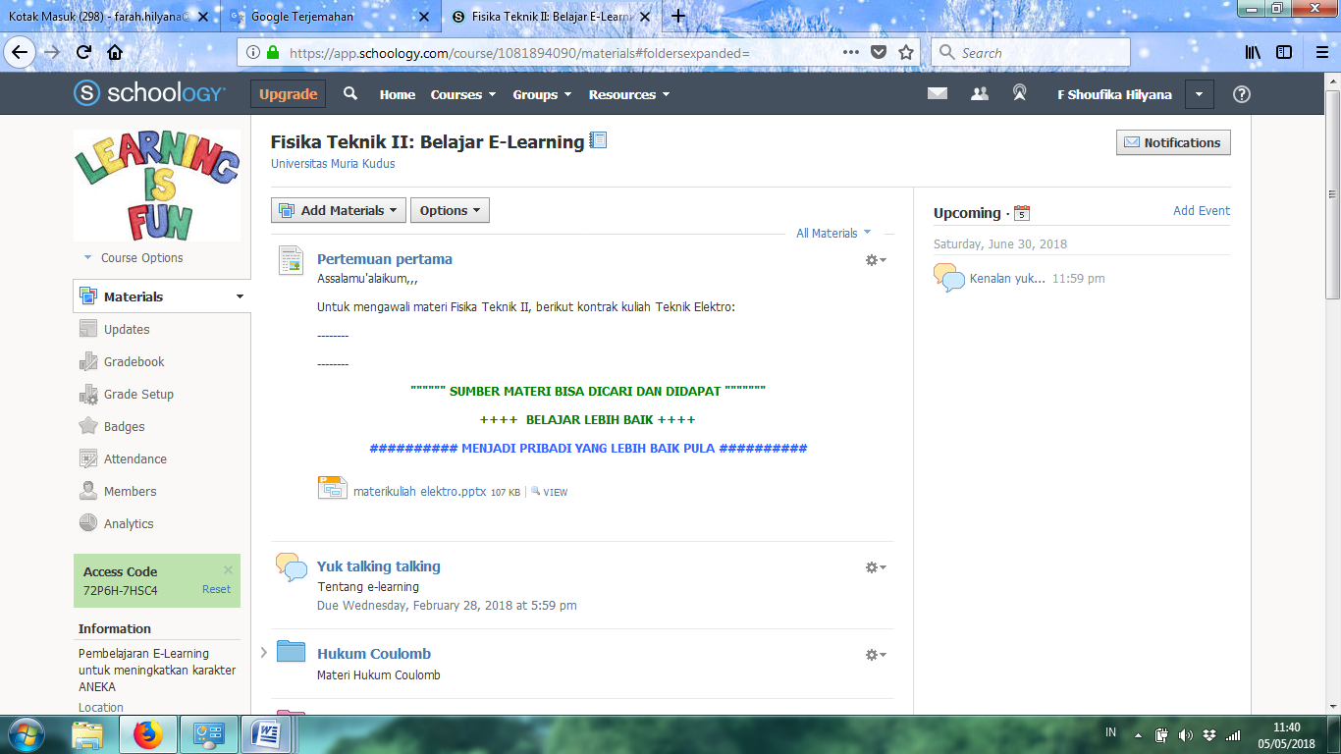
Figure 1. E-learning schoology in physics courses

E-learning schoology is done by integrating the ANEKA characters in the students with twenty indicators, which can be seen in table 1.

Table 1. Integration of the character ANEKA in e-learning Schoology
Characters | Indicators
Accountability | Can complete tasks as per responsibility
Accountability | No plagiarism in completing the task
Accountability | Can defend opinions as truth
Accountability | Can be active in discussion activities
Nationalism | Can practice religious values ​​- answer greetings and pray
Nationalism | Not distinguish one friend with another friend
Nationalism | Can grow the love or proud of the state of Indonesia
Nationalism | Can appreciate the opinions of other friends in discussion activities
Ethics Public | Be nice and polite to the lecturers and other students
Ethics Public | Can keep the honor of self and others with mutual respect
Ethics Public | Can obey the rules of every lecture and assignment duties
Ethics Public | Speaks good words in accordance with the actions done and not sharing the tasks that are individual
Quality commitment | Can provide opinions according to the purpose of the discussion
Quality commitment | Can use a given time well
Quality commitment | Can provide innovative ideas to solve future challenges
Quality commitment | Always uptodate in completing tasks and carrying out lecture / discussion activities
Anti-Corruptions | Can solve its own tasks well without involving other friends
Anti-Corruptions | Can earnest effort in completing tasks and conducting lectures
Anti-Corruptions | Courageous in expressing opinions and performance
Anti-Corruptions | Caring about Lecturers and Providing assistance to friends in need

In the e-learning schoology, there are various menus that we can make for the learning process. With the help of access code from schoology, students can enter in the class that has been made by lecturer. E-learning is almost the same as conventional learning but more is online and based on android. Menu on the look of schoology that created contains teaching materials in the form of power points made by the lecturer concerned for each meeting on the subject of Physics courses, accompanied by tasks or discussion activities as well as the process of learning in the classroom, member courses can be seen in Figure 2.

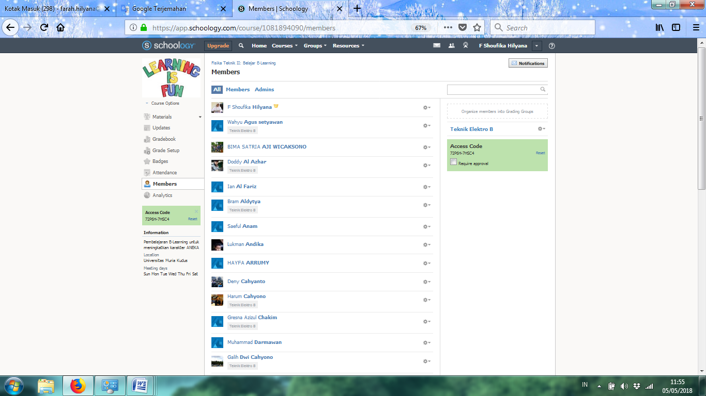Figure 2. Member course of Physics in e-learning schoology

Lecturers provide various materials that can be downloaded, and support materials that are linked url that can be searching by students. one of the ANEKA character indicators that are internalized into e-learning schoology can be seen in Figure 3. Students can access e-learning schoology materials anywhere and anytime, in accordance with the target time specified by the lecturer, because in the schoology there is also a menu to provide questions to be undertaken by students who are limited time, so that the clarity of target students with the consistent way of working on the problem can be met well. Students and lecturers can also interact in schoology with status updates and discussions related to a particular topic that has been shared and students can ask questions in the forum. In addition, a student can interact with other students to discuss and to cooperate.

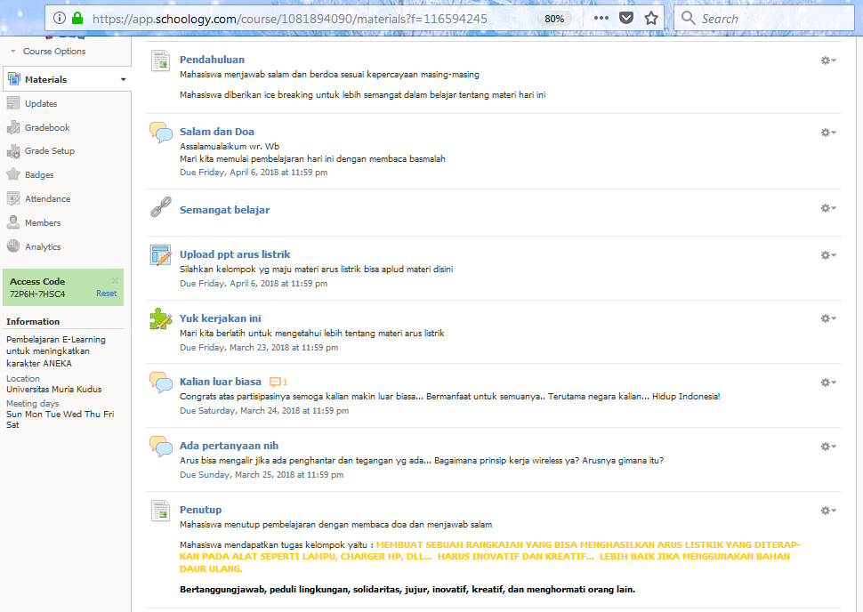
Figure 3. Learning proses using Schoology with character based on ANEKA

Table 2. Distribution of Frequency of Pretest-Posttest Score
Value | Interpretation | Pretest |  | Posttest
Value | Interpretation | Frequency | Percentage (%) | Frequency | Percentage (%)
≥80  70-79  60-69  50-59  ≤49 | Very High  High  Medium  Low  Very Low | 4  2  3  8  10 | 15  7  11  30  37 | 23  3  1  0  0 | 85  11  4  0  0
Total |  | 27 | 100 | 27 | 100

At the beginning of the lesson, a pretest is performed to determine the student's ability in mastery of the given material and the character's value initially. The maximum result of Pretest that can be obtained is 85, while the frequency distribution of pretest score is presented in table 2. It is known that the value of students in pretest implementation is mostly (37%) at very low interpretation, this is because the students do not know yet about the material to be studied. And the student score on posttest implementation gets dominant (85%) at very high interpretation. This indicates that students at this stage have achieved very high learning outcomes, no students are at low and very low levels, and the lowest results are on medium interpretation.
The result of student character ANEKA can be seen in figure 4. Students at this stage before using e-learning schoology with ANEKA character have average value at medium category, and after using e-learning schoology, at the end of the learning is done posttest to know the improvement of learning result and the increase of ANEKA character value to the students. From all indicators of the average value of ANEKA characters, the students experienced a high category increase in the character of Quality Commitment because in this character the students less visible of improvement in provide innovative ideas to solve future challenges and always uptodate in completing tasks and carrying out lecture/discussion activities. And the category is very high on the characters value of Accountability, Nationalism, Public Ethics, and Anti Corruption. After obtained the initial and final values, then the gain test to determine the increase in the value of ANEKA characters obtained by students. The comparison of gain test results can be seen in table 4.
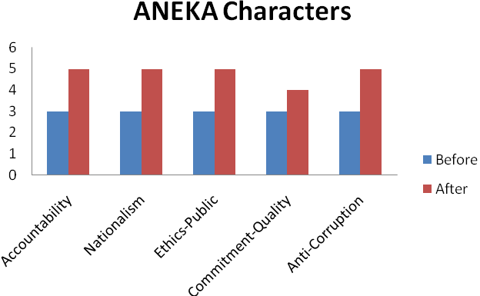
Figure 4. Result ANEKA character before and after using e-learning Schoology

Table 4. Results Student Gain of ANEKA characters
Gain Index | Interpretation | Frequency | Percentage (%)
≥ 0,7  0,7 - ≥ 0,3  < 0,3 | High  Medium  Low | 19  6  2 | 70,4  22,2  7,4
Total |  | 27 | 100

From all 27 students (table 4), there were 19 students (70,4%) who experienced high interpretation, 6 students (22,2%) were improved with medium interpretation, and 2 students (7,4 %) has improved with low interpretation, and can be see in figure 5.
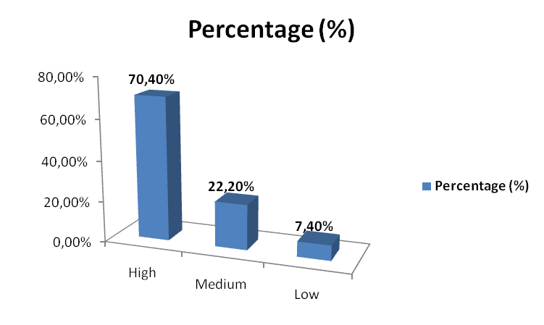
Figure 2. Interpretation Gain index of ANEKA characters
From the gain test it can be seen that most of students have ANEKA character improvement by using e-learning schoology. The results of this study proves that by using learning e-learning based on the schoology in the Physics course, proved to increase the value of ANEKA characters in the students.
conclusion
Implementation of e-learning based on schoology to increase the value of ANEKA character to the students is found in the implementation of pretest mostly (37%) on very low interpretation, and has the characters ANEKA in the medium category. After e-learning schoology, the posttest score of most (85%) on interpretation is very high, the lowest outcome on medium interpretation, and no students at low and very low levels. From all indicators of the characters ANEKA, the students experienced a high category improvement on the character of quality commitment, and very high category on the value of character of accountability, nationalism, public ethics, and anti corruption. There were 19 students (70,4%) which experienced improvement with High interpretation, 6 students (22,2%) which experienced improvement with medium interpretation, and 2 students (7,4%) had improved with Low interpretation. So it can be said that by using the learning of e-learning based on schoology on the Physics course, proved to increase the value of ANEKA characters in the students.
Acknowledgment
The authors are grateful to the research team, the entire academic community of Electrical Engineering, Engineering Faculty of Universitas Muria Kudus, and the RISTEKDIKTI ministry which has assisted in research and funders.
References
- D. Zhang, “Powering E-Learning In the New Millennium: An Overview of E-Learning and Enabling Technology”, Information Systems Frontiers, vol. 5:2, pp. 201–212, 2003.
- W. Treepuech, "The Application of Using Social Networking Sites with Available Online Tools for Teaching and Learning Management", IEEE International Symposium on IT in Medicine and Education. Cuangzhou. China, 9-11 Dec. 2011. DOI: 10.1109/ITiME.2011.6130844.
- A. Krouska, C. Troussas, and M. Virvou, "Comparing LMS and CMS platforms supporting social e-learning in higher education", IEEE 8th International Conference on Information, Intelligence, Systems & Applications (IISA), Larnaca. Cyprus, 27-30 Aug. 2017. DOI: 10.1109/IISA.2017.8316408.
- W.Suana, N.Maharta, ID.P.Nyeneng, and S. Wahyuni JPII 6 (1) (2017) 170-178. Jurnal Pendidikan IPA Indonesia. "DESIGN AND IMPLEMENTATION OF SCHOOLOGY-BASED BLENDED LEARNING MEDIA FOR BASIC PHYSICS I COURSE"
- N. Hindarto, “Pendidikan Karakter Dalam Pembelajaran Fisika Modern”, Pidato Pengukuhan Guru Besar disampaikan dalam Rapat Senat Terbuka Universitas Negeri Semarang pada hari Kamis, 25 November 2010.
- A. Pala, “The Need for Character Education”, International Journal of Social Sciences and Humanity Studies, Vol. 3 (2),pp. 23-32, 2011.
- R.B. Kusumandari, “Character Education Model for Early Chilhood Based on E-Learning and Culture of Java”, Indonesian Journal of Early Childhood, vol. 2 (1), pp. 20-28, 2013.
- D.W. Maharani, and N.R. Dewi, “The Implementation of Science Inquiry-Based Website Oriented by Cultural Deviance Solution to Instill Students’ Character and Independence”, Indonesian Journal of Science Education, vol. 4 (1), pp. 25-30, 2015.
- N.K.Y. Ratnasari, I.M. Tegeh, and I.K. Suartama, “Pengembangan E-Learning Dengan Model Waterfall Berorientasi Pendidikan Karakter Pelajaran IPA Kelas VIII SMPN 1 Negara”, E-Journal Edutech Universitas Pendidikan Ganesha, Vol. 5 (2), 2016.
- N.M.S. Mertasari, “Media Online untuk Asesmen Pendidikan Karakter Terpadu”, Jurnal Sains dan Teknologi, Vol.5 (1), pp. 683-691, 2016.

