ENGLISH FOR SPECIFIC PURPOSES FOR VOCATIONAL HIGH SCHOOL STUDENTS: A NEEDS ANALYSIS OF READING MATERIALS

Ika Kurniawati Khasanah¹, Suwarsih Madya²
^{1,2} English Education Study Program, Graduate School, Yogyakarta State University
1ikakurniawatikhasanah@gmail.com, 2 suwarsihm@yahoo.com
Abstract
This article deals with a needs analysis study as a part of research and development under the issue of developing English reading materials on the basis of applying English for Specific Purposes (ESP) in vocational high school. This is based on the evidence that the English materials in the form of textbooks available have not fully implemented ESP. Moreover, many English teachers for vocational high school do not have adequate time, fund and power to develop their own ESP materials. Besides, an emphasis on the implementation of ESP can facilitate vocational students to be competent in their future workplaces in which the working world is now competing globally. This study aims at finding the needs of vocational high school students of electricity installation engineering study program as regards their reading materials. To achieve the objective, there were 31 students from one school involved in this study. The instruments of this study were questionnaire and interview guidelines. The gathered data were analyzed using a quantitative method and descriptive qualitative method. Based on the data analysis, there were two findings discussed in this article. In conclusion, there was a positive response from the students toward the development of the reading materials which implemented ESP.
Keywords: English for specific purposes, reading materials, vocational high school, needs analysis

- Introduction
English for Specific Purposes (ESP) in language teaching and learning is essential for the implementation of vocational education in which some of countries start this education from vocational high school. In Indonesia vocational high school is known as Sekolah Menengah Kejuruan (SMK). It is known that vocational education currently has an important role to face a global industrialization era due to its benefit in economic and social dimensions which cover individual, enterprise and labor market (Cedefop, 2011) and affect to stability of a country. Moreover, Billet (2011: 26) asserts that vocational education refers to “provision of education that occurs prior to individuals or groups commencing their working lives, and which prepares them for it”. In other words, vocational education helps students to be competent and able to compete in their future workplaces. In this case, one of factors to be competent is to be able to communicate globally in which ESP plays its role in vocational education.
In language teaching and learning, ESP is considered different from English for General Purposes which is commonly known as General English (GE) as the branches of English Foreign Language (Hutchinson and Waters, 1987:17). ESP is one of varieties of English based on the purposes of language use. In other words, ESP provides and caters the need of the students to use English in real-time communication in their field or work situation. As has been mentioned previously, it is inevitable that ESP is important. It provides a way out since the students deal with English language which is frequently used in their work environment. This means that ESP accommodates what the students need in order to function effectively in work life communication.
In regard to this, English language teaching and learning in vocational high school should apply ESP in the teaching and learning process. One of ways to do it is by the provision of appropriate English materials in terms of a textbook. As has been known, a textbook is one of important aspects in the teaching and learning process since it provides learning sources for students and teaching materials for teachers. As has been stated by Tomlinson (1998: 2), materials can be defined as “anything which is used by teachers or learners to facilitate the learning of a language”. Therefore, ESP should reflect in the textbook used to teach SMK students.
In reality, however, the provision of English textbooks for SMK is far from the use of ESP. The English textbooks which are provided either by government or by private publishers are generalized to all study programs and even equalized to the textbook for senior high school which applies GE. Besides, senior high school has a different goal for its graduates as has been set in Law number 20 in 2003 about National Education System. Additionally, the English teachers which are expected to be able to develop their ESP materials have obstacles in time, fund and power. As a result, they teach their students with the available materials which do not implement ESP.
In reference to the problems, it is important to develop the English materials which are based on vocational high school students’ need. Further the materials the researcher has developed were supplementary reading materials. The reason of choosing reading as the skill to develop the materials is that through reading readers can get any information they need. This is in line with Linse and Nunan (2005:79) who state that there are two prime purposes to do reading: for pleasure and for information. Moreover, since the materials were developed for Electricity Installation Engineering students, reading skill is more often to use in their field to read electrical and technical terms.
In response to this, the researcher conducted a needs analysis of the materials to the students of Electricity Installation Engineering study program It was an initial step to develop the reading materials. The needs analysis gathered the data of the target needs and the learning needs.
- Method
In order to find out the students’ needs, a needs analysis as an initial part of research and development was conducted in February 2016. The respondents were the students of Electricity Installation Engineering study program in Batang regency. The needs analysis data were gathered through survey and interview. There were 31 students who participated as respondents in the survey. The respondents were asked to answer a multiple-choice questionnaire with two types of answer in which the respondents can either answer one choice or more than one. The interview guidelines were used for interviewing the respondents to get deeper their point of view. The interview was attended by three interviewees. The data of the needs analysis were further analyzed by using quantitative method in the form of percentage and using a descriptive qualitative method.

3.Results
The data of the needs analysis were analyzed to achieve the objective. The data analysis resulted in the following findings.
- The target needs
Almost all students argued that reading skill is important in learning English. Only few students (6.5%) did not consider it important because of their lack of interest in learning English. Further, as shown in Figure 1, the majority of the students considered they would use English when reading the manuals of electrical tools (90.3%) and reading English texts to improve knowledge and ability in electrical field (74.2%). Therefore, it is valuable to develop supplementary English reading materials to support the majority students and to encourage the minority ones in reading since the content of the materials is related to their expertise. Moreover, it was confirmed 100% of the students choosing electricity as the main topic for the materials. 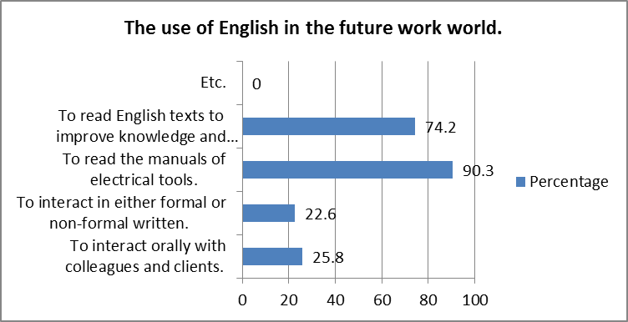
Figure 1. The use of English in the future work world.
However, more than a half of the number of the students has not been able to understand various English texts maximally. They (48.4%) were only able to understand few kinds of English text, even some of them (35.5%) were not able to understand English text. As a consequence, the students (58.1%) expected to master vocabulary related to electrical field through reading. The data analysis in Figure 2 gave the researcher enlightenment on the students’ current reading ability which then became a concern in developing the reading materials.
- The learning needs
Input is inevitably one of crucial aspects in the teaching and learning process. In the survey, the result shows that the majority of the majority of the students expected texts about electricity (74.2%) and text with pictures or illustrations (58.1%) as their inputs in reading. Moreover, 48.4% of them considered authentic texts important as their input. In other words, the texts included in the reading materials should be not only related to electricity and accompanied by pictures or illustrations but also authentic in order to make the students interested and facilitate them understanding the texts better as can be seen in Figure 3.
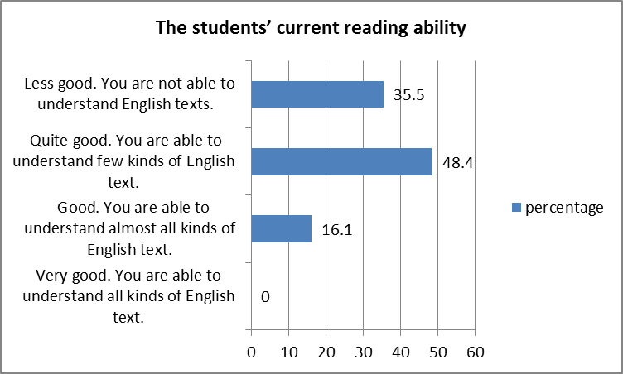
Figure 2. The students’ current reading ability
Beside the input, how the students prefer to perform the learning process needs to take into account. Related to media for learning reading, 58.1% did not need any media in reading learning except the textbook. It indicates that the reading
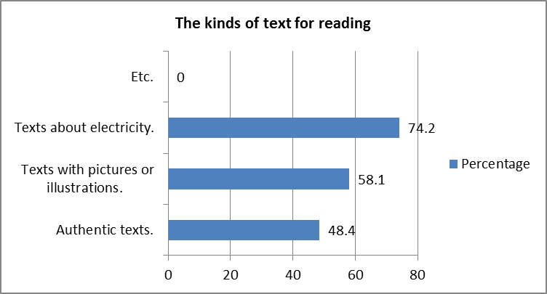
Figure 3. The kinds of text for reading
materials should be well-designed in order to fulfill the students’ expectation. Additionally, the reading activities should also adjust the students’ need in which the majority of the students expected to answer questions after reading (80.6%) and find the meaning of vocabulary in a text (54.8%) and should let the students do their tasks

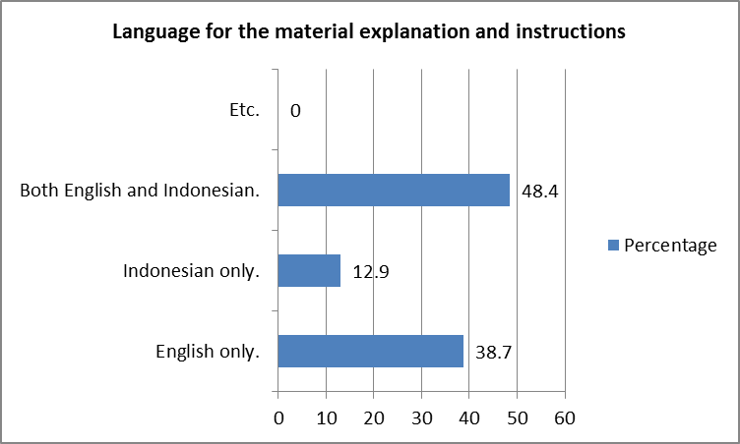
either individually or in group. Figure 4 shows that 48.4% of the students expected the use of both English and Indonesian to use for the languages of the material explanations and instructions. This was more than the amount of the students (38.7%) who expected English only as the language used in the materials.
In developing the materials, the students’ and teachers’ roles are also important. The result shows that 50.0% of the students preferred to have discussion with friends and the teacher to understand the text well in reading learning. Thus, the two biggest percentages of the teacher’s role result as shown in Figure 5 show that the students expected the teacher to give difficult words in the beginning and give questions that induce their curiosity.
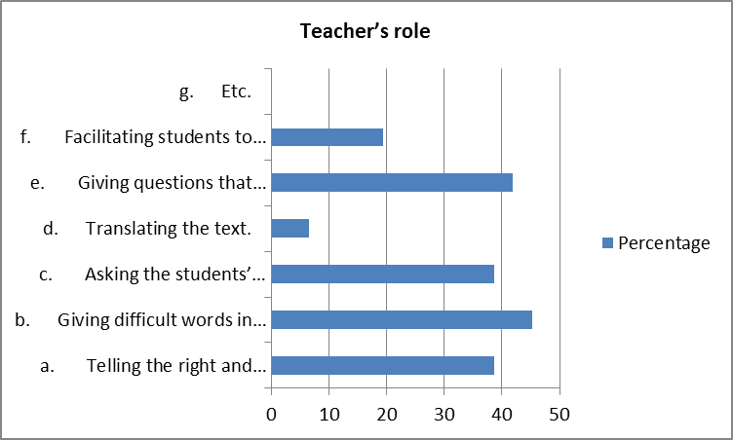

Figure 1. Figure name

- Discussion
In reference to the findings mentioned previously, there are some issues to discuss. First, it is evident that it is significant to develop the ESP reading materials for Electricity Installation Engineering study program. All the students agreed that electricity must be the main topic in the materials developed since their study program is related to electricity. Therefore, the reading materials should contain ESP which reflects the students’ needs. It is in accordance with the result of the study conducted by Chostelidou (2011) with the findings that the students taught based on their needs have better achievement. Furthermore, the development of the reading materials is needed since most students were not able to
References
- S Billet, Vocational education: Purposes, traditions, and prospects, London: Springer, 2011.
- European Centre for the Development of Vocational Training (Cedefop), The benefits of vocational education and training, Luxemburg: Publications Office of the European Union, 2011.
- T. Hutchinson, and A. Waters, English for specific purposes: A learning-centered approach, Cambridge: Cambridge University Press, 1987.
- C.T. Linse, and D. Nunan, Practical English language teaching: Young leaarners, NY: The McGraw-Hill Companies Inc, 2005.
- B. Tomlinson, Materials Development in Language Teaching, Cambridge: Cambridge University Press, 1998.
- D. Chostelidou, “Needs-based course design: The impact of general english knowledge on the effectiveness of an ESP teaching intervention”, Social and Behavioral Sciences, vol. 15, 2011, pp. 403-409.

