THE EFFECT OF LABORATORY PROCESSING CAPABILITY AND SCIENCE LITERACY OF READINESS BECOME A PROFESSIONAL PRE-SERVICE PHYSICS TEACHERS

Muhammad Minan Chusni1, Rizki Zakwandi2, Resy Fauziah Ratna Nurzaman3 Muhamad Fasha Nurfauzan4, Rena Denya Agustina5, Aan Hasanah6

1,2,3,4,5 Department of Physics Education, UIN Sunan Gunung Djati Bandung, Indonesia

6 Department of Islamic Education, UIN Sunan Gunung Djati Bandung, Indonesia

1minan.chusni@uinsgd.ac.id, 2rizki.zakwandi@student.uinsgd.ac.id, 3fauziahresy@gmail.com, 4 mfashanurfauzan@gmail.com , 5renadenya@uinsgd.ac.id, 6aanhasanah11@yahoo.com

Abstract

This research aims to describe the state of readiness of physics teachers candidates are graduate from PTKIN to greet corporate world, especially in education. Aspects of observed in this research is effect of skill of laboratory processing and science literacy of quality physics teachers candidate. The research was conducted by collecting related management data capabilities of laboratory and science literacy of students as graduate by PTKIN and to be a teacher. Subjects in the research are students of physical education at UIN Sunan Gunung Djati Bandung in three bacthes. The data in this research were collected by spearding the instruments in the form of a multiple choice test and essay for determine the ability of students theorically in the terms of management of laboratory and science literacy. Second instrumen was a questionnaire the contains of the questionnaire were statments about attitude to do prospective teachers in the implementation of learning. The collected data were analyzed using multiple regression analysis to determine the effect of skill of laboratory processing(X1) to readiness professional physics teacher (Y) and the same analysis was also conducted to clarify the effect of the science literacy (X2) to readiness professional physic teachers (Y). The result of this research are expected to be reference to make improvements in the course have a planning for prepare professional physic teachers.

**Keywords**: Processing, laboratory, literacy, science, teacher .

**Content**

Introduction

The curriculum that used at the university is directing the student to have a plan after their studies. Based on the president regulation number 8 of 2008 is make the rule that the student have choice their job corresponding to the performance. To student of physics education have three choices as minimum profession there are the teacher, laboratory assistant and the researchers [1].

To be a professional teacher the student must be have the interesting and good performance in educational process because the key of teacher is not transfer knowledge only. More than that, the teacher must be able the student to be interest in the lesson and let them to get the knowledge alone [2]. To make the student interest in the lesson so the teacher is must be come from the good background in education, interesting to be a teacher and have a good ability to teach the students.

Based on the results of research conducted suggests that the average laboratory processing at the school/ Madrasah is still in the poor category. It is shown by the acquistoin of laboratory processing in madrasah/school which shows the average value of 37,28 with aspect be reviewed by the knowladge about laboratory processing and observations about the conditions and management system. [3] [4] [5]. Other related research states that there is a significant correlation between laboratory processing capabilities with the skill to design and implement practical by the teacher. So that the weakness of teachers in managing the laboratory must be overcome so that the implementation can be optimized physics learning through practical activities [6].

In 2015 the majority of children in Indonesia get a test by the programme for International Students Assessment (PISA). It tested include science literacy which Indonesia students have. PISA result obtained showed that Indonesia students still has a low science literacy, the rate Indonesia ranks is 62nd out of 69 countries evaluated [7]. Accordingly, one of other research suggested that the low level of science literacy Indonesia students starting from a low lavel of science literacy that a teacher at madrasah/school [8].

The second indication would be a consideration for Institutions of Higher Education Teaching (LPTK) to seriously prepare graduates to be able the problems and obstacles encountered in the vocations. This research aims to show the readiness of candidate profiles LPTK especially graduate teachers under the auspies of Kementrian Agama on both aspects of the contributors to the low quality of education in Indonesia. The result of this research can be a references to make improvements in the lecture program planning in the order to prepare professional physics teachers candidate.

Based on the background of these problems this research aims to identify how the influence of a skill of laboratory processing and level of science literacy readiness prospective professional physics teachers.

Method

This research was conducted using quantitative research methods. Quantitative research method is a method used to examine the population or sample that aims to the hypothesis that has been formulated. This quantitative research methods must use a valid and reliable instrument, but it must using appropriate statistical analysis and precise so that the result does not deviate from actual conditions [9] .

In the implementation of the research variables measured were lab management capabilities, the level of science literacy of students and readiness of students into professional physics teacher. Skill of labratory processing and science literacy is the independent variable with each as X1 and X2. As for the readiness become a professional physics teacher is the dependent variable of the study. In these simple mapping of variables can be seen in the following table:

1. Variabel Penelitian

|  |  |  |  |
| --- | --- | --- | --- |
| No. | Variabel | Jenis | Lambang |
| 1. | Capabilities of Laboratory Management | Independent Variabel | X1 |
| 2. | Physical Science Literacy | Independent Variabel | X2 |
| 3. | Readiness become a professional physics teacher | Dependent Terikat | Y |

Diagrams of research conductes as follows:

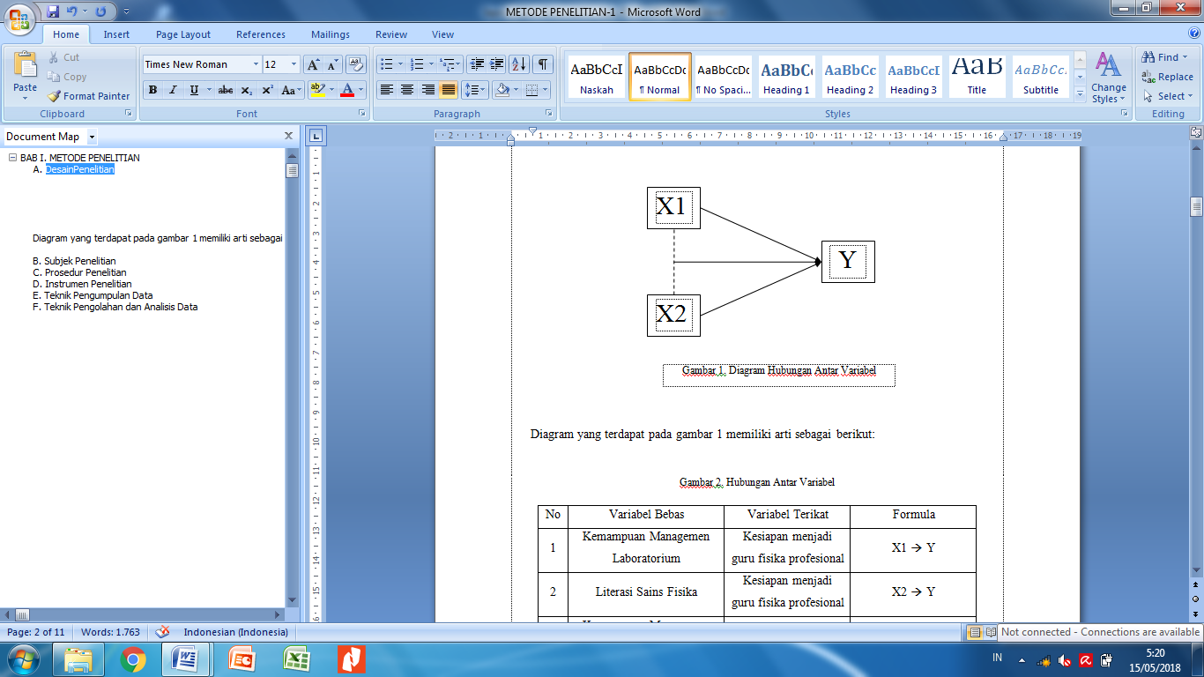

Figure . Diagram Variabel

The diagram show in the figure 1 have the following meanings:

Relations of Variabel Research.

|  |  |  |  |
| --- | --- | --- | --- |
| No. | Independent Variable | Dependent Variable | Formula |
| 1 | Capabilities of Laboratory Managemen | Readiness become a professional physics teacher | X1 🡪 Y |
| 2 | Physical Science Literacy | Readiness become a professional physics teacher | X2 🡪 Y |
| 3 | Capability of Management Physics Laboratory and Science Literacy | Readiness become a professional physics teacher | X1 and X2 🡪 Y |

Collecting data in this research conducted by spreading the instruments to the pre-defined subject. The technique used to collect data in this research is the used of multiple choice questions, essay, and use of questionnaires.

Data obtained from this research were analyzed with receipts regression of each variable as seen on the research chart. Before carrying out the regression test then tested prerequisite of research data covering normality test, homogeneity test and linearity test.

1. **3.Results and Discussion**
2. Based on the results of data processing research data obtained a description that is not a significant difference between science literacy and student lab management capabilities to become a readiness professional teacher. Prerequisite test results on the data indicates that all data collected is already meet the level of normality and homogeneity of data. At this stage of hypothesis testing data looks a picture of how the influence of each independent variable on the dependent variable.
3. The first research hypothesis put forward is a significant difference between lab management capabilities to become a readiness professional teacher.
4. Linieritas X1-Y

|  |  |  |
| --- | --- | --- |
| Variabel | F | Sig |
| Readiness to be a teacher capabilities of Laboratory Management | 1,515 | 0,216 |

1. The line of level testing is have done by providing the results as presented in Table 3 which indicates that the relationship between these two variables is linear in Physics Education Study Program UIN Sunan Gunung Jati Bandung with significant value 0.216> 0.05.
2. Regression X1-Y

|  |  |  |
| --- | --- | --- |
| Variables | F | Sig |
| Readiness become a teacher* Capabilities of Laboratory Management | 0,107 | 0,746 |

1. The regression coefficient X1-Y

|  |  |  |
| --- | --- | --- |
| Variabel | Constant | B |
| Readiness become a teacher* Capabilities of Laboratory Management | 0,835 | 0,000 |

1. The next analysis of the level of influence exerted by variables lab management capabilities to become a teacher readiness shown by Table 4 and Table 5. Based on the calculation of the data obtained significance value of 0.746 with the interpretation of regression does not significantly [10]. It is if the review is more deeply to see the great value given the regression coefficient is worth 0.162 with kepengaaruhan level of 4% only. By plotting the data obtained regression equation calculation results for the variable relationship with the lab management capabilities become a physics teacher professional readiness at UIN Sunan Gunung Jati is Y = 0.835 + 0,00X2. From these equations we can see that the contribution provided by the laboratory management capabilities virtually no or very little at all. This is shown by the coefficient of the variable X in the equation is worth 0.00 [11]. Such data when presented in chart form are as follows:

Readiness

Professional

Teachers

4 %

Capabilities

of Laboratory

Management

Figure 2. Laboratory management influence on the readiness to become a teacher

Thus it can be stated that the initial hypothesis of the study which states that a significant difference between lab management capabilities with the readiness to become a teacher was rejected because of influence exerted by the variable laboratory management capabilities are very small.

Second analysis is about the effect of science literacy to become aprofrssional physics teachers. At the initial hypothesis the researchers stated that a significant difference between the level of science literacy of students with readiness be a teacher. According to the research done, it can be stated that the initial hypothesis was rejected. This is based on linearity and regression test results in table 6, 7 and 8 as follows:

1. Linieritas X2-Y

|  |  |  |
| --- | --- | --- |
| Variables | F | Sig |
| * Readiness to be a teacher of Science Literacy | 1,279 | 0,331 |

1. Regresi X2-Y

|  |  |  |
| --- | --- | --- |
| Variables | F | Sig |
| Readiness to be a teacher of Science Literacy | 0,363 | 0,552 |

1. Koefisien Regresi X2-Y

|  |  |  |
| --- | --- | --- |
| Variabel | Constant | B |
| Readiness to be a teacher * capabilities of Management Laboratory | 0,831 | 0,000 |

1. In Table 7 and 8 obtained information that the results of the regression of the data not show a good linearity. It refers to the value obtained for 0.552 significance far greater than 0.05 degrees of freedom. On the basis of this interpretation indicates that there is no significant effect between the level of science literacy of students with a readiness professional teacher [12]. Further influence exerted by science literacy variable regression coefficient dala otherwise only obtained a value of 0.113 with a given level of contribution of 1.3% to support the readiness become professional teachers. The result of this calculation is supported by the results of plotting the data and identification of the linear correlation shown by the linearity of the equation Y = 0.831 + 0,00X1. The value of the coefficient for literacy variable is 0.00. So it can be stated that there is no contribution or contributions which given by the level of science literacy for readiness to become professional teachers in UIN Sunan Gunung Jati. In the diagram the influence given are as follows:

1,3 %

Readiness

Professional

Teachers

Science

Literacy

Figure 3. Science Literacy contribution to the Readiness Professional Teachers

Final testing phase is to test the hypothesis that the second linkage independent variables on the dependent variable. The third hypothesis of this research reads: "There is a significant contribution of laboratory management ability and science literacy to be a readiness profrssional physics teacher ". Based on the research results obtained refute the hypothesis put forward at the beginning of the research. This is evidenced by the low index of regression resulting from the researchconducted

Regression [X1X2] - Y

|  |  |  |
| --- | --- | --- |
| Variable | F | Sig |
| Readiness become a teacher* Ability Laboratory Management and Science Literacy | 0,205 | 0,816 |

1. Koefisien Regresi [X1X2] - Y

|  |  |  |  |
| --- | --- | --- | --- |
| Variable | Constant | X1 | X2 |
| Readiness become a teacher* Ability Laboratory Management and Science Literacy | 0,818 | 0,047 | 0,107 |

1. Based on the tables 9 and 10 which illustrate the regression of the three variables of the study at UIN Sunan Gunung Jati provides enormous significance value is 0.816 with a variable data interpretation does not make a significant contribution. Followed by reviewing formula regression produced by Y = 0.818 + 0.00 + 0,00X1 X2 shows that the contribution of independent variables X1 (lab management capabilities) and X2 (scientific literacy) together does not significantly [13]. The correlation is given as follows:

1,5%

Readiness

Professional

Teachers

Capabilities

of Laboratory

Management

Science

Literacy

1,3%

4%

Figure 4. Contributions Laboratory Management Capabilities and Readiness Literacy to become Teacher of Science

Based on the figure 4 above can be seen that the contribution made by the independent variable is below 5%, which means very little. In this research the effect of laoratorium management capabilities are not the focus of research so that in Figure 4 are also not included how the influence exerted by both.

1. Conclussion

Based on the results of the discussion there are conclussions of this research are: 1) There is a significant difference between the ability of the management of laboratory on the readiness profesioanl prospective physics teachers, 2) There is a significant difference between science literacy on the readiness profesioanl prospective physics teachers, 3) there significant influence of laboratory management ability and science literacy on the readiness profesioanl physics teacher candidates. Based on this result, the phase further research is needed on the development of physics teaching model to improve the scientific literacy of physics and is also necessary for the development of teaching materials such as books, student worksheets and lectures authentic observation sheet.

1. Acknowledgement

The researches thank you to Research Centre of UIN Sunan Gunung Djati Bandung as help us in material research.

1. References

Pemerintahan Negara Republik Indonesia, "Peraturan President Nomor 8 tahun 2008," Indonesia, 2018.

K. Komalasari, "The effect of contextual learning in civic education on students’ civic skills," Educare, vol. 4, no. 2, 2016.

R. Kastijono, “Implementasi student centered learning dalam praktikum fisika dasar,” Jurnal Penelitian Fisika dan Aplikasinya, vol. 1, no. 2, pp. 19-32, 2011.

N. Hidayah, U. Rosidin dan D. Maulina, “Deskripsi kemampuan guru IPA di SMP swasta Bandar Lampung dalam mengelola laboratorium,” Jurnal Bioterdidik, vol. 3, no. 4, 2015.

H. S. Wattimena, A. Suhandi dan A. Setiawan, “Profil penyelenggaraan praktikum fisika sekolah sebagai penyiapan mengembangkan kreatifitas calon guru,” Jurnal Pendidikan MIPA, vol. 15, no. 2, 2014.

R. Jonuarti, Yurnetti, Hidayati dan F. Mufit, “Efektifitas pengetahuan pengelolaan laboratorium dan substansi bahan ajar terhadap pengetahuan guru membuat modul praktikum IPA SMP dalam menyambut kutikulum 2013,” Jurnal Penelitian Pendidikan, vol. 5, no. 1, pp. 1-8, 2014.

H. Iswadi, “Sekelumet dari Hasil PISA 2015 yang Baru Dirilis,” 07 Desember 2016. [Online]. Available: http://www.ubaya.ac.id/2014/content/articles_detail/230/Overview-of-PISA-2015-result-that-have-just-been-Realesed.html. [Diakses 08 Nopember 2017].

J. Maknun, “Pembelajaran mitigasi bencana berorientasi kearifan lokal pada pembelajaran IPA di sekolah menengah kejuruan,” Jurnal Kajian Pendidikan, vol. 5, no. 1, pp. 143-156, 2015.

A. M. Yusuf, Metode Penelitian: Kuantitatif, Kualitatif dan Penelitian Gabungan, Jakarta: Kencana, 2014.

I. Gani dan S. Amalia, Alat Analisis Data, Yogyakarta: Penerbit Andi, 2015.

D. Sambada, “Peranan Kreativitas Siswa Terhadap Kemampuan Memecahkan Masalah Fisika dalam Pembelajaran Kontekstual,” Jurnal Penelitian Fisika dan Aplikasinya (JPFA), vol. 2, no. 2, p. 3, 2012

E. Listia, Asrul dan A. Fauzi, “Pengaruh Lembar Kerja Peserta Didik (Lkpd) Terintegrasi Materi Tsunami Terhadap Kompetensi Fisika Dalam Pembelajaran Reasoning And Problem Solving Pada Materi Getaran Harmonik, Impuls Dan Momentum Di Kelas Xi Sman 10 Padang,” Pillar of Physics Education, vol. 7, no. 1, 2016

Surie, A. Novira, N. Maharta dan U. Rosidin, “Hubungan Pembelajaran Berbasis Tugas Terstruktur Terhadap Hasil Belajar Dan Minat Belajar Fisika,” urnal Pembelajaran Fisika Universitas Lampung, vol. 2, no. 7, 2015.