THE STRATEGY OF "PADEPOKAN KARAKTER" IN IMPROVING CRITICAL THINKING SKILLS ON YOUTH CITIZENS IN THE 21TH CENTURY
Sutiyono1¹, Suharno²
^{1,2} Universitas Negeri Yogyakarta
1sutiyonoa362@gmail.com, 2suharno@uny.ac.id
Abstract
Young citizens are vulnerable to global developments in the 21st century. Increasingly sophisticated technology is a massive globalization process that tends to be massive. The country's borders are fading due to the ever-evolving technological sophistication. Cultures from different countries can be accessed and dispersed quickly through modern technology. As a result, there is an unbalanced cultural acculturation. There is a new cultural influence on the native cultural values ​​of Indonesia. This causes a lot of problems of character irregularities that occur in young citizens. One solution to overcome to filter the influence of foreign culture is to instill critical thinking in young citizens. Critical thinking is thinking that involves the ability to analyze, evaluate, rate, and solve a problem. Semarang State University as an institution of higher education has the responsibility of creating graduates with character. Innovation conducted by State University of Semarang is creating Padepokan Character. Character Padepokan is the result of innovation in the field of character education. One focus of Padepokan Karakter is to develop value-based learning model to strengthen student thinking. This study aims to identify qualitatively the strategy of Padepokan Karakter with value-based value-based learning model as an effort to strengthen the critical thinking character of the students. This research is a supporter of the theory of critical thinking that includes the ability to analyze, evaluate, assess, and solve a problem.

Keywords: character matching strategy, critical thinking skills, young citizens

- Introduction
Character study is an endless problem. Characters are always an interesting topic to discuss over time. This is because the character traits attached to humans develop dynamically. The cause of the dynamics of human character can come from within itself (intern factor) and from outside human itself (external factor).
Internal causes can come from diverse human knowledge. Each person's knowledge has a different level of thinking ability, even in the same group. Meanwhile, the influence from outside (external factor) can come from community environment, education, even impressions from modern technology. This, then, makes the ability to think critically as an important character for human beings.
Banks, said that this era of globalization is a necessity that must be faced by all nations in the world [1]. Coupled with the emergence of sophisticated technology increasingly smooth the development process of globalization which has the principle of interdependence between people in one country with other countries. In the era of globalization there is a culture that serves as a central in determining the system, commonly referred to as the one and there is referred to as the others or the periphery culture included in a country that is indirectly controlled [2].
Due to the freedom of technology in accessing the content, will lead to a shift of native culture towards the less precise or referred to as acculturation of culture. This issue will easily affect the behavior of young people as human beings are developing. As reported by the Sexual Behavior Survey survey conducted in five major cities in Indonesia. Data found that of 663 respondents directly admitted that 39% of respondents aged 15-19 years have had sex, the remaining 61% aged 20-25 years. More apprehensive seen from the profession, the highest rank ever to do free sex is among the students 31%, office employees 18%, the remaining 6% of junior and senior high school students. Based on these cases, it shows that education is not yet optimal to strengthen the nation's character [3].
One sector that can educate young citizens is a formal educational institution. Semarang State University as one of the educational institutions and educational staff (LPTK) has a special autonomous institution to educate students to have critical thinking skills as the competence of dealing with character degradation. Critical thinking is the ability to analyze, evaluate, rate, and solve problems [4].
This innovation is in line with the skills needed in the 21st century: innovative skills in learning, digital literacy, and life and career skills [5]. Learning innovation is embodied in a place called "Padepokan Karakter" at Semarang State University.
- Method
This research uses qualitative approach with phenomenology study method [6]. This research was conducted in "Padepokan Karakter" State University of Semarang, Semarang City. The research was conducted in December 2017 until April 2018. The instruments used were documentation study, observation, and direct or indirect interview. The interview was conducted in Padepokan Karakter with 5 lecturers and 18 students as young citizens residing in Padepokan Karakter. This research uses purposive sampling because some resource and research object have been determined from the beginning. Documentation study was conducted to view documents owned by Charapokan Karakter. Meanwhile, observation is done to observe the implementation of strategy in Padepokan Karakter. The last step is data analysis through data reduction, data clarification, and presentation of data to be drawn conclusions.

3.Results
Based on the various issues of young citizen character "Padepokan Karakter" has several strategies to overcome the problem. One of the strategies used is to develop a model that can strengthen the critical thinking character of young citizens. This learning model is part of the model being developed by Padepokan Karakter. This model is named after the value-based learning model.
Based on research data from observation, interview, and documentation, the development of value-based learning model in Padepokan Karakter, that the value-based learning model takes model applicable in capital market society. Particularly about the way members of the community engage in the process of social mechanisms through a series of social agreements. There are two positions in the learning model of this indigo market: the investor as the owner of the capital and the issuer as the seller of the work as a solution or object being discussed. It is through this agreement that the investors and the issuers are learning academic knowledge and they are involved in solving the crisis problems of the nation's character values. This developed model has three main concepts of research, knowledge, and group learning dynamics.
The research phase in the value exchange model is intended to be a process whereby the investor group and the issuer group are stimulated by confronting it with the crisis of character values. In this process, the two groups enter a situation in which they respond to the value crisis of the character they feel to be solved. The problem itself arises from the Supporting Institution (lecturer), and from the wishes of the investor (group of buyers / investors) or from the issuer (the seller). To solve this problem, prosecuted procedures and requirements that have been determined. Meanwhile, at the stage of knowledge is an experience that is not brought from birth but obtained by individuals through and from experience directly or indirectly.
At the stage of group dynamics refers to an atmosphere that describes the group of investors and groups of emitents interacting with each other about the problem-solving crisis character values that are deliberately viewed or studied together. In this interaction, there is an involvement of the process of sharing ideas and opinions as well as exchanging experiences through the process of mutually arguing against the effectiveness, simplicity, ease, and nature of the measurement model of crisis response character values traded. They are the basis of the value exchange model. The steps in the bursai-based learning model of this value can be seen in table 1. as follows.

Table. 1 Stock Exchange Model In Character Match
Growing Nation Character Values
Activities of Teacher | Basic Steps | Aktivities of Student
Serve the crisis situation of the nation's character values  Lecturers act as Supporting Institutions, dividing the class into two groups  (1) Investor (buyer / investor) securities (securities) on the stock exchange  (2) Issuer (seller) of securities (effect) crisis solution character values  Spur group discussion solutions character value crisis  Monitor the learning activity of character value growth solutions  Check the progress of the group (invesor and issuer) buying and selling model / solution character values growth  Encourage the action of value exchange impact solutions on the growth of character values | Elaboration situation of the character value crisis  Classroom management and material Exploration of group responses  Exploration of group response  Supervision: start, go, integration  Analysis of progress and reflection  Repetition and feedback  Auction Activities | The Issuers' group discussed modeling / solution of crisis character value problems and selling to investors  Investor Group medialogkan effectiveness, simplicity, accuracy, measurement model growth character character values  Organize the division of tasks of each group  Explore and discover the key issues and solutions for the growth of the nation's character values  Formulate what to do  Revise the results of the dialog  Check out the process and results of group discussions  Follow-up result of solution of character value of nation  Report the results of the value exchange

(Source: The results of the study which is thought Maman Rachman)

Based on the table Table 1. it can be explained that the operational steps of activities in the learning model based on bursai this value consists of (1) presents the situation of crisis character of responsibility, honesty (scholarship); (2) divide the class into two groups: Investors and Issuers. Investor (selected from student). Individually (investors) in charge of buying securities (effects) as a work in the form of solutions to the character issues studied and strengthening the character of the Issuer as a seller. The high / low price of securities is highly dependent on the effectiveness and effectiveness of securities. Capital is obtained from the Supporting Institution (Lecturer). Issuers sell (effects / works) as a solution to the character crisis to investors. Works or effects can be models, ways, strategies, which aims to strengthen the character due to problems encountered. Each issuer consists of 3 people. Bargaining the price of securities is highly dependent on the expertise of the issuer to explain, the effectiveness / usefulness of the model; (3) spur group discussion of crisis character solutions; (4) checking the progress of the group (investors and issuers) selling and selling securities as solutions for strengthening the character; (5) ask the representative of the investor to present the result of the purchase of securities; (6) invites students to reflect meta-cognitive character-strengthening solutions; (7) ending Value Exchange activities with auction activities.
Application of learning model based on bursai value is done during 4 (four) meetings. The first and second meetings were delivered on the college contracts, and submitted permalasahan that must be criticized by the students as well as an explanation of the implementation of the value-based learning model.
The third meeting, at the beginning of the meeting, begins with the usual presence and prayer. Then, checked for the assignment given in the previous week. Direct students are asked to position the selected ones as investors (sub-agents) and groups for the selected students as issuers (sellers). These activities can be seen in Figure 1. as follows

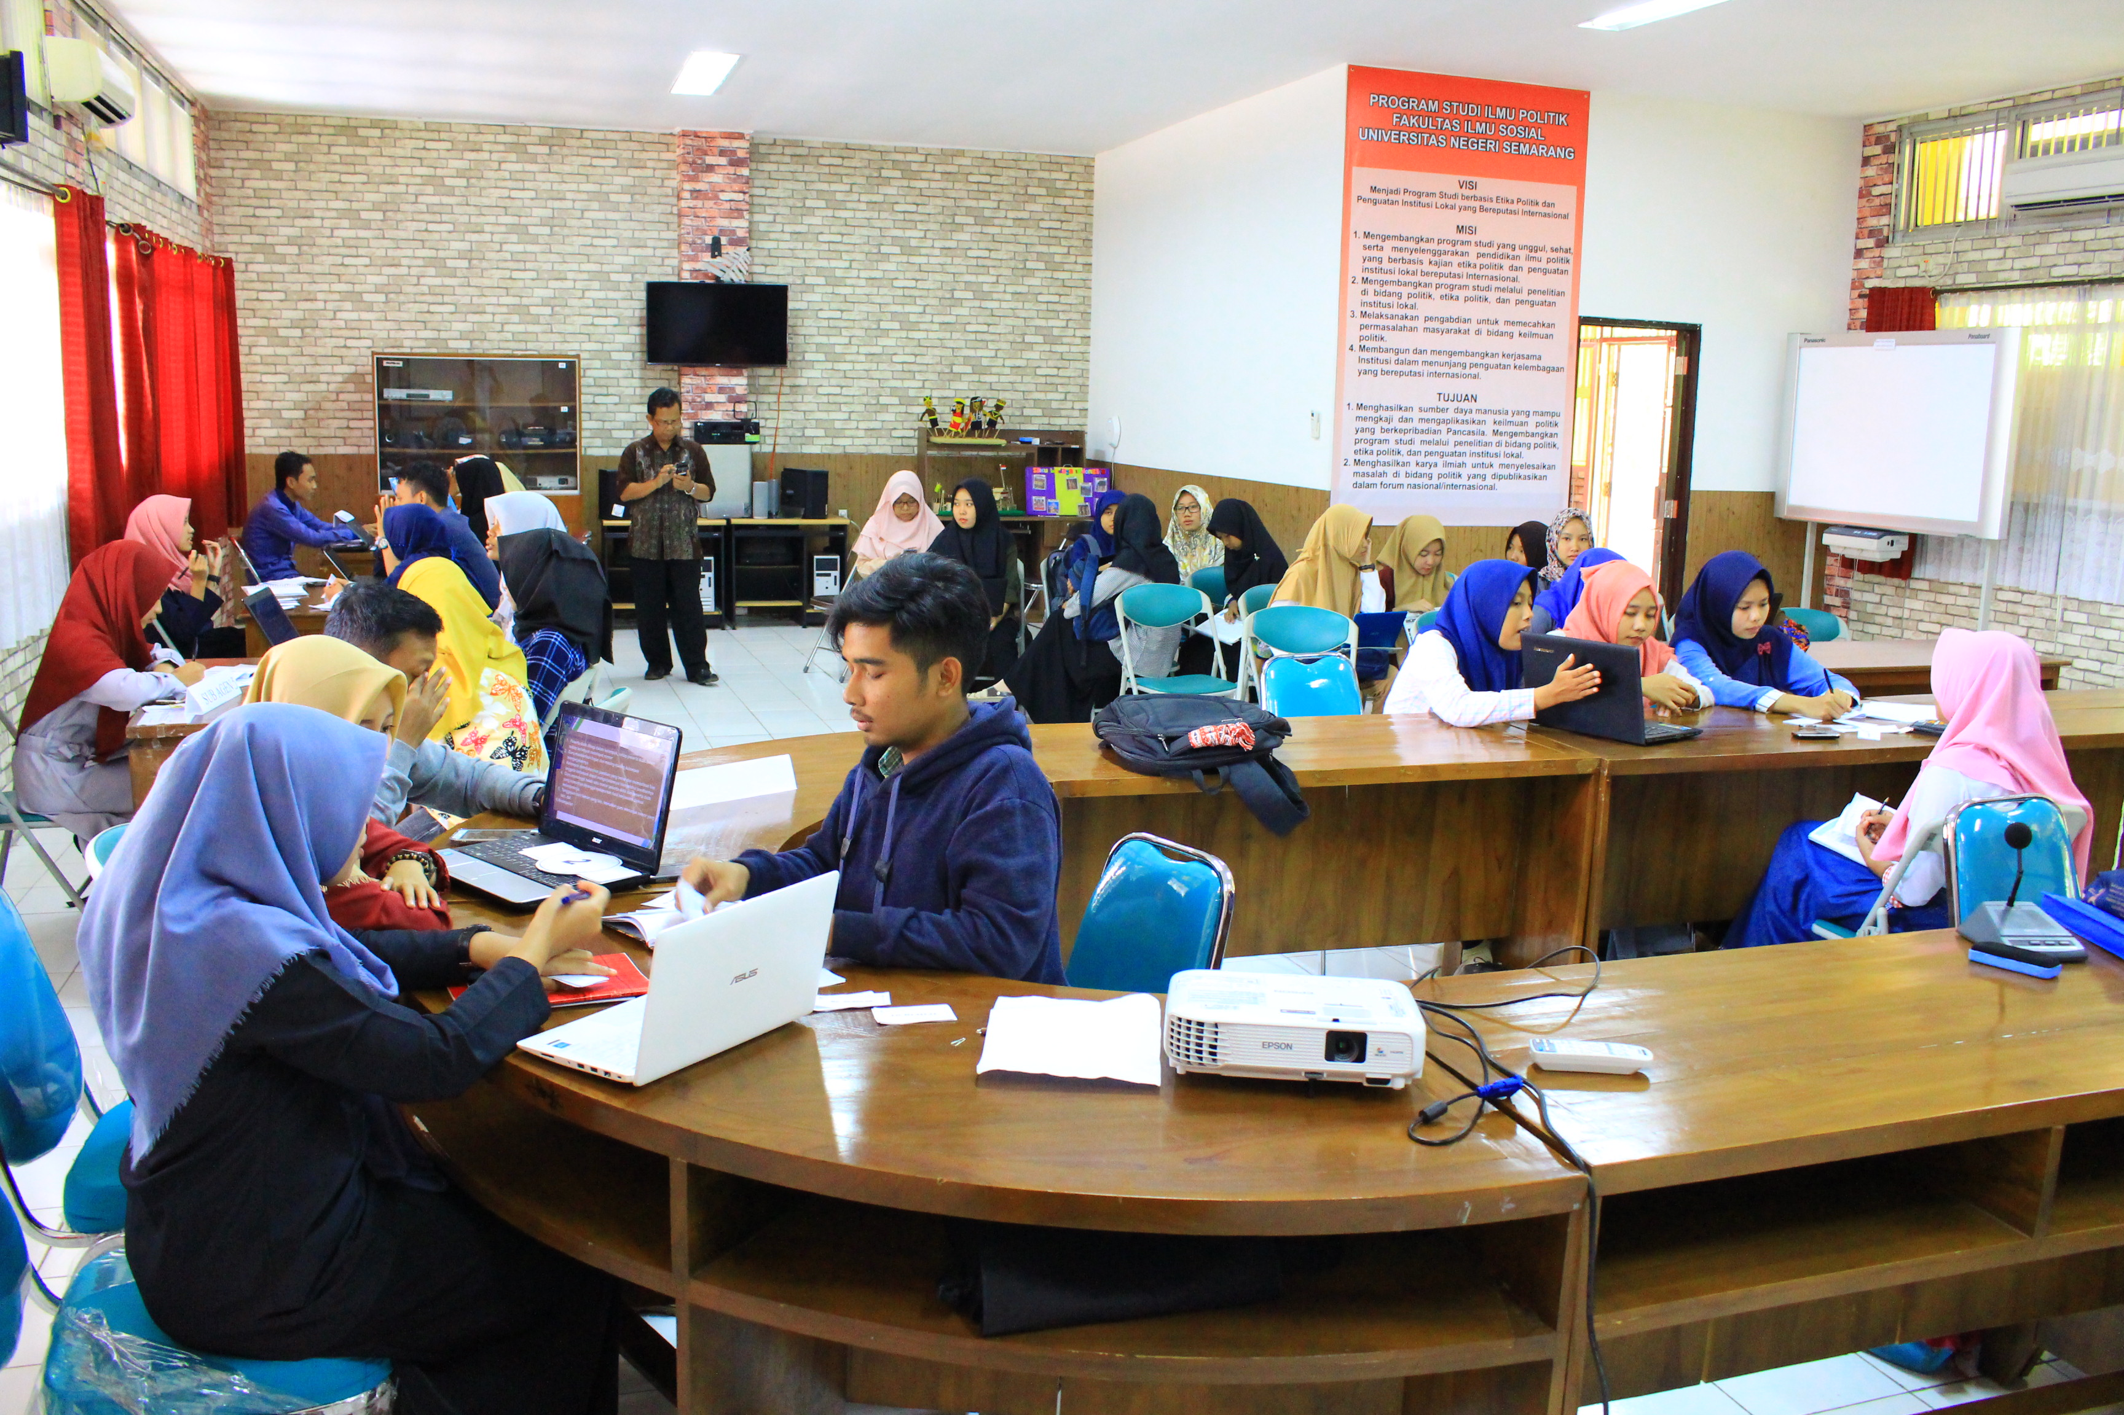
Figure 1. Implementation of value-based learning model Character Padepokan to cultivate the critical thinking character of young citizens in Unnes (Source Documentation Research on March 27, 2018)

Based on the picture, it is seen that the implementation of strengthening the character of the nation in Padepokan Character with the value-based learning model has its own peculiarities. Students who become sellers in groups of three people are outside the circle. Meanwhile, students who have been selected to be buyers or investors are in the circle. Investors and emitents discuss and argue to promote the urgency of innovation made by issuers as the solution of the nation's character encountered. Meanwhile, investors ask the advantages of the solution offered to be purchased when it has reached an agreement.
In the implementation of strengthening the character of the nation using a model of exchange-based learning value in Padepokan Character is democratic. There is a social system characterized by decisions developed from the investor on the offer of the issuer by reinforcing the group experience in the context of the problem that becomes the central point of learning. The activities of the issuers group with the first good investor with the next occur simultaneously. The status of supporting institutions (lecturers), investors, and issuers have similarities in dealing with problems that are solved with different roles. The classroom climate in the learning model based on bursai value is marked by the interaction process is agreement or consensus between investor and issuer with the direction of supporting institution.
Briefing done by supporting institutions (lecturers) is to perform three stages of problem-solving, classroom management, and meaningful stages by each group. The problem-solving stage concerns the character's crisis, the nature of the character crisis, and what is the focus of the crisis. The classroom management phase deals with the process of selling / buying models how to solve the character's crisis problem, what information is needed, how to organize the group to obtain the information. While the meaning of group stage is related to the process of studying how the group / one appreciate the impact of the process of following the value-based learning model.
Based on Figure 1., it is seen that there is a companion impact that is (1) democratic character and commitment to nationalism, (2) awareness and adherence to social rules, (3) intelligence and honesty in togetherness, and (4) logical, critical, creative, and innovative in problem solving.
Critical thinking of young citizens is demonstrated by the way of thinking and doing things logically to produce new ways or new findings that have muktakhir to existing or owned. The students in dialogue and interacting and selling the model of character crisis solving is done by paying attention to logic, kebaharuan, so that critical thinking raises creativity to be done by members of the group of emitters and investors themselves.
After implementing some value-based learning models in Padepokan Karakter, students as young citizens are given reflection as a form of effort measurement of value based learning model of bursa developed in Padepokan Karakter. This reflection is in the form of a message and an impression in writing, the expression of attitudes toward learning, and comments about what character values ​​are felt and performed when the learning takes place. A reward or reward is given in the form of an auction at the end of the lesson.
- Discussion
Based on the results of research, obtained some activities due to innovations conducted by the State University of Semarang. Innovation in question is Padepokan Karakter as a new container of strengthening the character for the students to become graduates who have character of Indonesia. One of the strategy of Padepokan Karakter is to create value based learning model. This new model has a positive impact on young citizens to have logical and reflective critical thinking skills. As Ennis says that critical thinking refers to a logical and reflective way of thinking to a certain decision [7].
Implementation of value-based learning model based on the assignment of tasks to students to look for character crisis that hit the youth of Indonesia. The search is done using modern technological tools such as internet. It complements the students' ability as a young citizen to take advantage of modern technology in the 21st century.
In addition, this searching and analyzing activity triggered students' curiosity to find out a case of character crisis. As Wilson said that critical thinking relates to self-reflection in which there is high curiosity [8]. The point of critical thinking is the skill to perform interpretation, analysis, evaluation, and conclusion with the ultimate goal of explanation [9].
In the activity memaknai information obtained also there are activities to discuss with peers to find the best solution to the issues studied. This activity gave birth to a cognitive way of thinking from students to find a basis to interpret and provide solutions to the issues studied. Miller et al explains that critical thinking requires a coherent application to the goal of practicing cognitive and habitual abilities [10]. The kignitive ability is the main skill that underlies how the desired character appears in the student. This is the basis that can influence how feelings and actions emerge from every human being. At the theoretical level is disebuat as moral knowledge, moral feeling, and moral action.
After searching, interpreting, and assessing as a first step in the bursay-based value model of learning is referred to as research and knowledge activities. Furthermore, the result of the working group of issuers (sellers) as a group that has a solution of "securities" sells to investors as buyers or investors. Here is the activity called group dynamics.
Group dynamics required a brilliant idea to offer emitter products as solutions to a character crisis issue. This stage requires a persuasive effort to influence the inevestor in order to purchase a product or a letter of effect as a solution to the issues studied. There is an elusive problem construction activity to be defined and understood from field studies [11]. This activity is a critical thinking that is understood as skill and disposition [12]. This activity also involves a set of capacities which includes interpreting, predicting, analyzing, and evaluating activities [13]. The evaluator evaluates on what the issuer's group of "effec letters" offers as solutions to the character crisis issue.
Bargaining between issuers as sellers and investors as buyers coupled with a strong argument from both. This argument for issuers is used to make an ethic so that investors can buy their products as a sign of the success of the products made. This activity is a student activity that has a deep understanding of the products and issues studied so that they can be promoted well. Kallet's opinion that critical individuals have a deep understanding of what is being studied [14].
Learning activities are closed with auction activities as a form of reward. This activity is the closing activity of the learning activity using the value-based learning model. Thus, the activity of students in value-based learning is found to be an activity of interpreting an issue and issue of character crisis, analyzing the problem for a given assessment. From that assessment, concluded a core of the problem to look for solutions. Lastly explained to the investor for the sale of the idea of ​​solutif or "effec letter" as a form of successful working group of issuers. It gradually teaches learners to immerse critical ways of thinking that are shared with each other's character.
The closing activity of the value-based learning model is the auction activity. This activity as an upacaya give appreciation to students to stimulate knowledge and feelings. This is in line with what Kristik et al says that rewards are factors that affect consciousness as knowledge management [15]
This learning activity meets several steps in critical thinking. The syntax that is the indicator of critical thinking is the interaction of interpretation, analysis, evaluation, conclusion, and explanation [16].
- Acknowledgement
The authors would like to thank Indonesia Endowment Fund for Education (LPDP) Ministry of Finance Republic Indonesia which has given opportunity to continue study in Master Eduation Program. Then, thanks to Dr. Suharno, M.Si who has reviewed and cooperated to follow this event.
References
- Banks, J.A. (2008). Diversity, group identity, and citizenship education in a global age. Educational Researcher, 37 (3), 129-139.
- Abidin, Z. (2000). Filsafat manusia; memahami manusia melalui filsafat. Bandung: PT Remaja Rosda Karya.
- Sexual Behaviour Survey. Lima puluh persen abg kota besar pernah free sex. (2011). Sumber: http://www.hakimtea.com (Downloded on date 21 Maret 2018).
- Phillips, W. E., & Burrell, D. N. (2009). Decision-making skills that encompass a critical thinking orientation for law enforcement professionals, 11(2), 141–149.
- T. Bernie., & C. Fadel. (2009). 21 Century Skills. United State of America: Jossey-Bass
- Creswell. J.W. (1998). Qualitative inquiry and research design: choosing among five tradition. London: Sage Publication
- Dispositions and Abilities, [Online]. Tersedia: http://faculty.ed.uiuc.edu/rhennis. [downloaded on date 21 Maret 2018]
- Wilson, K. (2016). Critical reading, critical thinking: Delicate scaffolding in English for Academic Purposes (EAP). Thinking Skills and Creativity, 22, 256–265.
- Facione, Peter A. The California Critical Thinking Skills Test—College Level. Technical Report 2. Factors Predictive of CTSkills. American Philosophical Association, Newark, Del., pp. 3. (2015).
- Moore, C., Peverill, S., Garon, N., & Brown, A. (2017). Depleting and motivating self-regulation in preschoolers. Cognitive Development, 44(September), 116–126.
- Wade, C. (2014). Using Writing to Develop and Assess Critical Thinking. Sage Publisher, Vol. 22
- Buckley, J., Archibald, T., Hargraves, M., & Trochim, W. M. (2015). Defining and Teaching Evaluative Thinking: Insights From Research on Critical Thinking, 36 (3), 375–388.
- Carmel, J., & Yezierski, J. E. (2013). Are we keeping the promise? Investigation of students’ critical thinking growth. Journal of College Science Teaching, 42 (5), 71-78.
- Kallet, M. (2014). Think Smarter Critical Thinking to Improve Problem-Solving and Decision-Making Skills.
- Kristin, D. Maya., & Evy. (2016). Knowledge Management System Evaluation. Pertanika Journal. 24 (S): 5-6
- Airasian, Peter W., et al. Kerangka Landasan untuk Pembelajaran, Pengajaran, dan Asesmen (Revisi Taksonomi Pendidikan Bloom). Alih Bahasa: Agung Prihantoro. pp. 106-125, (2010).Yogyakarta: Pustaka Pelajar.

