PROSPECTS OF PHYSICS LEARNING MEDIA BASED ON ANDROID: STRATEGIC STUDIES ENTERING THE INDUSTRIAL ERA IN THE 21st CENTURY
Wahyu Hari Kristiyanto
Physics Education Department
Study Center for Education of Science, Technology, and Mathematics (e-SisTeM)
Faculty of Science and Mathematics, Universitas Kristen Satya Wacana, Salatiga Indonesia
Email: whkris@staff.uksw.edu
Abstract
Games based on android has become a popular thing owned by android smartphone owners these days. The purpose of this study describes the study of the application of physics-based learning media android in the 21st century industrial era. The study presented through the stages of cognitive theoretical study of students, practical studies android application development, and application of strategic studies of android as a medium of physics learning based on students' cognitive profiles. The results showed that the cognitive theoretical study of students put the learning media as a source of information that acts as a stimulant in the process of information processing. Application of physics-based android-based learning media made using various software through workmanship on the computer such as Adobe Flash CS6 ActionScript 3.0 and then done deployment to apk with Adobe AIR facility that can be installed in the smartphone is a category of multimedia learning. The concept of dual code that explains that the processing of information can be through two lines of visual and audio can occur to mutually reinforce the stimulus understanding of information content becomes very instrumental in the design of this learning media. Common concept errors in the contents of instructional media in the form of computer simulation animation can be a reference in the development of the application of physics learning media correct. The conclusion of this research shows that the application of physics-based learning media android becomes a strategic thing in realizing the expectation of educational achievement in 21st century industry era in the form of digital literacy or digital learning by taking into account the concept of physics and multimedia learning. This research suggests that application developers need to pay attention to the dual code concept in information processing cognition and correct physics concepts.

Keywords: android, learning media, physics, dual code, industrial era, digital literacy.

- Introduction
Indicators of educational achievement in 21st century industry era one of them is the implementation of digital literacy. This is expressed in the speech of the Minister of Research, Technology and Higher Education on the commemoration of National Education Day on May 2, 2018. Digital literacy can be done through digital learning that supported digital learning media.
Digital learning media "era now" allows accessible using gadgets such as smartphones wherever located. The results of [1] [2] showed that smartphone and internet users in Indonesia are dominated by young age, even school age. Smartphone selected can be from the consideration of the ability of the existing camera to the performance of operating system performance capabilities. Operating system that is widely used by the school-age community is android in addition there is also IOS (Apple product specifically).
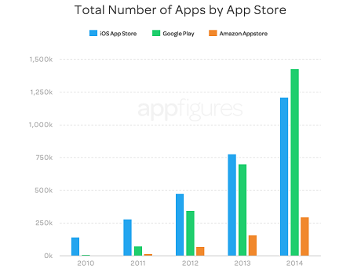
Figure 1. Number of apps for smartphone available [21]
The android based game has become one of the popular apps owned by android smartphone owners. Fig. 1, showing there are 1.4 million game apps that can be downloaded for free using android smartphone [21]. The ease given by today's technology makes the user get and do everything that is needed easily in the grip of his hand.
This allows users to spend a lot of time with their smartphones in all circumstances. The result of [3] study shows that Indonesian people use their time on average 5.5 hours or equivalent more than 50% of their activities outside the bed with their smartphone. This phenomenon can actually be a potential in addressing government policies related to digital education in the era of this 21st century revolution. One potential is visible availability of smartphones and user skills in using android-based applications.
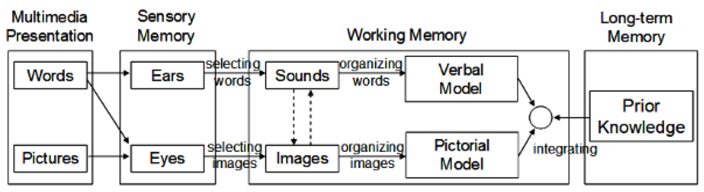
Figure 2. Dual coding of multimedia learning by Mayer
(Mayer, 2009)
The school's policy on smartphones is still a lot against the expectations of the digital education industry era in the 21st century. Many schools are implementing the rule of prohibition of the use of mobile phones in the school environment. This prohibition is not yet supported by facilities for replacement of digital learning media needs such as computer laboratory, multimedia laboratory, and internet network. The existence of this limitation directly also limits the creativity of teachers to bring digital learning to learners.
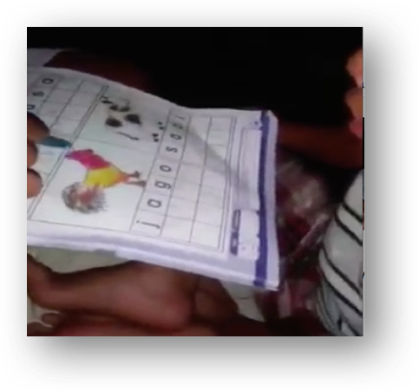
Figure 3. Media image "rooster" and the word "jago" as a medium of learning to read

Based on this, it becomes a problem when there is a gap between the expectation of digital learning in the era of 21st century industrial revolution with policy limitations and the potential of schools in its application. Application of android-based applications that require computer devices and smartphones in the implementation of physics learning in the classroom is in accordance with the criteria of industrial era achievement in the 21st century in the form of digital literacy or digital learning. The purpose of this study describes the study of the application of physics-based learning media android in 21st century industry era.
- Method
This qualitative research is conducted with the study of cognitive theoretical studies of students, practical studies of android application development, and strategic study of application implementation of android as a medium of physics learning based on students' cognitive profile. Source of data obtained from the literature on information processing and student thinking processes, development and efficiency of android applications, and blueprint education field of 21st century industrial era. Data analysis is done by using tacit knowledge researchers in interpreting the study data.

3. Results
The results of this study include the results of cognitive theoretical studies of students, practical studies android application development, and strategic assessment of application android application as a medium of physics learning based on students' cognitive profile.

  - Results of The Cognitive Theoretical Studies of Students

The result of cognitive theoretical study of students put the learning media as a source of information that acts as a stimulant in the process of information processing. The concept of dual code that explains that the processing of information can be through two lines of visual and audio can occur to mutually reinforce the stimulus understanding of information content becomes very instrumental in the design of this learning media. Common concept errors in the contents of instructional media in the form of computer simulation animation can be a reference in the development of the application of physics learning media correct.
Active learning media is a medium in learning that can facilitate students in physical activity as well as cognitive. Student cognitive activity can be facilitated with questions and information that students need to process. Processing of information related to the thinking process of students needs to be guaranteed accuracy and effectiveness.
Mayer (2009) states that information processing is related to instructional media related to dual code of visual and audio information processing (Fig 2). It is also found in Kristiyanto's research [4] which shows that impressions in the form of pictures and related writings and simultaneously aired can interfere with each other. Disruption of the quality of information to be processed from 2 or more information received through the same senses due to the process of selecting words on the audio input channel or selecting images on the visual input channel.
The interesting thing that needs to be shown here as an example is the viral video on WhatsApp as well as YouTube about teaching reading to a child using the image of a rooster and the "jago" (Fig.3). The possibility of a child is familiar with the Javanese language where the chicken is usually called pitik, so when the companion learns (maybe his parents) who teaches spelling "ja ... ja ... go ... go" while students follow, but when students are asked to read it, students read with call "pitik". This shows that to teach visual reading, only writing is required, it is not necessary to give visual images that are expected to help but instead become an obstacle.

  - Results of Practical Review of Android Application Development

The results of literature studies show that research development of android-based learning media and effectiveness test has been done. The effectiveness test of the application of android-based learning media in the learning class shows that students are motivated and happy and have good learning outcomes according to their criteria [7] [8] [9] [10] [11] [12]. Based on this, it is necessary to support the development of android-based learning media both policy, infrastructure and the ability of teachers in effective application.
The results of field studies found that almost all schools implement a policy prohibiting students carrying or using mobile phones at school. This policy is applied to avoid disruption of student concentration in following lessons or school activities if in the school students holding mobile phones. This is indeed a great opportunity to happen, even in the environment of students and adults too will experience the disruption of concentration in following activities that do not require the role of mobile phones while holding the phone.
Development of android-based instructional media applications is not difficult, only drawing knowledge and programming using software that one of them Adobe Flash CS6 and adequate computer devices and smartphones with android operating system. Application of physics-based android-based learning media made using various software through workmanship on the computer such as Adobe Flash CS6 ActionScript 3.0 and then done deployment to the apk with Adobe AIR facility that can be installed in the smartphone is a category of multimedia learning.
The basic knowledge of media creation that needs to be owned is the operation of menus on Adobe Flash CS6 shown Fig. 4.
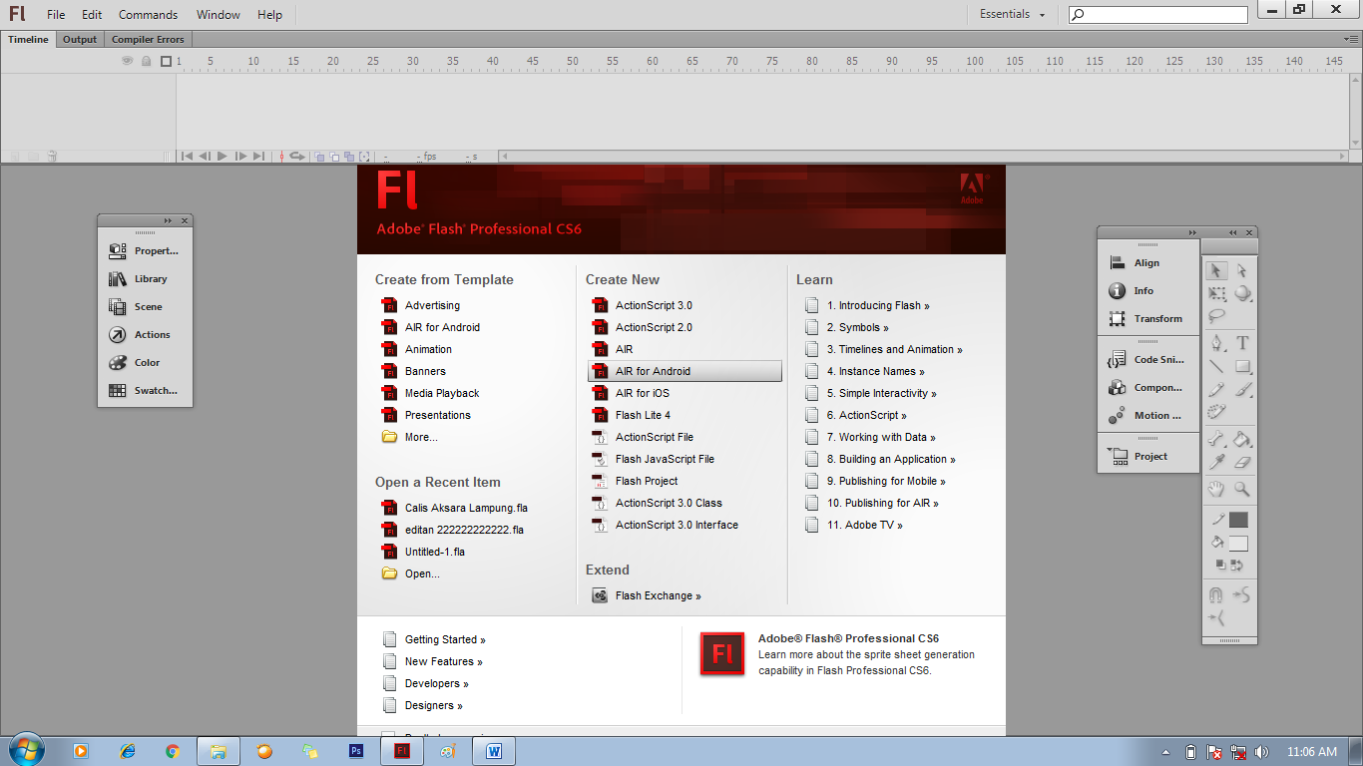
Figure 4. AIR for Android menu to create android apps.

The basic knowledge of subsequent media creation is the ActionScript 3.0 programming syntax shown in Figure 5.

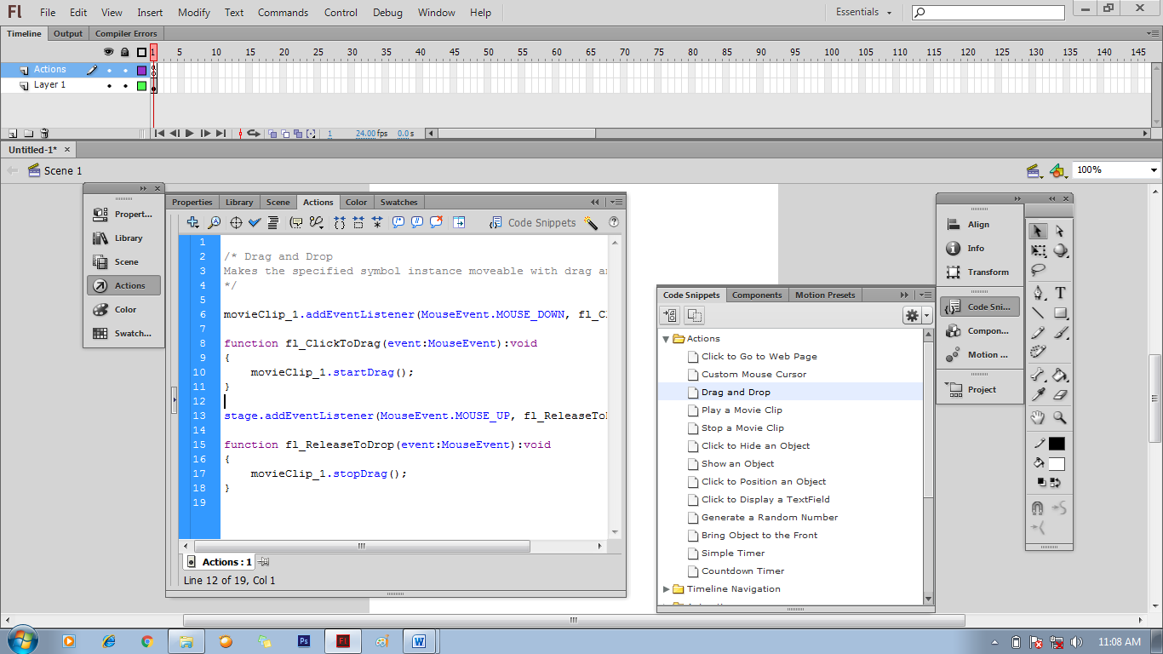
Figure 5. ActionScript 3.0

The next step is the knowledge of converting flash files into android with the deployment step into the apk application file described in Figure 6.
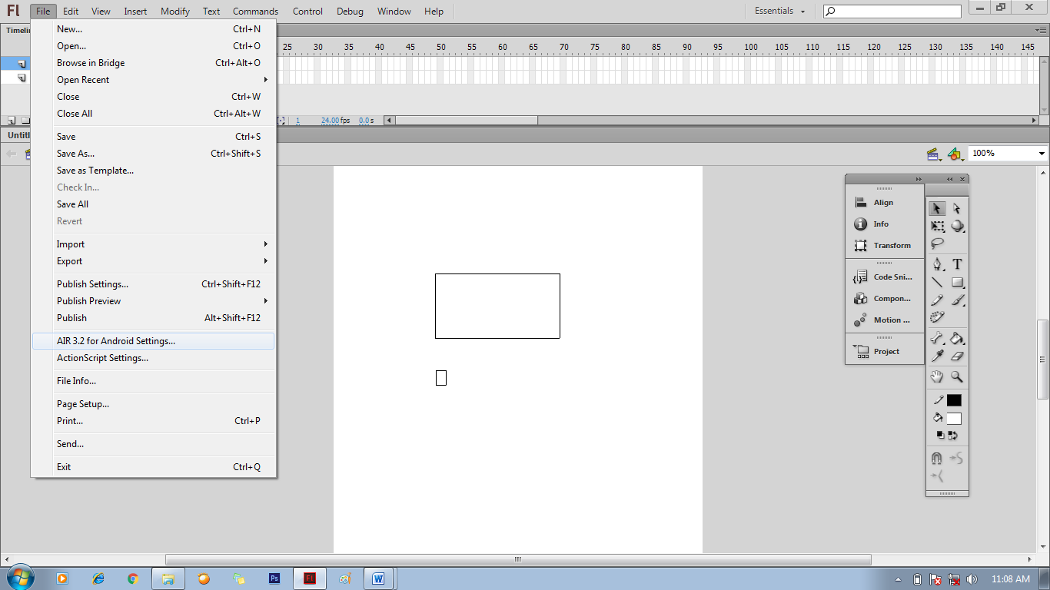

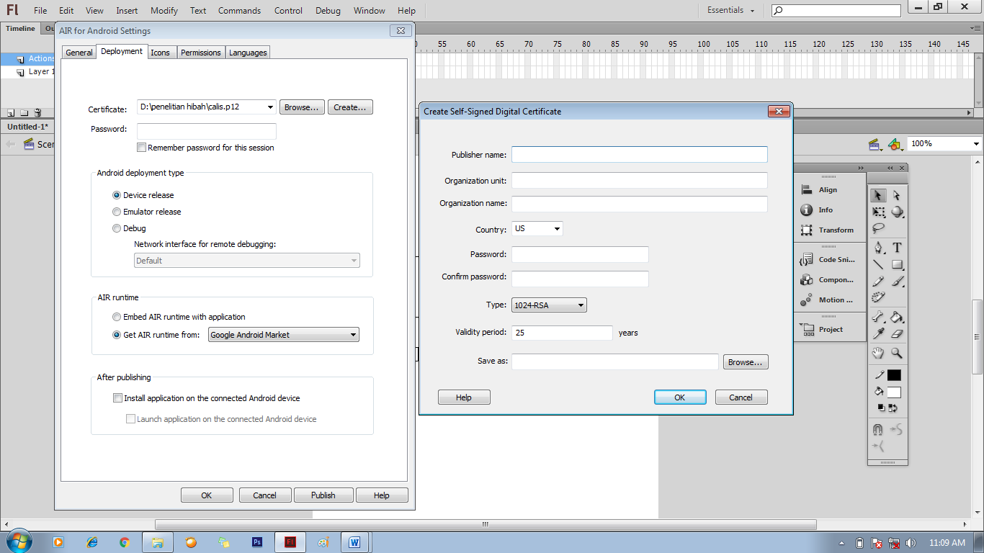
Figure 6. Step Menu for deploy to the apk.

The apk files that have been generated can be moved to smartphone and done installation / install so that the icon will appear on the smartphone screen to be operated as shown in Figure 7.

  - The Result of Strategic Review of Application of Android Applications as Media of Physics Learning in Industrial Era of 21st Century

The concept of educational development in the 21st century industrial era is contained in the National Education Standards Agency (BNSP) version 1.0 of 2010 on the National Education Paradigm of the XXI Century. Along with the coveted, digital literacy development or digital learning becomes the main focus in achieving it. The strategic thing that is prepared in the implementation of digital literacy is the source of digital learning, installation and digital devices, the competence of teachers and students in using and operating and developing digital learning resources and installations and digital devices.
Digital learning resources are a source of paperless learning. This learning resource can be e-book that can be read by using laptop or smartphone computer such as eBook and Teacher Book Student Book Curriculum 2013, and application or game learning android that can be accessed using laptop computer or smartphone like Game Physics Fun. Applications or games android physics learning is very laden once to load animation computer simulations that make it easier to give illustrations and explanations of a physical phenomenon.
The use of internet in the search of teaching materials can be done through search engines (Search Engine) which can be used by writing the web address, for example Google, yahoo, MSN, Wikipedia, etc. By using the internet, the information available is vast, varied, and new. Interactivity of students to be more alternatives, and certainly is currently classified as "cool". Constraints of this media is required computer and internet network and skills to operate it. Teachers play a role in seeking appropriate and appropriate information, and provide more explanation through discussion, laboratory experiments if needed. If the internet network is limited or not available, the teacher can access it in the cyber cafe and then stored on the disk and can be presented in the classroom with just a computer.
Learning media animation for learning Physics is very interested students and educators. This is evident from the many studies on the development of animation learning media. Various animation making programs used are various, for example Microsoft Visual Basic, Delphi, Mat Lab. Pascal, Macromedia Flash, and Power Point. From the experimental results of the development of animation learning media all showed a positive result on Physics achievement. When viewed in terms of production, making animation Physics is not all made by a programmer with a background of Physics. This allows the existence of deviation from the existing animation to the correctness of the concept of Physics, because in the process of making it ignore the related Physics concepts. It is possible that when the trial does not get a mistake the concept of the learners because the competence tested at that time not on the concept. Nevertheless, the animation should be observed for Physics learning must still obey the rules of Physics in each part.
Some things to consider in building a learning media, namely:
- The information displayed by the learning media with the same sense access will contribute negatively to each other
- Dual code suggests simultaneous audio and visual presentation.

4. Discussion
The era of globalization is characterized by the scientific progress very rapidly, especially in the field of increasingly sophisticated technologies such as mobile phone progress. One type of mobile phone that is used by most people this is an android globalization era. Android introduced the approach of higher and more complete with variety of important applications that allows users to access information [13].
The use of e-learning environment based on Android to adapt to the learning styles of the students of the 21st century [14]. Android is open source but free in use, all the applications made for android phones are not as free, depending on the manufacturer [12]. The use android as a medium of learning will bring both positive and negative impacts. The positive impact that the presence of the teacher assisted learning media in his teaching, because through a medium of learning students can more easily understand the material presented. The negative impact that the difficulty teachers to monitor the use of android by students. Android provides many features, so it is possible that students turn to other features not related to learning. This is certainly a problem for the teacher in the classroom condition [12].

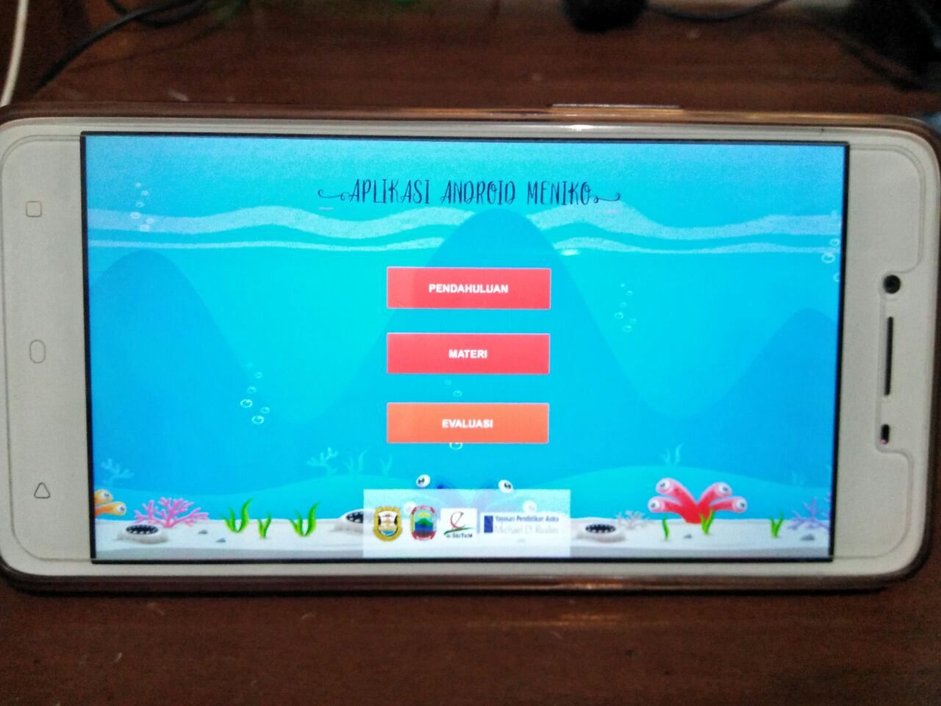

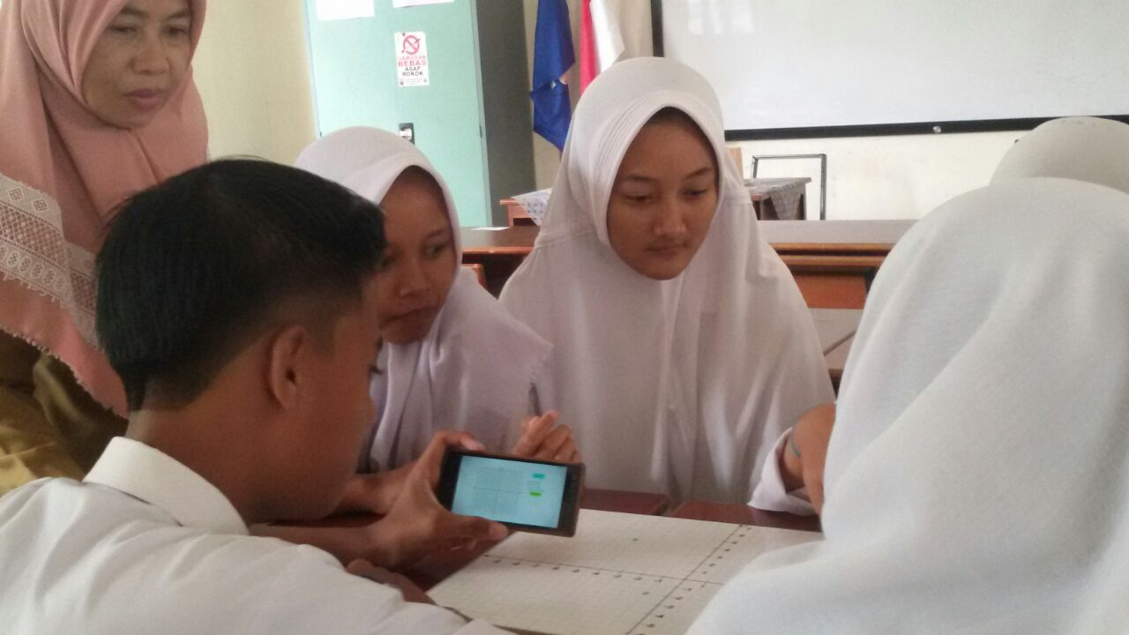
Figure 7. Android app already installed on smartphone.

Cabanban [15] explains that the use of the android system to help the learning process in schools has changed the primary function of manufacture is used as a communication tool has turned into a means of socialization, entertainment and learning. The studies conducted have provided benefits and convenience by applying mobile technologies (such as personal digital assistant, smartphones, and laptops) to the learning activities in various subjects such as science. These features are provided in a very supportive learning Android because it is very useful to help students understand the subject matter. This feature also allows teachers to explain the lessons learned through the media, so the teacher does not need to explain repeatedly [16].
There is a theory of learning that states that, learning is a change of behavior, learning is a process of communication. In order for the learning process to take place properly, then the required learning media. Currently schools (teachers) are required to be able to use information and communication technology in learning. Many learning media based on information and communication technology that can be used, for example radio, television, teleconference, computer and internet. But apparently computer-based learning media and the Internet is more profitable and more "cool".
In the use of android as a medium of learning, the teacher acts as a learning facilitator tasked with directing learning topics, explaining the concepts, shaping emotional and social, modeling applications and experiments in the laboratory, and so on. In this case the teacher should not allow students to seek their own information without guidance and affirmation, for example, only assigning students to seek information as much as possible and make a report and then assess the teacher. Teachers need to give a discussion and explanation of the information that students have obtained from the android
The conclusion of this research shows that the application of physics-based learning media android becomes a strategic thing in realizing the expectation of educational achievement in 21st century industry era in the form of digital literacy or digital learning by taking into account the concept of physics and multimedia learning. This research suggests that application developers need to pay attention to the dual code concept in information processing cognition and correct physics concepts

- References
[1] Adiarsi, G. R., Stellarosa, Y., & Silaban, M. W. (2015). Literasi Media internet dikalangan mahasiswa. HUMANIORA Vol.6 No.4
[2] Malik, A. U., & Ra q, N. (2015). Exploring the relationship of personality, loneliness, and online social support with interned addiction and procrastination. Pakistan Journal of Psychological Research, 31 (1), 93-117.
[3] Nistanto, R.K. 2015. Kebiasaan Orang Indonesia, Pelototi "Smartphone" 5,5 Jam Sehari. https://tekno.kompas.com/read/2015/09/04/11301837/Kebiasaan.Orang.Indonesia.Pelototi.Smartphone.5.5.Jam.Sehari.
[4] Kristiyanto, W.H. 2017. Proses Berpikir Mahasiswa dalam Mengolah Informasi dari Media Pembelajaran Fisika. Disertasi (tidak dipublikasikan). Surabaya: Program Studi S3 Pendidikan Sains Pascasarjana Universitas Negeri Surabaya.
[5] Noname. Viral video “Belajar Membaca Pitik”. WhatsApp diakses tanggal 7 Mei 2017.
[6] Noname. Terlalu Cerdas!! Anak Kecil Jago Baca & Hafal Pitik. YouTube diakses tanggal 7 Mei 2017
[7] Anwar, K., Rusdiana, D., Kaniawati, I., & Viridi, S. 2016. Pemanfaatan Applikasi Smartphone Android sebagai Media Belajar Fisika. Prosiding Seminar Nasional Quantum. Yogyakarta: Universitas Ahmad Dahlan
[8] Polonia, B.S.E., Yuliati, L., & Zulaikah, S. 2015. Pemanfaatan Aplikasi Mobile Berbasis Android dalam Pembelajaran Fisika SMA. Prosiding Seminar Nasional dan Pembelajarannya. Malang: Universitas Negeri Malang
[9] Nurohimah, S., Wahyudin, & Partono. 2014. Perancangan Aplikasi Media Pembelajaran Fisika untuk SMP Kelas VII Berbasis Android. Jurnal Algoritma Sekolah Tinggi Teknologi Garut. 11(1).1-9.
[11] Muqarrobin, T.F., & Kuswanto, H. 2016. Development of an Android-Based Physics e-book to Ease Students’ Physics Learning and Its Influence on Their Learning Achievement. American Journal of Engineering Research. 5(10).223-229.
[12] Sari, S., Anjani, R., Farida, I., & Ramdhani, M.A. 2017. Using Android-Based Educational Game for Learning Colloid Material. Journal of Physics: Conference Series. 895(012012).1-6.
[13] Adi, N.P., Yulianto, R.A., Irwan, M., & Maulana, W. 2016. Android for the 21st Century Learning Media and Its Impact on Students. ResearchGate.
[14] Mednieks, Z., Dornin, L., Meike, G. B., N. Masumi. (2011). Programming android. United States of America: O’Reilly Media, Inc.
[15] Calimag, J. N., Mugel, P. A., Conde, R. S., et al. (2014). Ubquitous learning environment using android mobile application. International Journal of Research in Engineering & Technology, 2 (2), 119-128.
[16] Cabanban, Christianne L. G. (2013). Development of Mobile Learning Using Android Platform. International Journal of Information Technology & Computer Science (IJITCS), Vol 9 No 1.
[17] Sharples, M., Taylor, J., & Vavoula, G. (2007). A theory of learning for the mobile age. In R. Andrews and C. Haythornthwaite (eds.), The Sage Handbook of Elearning Research, pp.221–247, London: Sage.
[18] BNSP. 2010. Paradigma Pendidikan Nasional Abad XXI. Badan Standar Nasional Pendidikan versi 1.0.
[19] Kristiyanto, W.H., Prabawo, & Kardi, S. 2016. Neo-Strategy to Use Fixed-Whiteboard Based on Student’s Thinking Process and Cultural Ethically in Learning Physics. International Journal of Active Learning, 1(1).
[20] Poniyem. 2018. Aplikasi Android Meniko. Naskah Lomba Lingkar ASTRA.
[21] DetikCom. 2015. Jumlah Aplikasi Android Salip iOS. https://inet.detik.com/consumer/d-2806085/jumlah-aplikasi-android-salip-ios.

