The Analysis Of The Students’ Creative Thinking Ability In Mathematics As Viewed From Their Learning Style And Educational Background

Wahyudi1, St. Budi Waluya2, Hardi Suyitno3, Isnarto4

1 Universitas Kristen Satya Wacana, 2,3,4 Universitas Negeri Semarang

1yudhi@staff.uksw.edu, 2s.b.waluya@mail.unnes.ac.id, 3hardi.suyitno@mail.unnes.ac.id, 4isnarto@mail.unnes.ac.id

Abstract

This research is a qualitative research that aims to describe mathematical creative thinking ability viewed from students’ learning styles and educational background. The subjects of this research are 26 preservice teachers. The data of this research were taken from the questionnaires, tests, and interviews. The research design uses triangular qualitative. The result shows that the subjects possess different creative thinking abilities as seen from the perspectives of learning style and educational background. Most of the subjects (12 students) have low creative ability (46.1%). They are not yet able to apply the four aspects of the mathematical creative thinking. The subjects from high ability category have already done all of the aspects in creative thinking, except the originality aspect. They still used the same way of solution. The subjects from medium category also have done the four creative thinking aspects, except fluency and originality aspects. The highest mathematical creative thinking aspect was achieved by subjects from Senior High School (Natural Sciences class) with auditory learning style. The second high achievement was made by Madrasah Aliyah (MA) students with auditory style, and the next was from Vocational High School with auditory learning style too. Out of the four mathematical creative thinking ability aspects, the flexibility, originality, and elaboration aspects should remain to be the attention of teachers.

**Keywords**: *mathematical creative thinking, learning style, educational background*

Introduction

One of the objectives of the Indonesian education is to develop student’s potency to become creative citizens (Law Num. 20, 2003). It has even become one reason for the national curricular change from the KTSP (a locally operational curriculum) to the 2013 curriculum, to produce creative students. Thus, a prospective student-teacher needs to be prepared so as to be able to bring students to become creative individuals. A creative individual means one who has an ability to make something through intelligence and imagination. Being creative is closely related to creativity. Creativity is a continuous action as a process of producing something newly existing (Best & Thomas, 2007). Torrance (1969) defined creativity as a process in understanding a problem, finding possible solutions, drawing a hypothesis, testing and evaluating, as well as communicating its result to others.

According to Torrance, within the process are results of creativity which include original ideas, different points of view, solution to a series of problems, recombining ideas or finding new relationships among the ideas. Creativity as an ability is one that produces new ideas by combining, changing or reapplying existing ideas as a result of thinking creatively. Creativity as an attitude is one’s self ability to see changes and originality, a desire to play with ideas and possibilities, flexibility of views, a characteristic to enjoy goodness while finding ways to improve things. Whereas creativity as a process is a continuous activity to improve ideas and solutions while at the same time making gradual changes and improving past works. In such a way, the result of the creativity is the product of creative thinking ability by a person in his attempt to solve a problem or to produce something new with a new approach, a new perspective in many ways (McGregor, D., 2007).

Creativity, which is the result of the student’s creative thinking, has been included as one of the main components in the 21st education (Mann, 2005). Therefore, the contemporary curriculum puts an emphasis on the development of the student’s creative thinking ability (Lamon, 2003; Vale, I. &Barbosa, A., 2015; Sternberg. R. J., 2006), which produces student’s creativity in making something. Because creativity is so important for the students, it is essential to define in a good manner what is meant by creativity. Creativity may focus on the process or the creative product. (Haylock, 1997). Creativity can also be defined as a continuous action, a process to bring in something new to exist (Best & Thomas, 2007). Every individual has a creative potency in something special (Gardner (1993). It is also stated by Leikin (2008) that a person has a creative potency in a particular thing, for example, in mathematics.

In the Mathematics subject, there are many materials which can lead students to possess a creative thinking skill. It is, therefore, necessary to have a creative teacher. Nevertheless, up to this date teachers in mathematics give more emphasis on the mastery of mathematics basic concepts by using a deductive approach. It makes students tend to memorize mathematics formulas in a less meaningful way. The result is, the students are less able to build the desired attitude and skill in thinking creatively. It would be better if the result of the creativity comes from the ability to think creatively by somebody in solving a problem or in producing something new in many ways.

The student’s creativity is something that needs growing and developing, including the mathematics subject at the study program, which produces student-teachers. The subject conforms to the result of the research by Dyers, J.H. et al (2011) showing that two thirds of one’s creativity ability are acquired from education, the remaining one third is from genetic origin. Conversely, in terms of intelligence ability, one third of the ability comes from education, and the other two thirds come from genetic origin. It means, therefore, that we cannot do much to improve one’s intelligence, but we do have ample time to increase his or her creativity. It supports the other research outcome that creative thinking ability in relation with mathematics needs developing in order that student teachers possess high creativity in solving mathematical problems. In addition, this ability would become a measure of student’s success in learning (Mairing, Jackson P., 2016) and will provide them with their future needs when they he become teachers.

The success of student learning is affected by a number of factors both internally and externally, for example, the student’s learning style and his or her educational background. Learning style would determine how a teacher teaches and selects media to use (Nindiasari, H, 2016; Bire, A.L, 2014). Educational background would give an idea of the competence that has been possessed that enables the teacher to decide the scope and the depth of the teaching materials.

This research gives an outline of the student-teachers’ cognitive aspect in mathematical creative thinking ability as viewed from their learning style and educational background.

Method

This research is a qualitative research. The subjects in this research are 26 elementary school student-teachers, who were taking the Strategy of Solving Mathematical Problems for Elementary School class.

The design used is the triangular qualitative research design. Its scope includes the description of learning styles based on educational background. The description of creative mathematical thinking ability is put in categories which comprise those aspects as fluency, flexibility, originality, and elaboration, while the description of creative thinking ability is based on learning styles and educational background. Data on learning styles were taken by use of questionnaires. The test techniques to reveal mathematical creative thinking ability include the four aspects, i.e., fluency, flexibility, originality, and detailing. In order to know the problems more deeply, interviews to the selected student-teaches were conducted on the basis of the research objectives.

Indicators for learning styles were adopted from the learning style questionnaires developed by De Porter comprising visual, auditory, and kinesthetic learning styles (DePorter, 2014). Educational background was divided into three categories, namely, Senior High School (SMA), Madrasah Aliyah (MA), and Vocational High School (SMK). The indicators for creative thinking ability were described into four aspects, i.e., fluency, flexibility, originality, and elaboration.

To analyse data, triangulation method was used, that is, data analysis processing by comparing information or data acquired from test results and interviews. The steps used in this research are as follows: 1) distributing learning style questionnaires and educational background forms; 2) giving test problems on mathematical creative thinking ability to the students; 3) analysing test results; 4) conducting interviews to a number of students (very high, high, average, and low); 5) analysing test results and interviews.

1. **3. Results**

The research takes 26 student subjects who were taking a Strategi Pemecahan Masalah Matematika class, comprising of 19 students of SMA, 2 of MA, and 5 of SMK. Based on the questionnaires given to them, 4 students (15.4%) possess visual learning style, 17 students (65.4%) have auditory learning style, and 5 students (19.2%) own kinesthetic learning style. The following Table 2 shows the results in details.

**Table 2**. Research Subjects’ Learning Styles

|  |  |  |
| --- | --- | --- |
| **Learning Styles** | **Frequency** | **Percentage** |
| Visual | 4 | 15.4 |
| Auditory | 17 | 65.4 |
| Kinesthetic | 5 | 19.2 |
| **Total** | **26** | **100** |

The recap of the results of educational background and learning style of the 26 research subjects shows that their learning styles vary despite the fact that their educational background is the same. Most subjects, i.e., 17 students (65.4%) possess an auditory learning style. The detailed data can be seen in the following Table 3.

**Table 3.** Learning Styles Based on Educational Backgrounds

|  |  |  |  |  |
| --- | --- | --- | --- | --- |
| **Education** | **Visual** | **Auditory** | **Kinesthetic** | **Total** |
| SMA | 4 | 10 | 4 | 18 |
| SMK | 0 | 5 | 1 | 6 |
| MA | 0 | 2 | 0 | 2 |
| **Total** | **4** | **17** | **5** | 26 |

After the students had filled out learning style questionnaires and educational background form, they did test questions on plane geometry. The test was used to see their mathematical creative thinking ability. The recap of the result can be seen in the following Table 4.

**Table 4**. Mathematical Creative Thinking Ability

|  |  |  |  |
| --- | --- | --- | --- |
| **Interval** | **Category** | **Frequency** | **Percentage** |
| High | ≥ 9.6 | 6 | 23.1 |
| Average | 6.8 – 9.5 | 8 | 30.8 |
| Low | 4 – 6.7 | 12 | 46.1 |
| **Total** |  | **26** | **100** |

The test results show that 6 students (23.1%) are in the high category, 8 students (30.8%) are in the average category, and 12 students (46.1%) are in the low category.

Students in the high category always try to give all aspects of the answers creatively, except for fluency and originality aspects. They still used the same way of solving the problems as the others did. These subjects gave 4 solutions with different strategies. They gave successive steps to solve the problems clearly, but the strategies that they offered have not yet original because some of them are still the same as other subjects in the solution 1, 3, and 4. Students with average category also have done the four aspects of thinking.The aspect which is not optimally done Students with average category. To give an illustration on the high category subject’s work, the following shows one which has not indicated original answer but only gave one or two solutions and strategies.

Students with medium category also have done the four aspects of thinking. The aspect which is not optimally done students with average category. To give an illustration on the medium category subject’s work, the following shows one which has not indicated original answer but only gave one or two solutions and strategies. The result shows that the subject gave 2 alternative answers and both answers are the same as the other subjects. To solve the area in question was done by finding the width of a parallelogram and three of a triangle area.

Students with low category are not yet able to apply the four aspects of mathematical creative thinking and or to give a wrong solution. Based on the answer given, it shows that the subjects gave three solutions. In the first solution, the subject thought that the area in question is the subtraction of the area of a rectangular ABCD with the figure AKCO. Whereas, the problem is the area of the geometric figure AKCO; thus, the solution offered is not the correct one. The second solution is one of the correct solutions, considering that the area in question is a combination of two plane figures, so that they would form a parallelogram and its area can be found by calculating the area of a parallelogram, i.e., p x l. However, it does not give a detail in order to arrive at the correct solution. In the third solution, the subject thought that the area in question is the area of a triangle minus the area of a parallelogram. It is not, however, the correct solution.

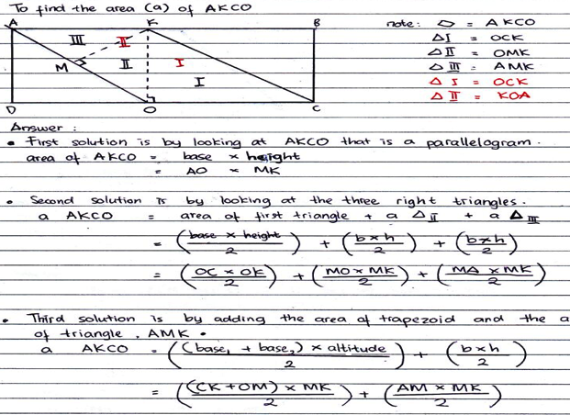**Figure 1**. Illustration High Category Answer

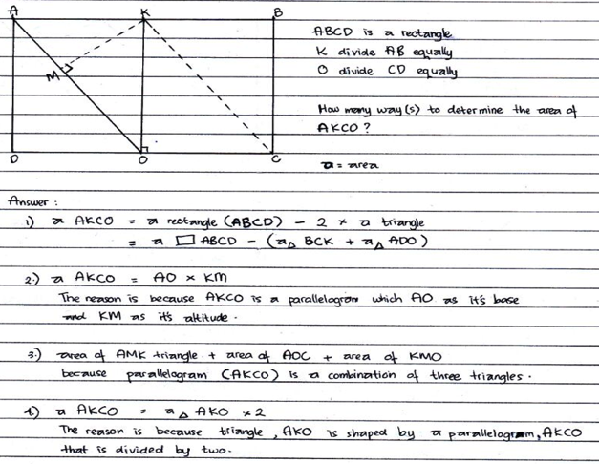**Figure 2** Illustration Medium Category Answer

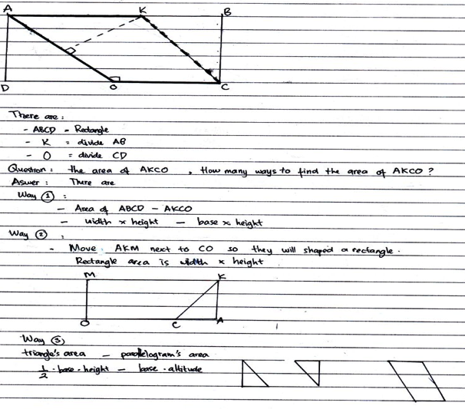

**Figure 3** Illustration Low Category Answer

The above data are made into a reference to decide future subjects, who are chosen for further detailed interviews. Based on the research need, the subjects who are selected for interviews are those with all educational backgrounds with all categories of learning styles and with low mathematical creative thinking ability. The total subjects chosen in the given data are 6 subjects. The interview topics are related to the problem of the lowness of the mathematical creative thinking ability, especially in the aspect of flexibility, originality, and elaboration all of which are the problem needing for solution.

**Summarized of the interviews**

|  |  |  |  |
| --- | --- | --- | --- |
| **Question 1** | **:** | ***How many solutions did you find to complete the given problem?*** | |
| Answer (SMA Visual) | : | I found three. | |
| Answer (SMA Auditory) | : | Three ways. | |
| Answer (SMA Kinesthetic) | : | Four ways. | |
| Answer (SMK Visual) | | : | There are three, Sir. | |
| Answer(SMK Auditory) | | : | There are four ways, Sir. | |
| Answer (SMK Kinesthetic) | | : | Four ways, Sir. | |
| **Question 2** | | **:** | ***Is the solution you offered the correct one?*** | |
| Answer (SMA Visual) | | : | I don’t know, Sir. I think one of them is correct, but don’t know how many. | |
| Answer (SMA Auditory) | | : | I’m confused, Sir. Because I didn’t really understand. Difficult. | |
| Answer (SMA Kinesthetic) | | : | I think one of them is correct, Sir. But I’m not sure, because I’m confused. | |
| Answer (SMK Visual) | | : | I don’t know, Sir. Maybe one of them is correct, Sir. | |
| Answer (SMK Auditory) | | : | Perhaps some are correct, Sir. | |
| Answer (SMK Kinesthetic) | | : | I’m sure some are correct, Sir. Although, the long version I don’t know. | |
| **Question 3** | | **:** | ***Let’s look at some correct answers, then, compare with your answer. Is there the same answer and the correct one? (While showing some correct answers of the other subjects.)*** | |
| Answer (SMA Visual) | | : | It’s sure there is no correct answer, Sir. I know now what is wrong. | |
| Answer (SMA Auditory) | | : | There is one correct answer, Sir. The second way. Others are wrong. The correct one is the same as the other’s way. | |
| Answer (SMA Kinesthetic) | | : | There is one correct answer, Sir. But I can’t explain the details. The correct one is also the same as the other friends’ way. | |
| Answer (SMK Visual) | | : | I’m sure none is correct, Sir. But now I know what is wrong. | |
| Answer (SMK Auditory) | | : | Two are correct, Sir. The others are wrong. | |
| Answer (SMK Kinesthetic) | | : | Two are correct, Sir. The two others are wrong. | |
| **Question 4** | | **:** | ***Based on your correct answers, can you explain detailed steps until the size of the area is found?*** | |
| Answer (SMA Visual) | | : | I can’t, Sir. There’s no correct answer, right? | |
| Answer (SMA Auditory) | | : | I can, Sir, by using equivalence of the area of the parallelogram, Sir. But I forget the formula, Sir. There are two parallel sides and heights, that’s it, Sir. I forget it for sure. | |
| Answer (SMA Kinesthetic) | | : | I can, Sir. I’ll draw it first, ok? The figures consist of two rectangles which are divided to two. So, I‘ll find the area of the rectangle first, then divide it into two. | |
| Answer (SMK Visual) | | : | No, Sir. There’s no correct answer, Sir. | |
| Answer (SMK Auditory) | | : | Viewed from the figure, it looks like a parallelogram, Sir. So, I used the parallelogram formula, base multiplied by height, Sir. But it’s hard to find the base, so I can’t find the result. This way is not a new way, Sir, the same as the other friends. | |
| Answer (SMK Kinesthetic) | | : | I used the sum of the areas of the triangle and the trapezoid, Sir. But, its height should be found, Sir. And it’s hard because I must use Pythagorean formula, Sir. This way is the same as some of my friends’ way, Sir. | |
| **Question 5** | | **:** | ***What caused you to be unclear about the problem in this form of test?*** | |
| Answer (SMA Visual) | | : | I’m from Social Science, Sir, so I can’t do mathematics. But I turned out to be able, Sir. But, basically, I can’t do it and it makes me dislike learning mathematics. | |
| Answer (SMA Auditory) | | : | I don’t like mathematics, Sir. I am taking Social Science. | |
| Answer (SMA Kinesthetic) | | : | Don’t like mathematics and I am taking Social Science, Sir, so mathematics will not be very difficult. | |
| Answer (SMK Visual) | | : | I’m not accustomed to the problem, Sir. One answer is usually enough, Sir. I also took SMK because there is not much mathematics, Sir. | |
| Answer (SMK Auditory) | | : | I actually don’t like it, Sir. That’s why I entered SMK. I am also confused finding another say to solve the problem. | |
| Answer (MA Kinesthetic) | | : | I can’t find any other way, Sir. I have no idea at all. I’m asking Social Science, Sir, so I will not meet mathematics. Don’t like it, Sir. | |

1. Discussion

The result of the interviews presents a clearer illustration on the subjects with a low ability in mathematical creative thinking, because of a number of factors, such as the lack of ideas in giving solution alternatives, the same solution strategies, and the unfinished and unorganized solution, resulting in no final solution.

**Table 5**. The Result of Mathematical Creative Thinking Ability on the Basis of Aspects

|  |  |  |  |
| --- | --- | --- | --- |
| **Number** | **Mathematical Creative Thinking Aspect** | **Average** | **Category** |
| 1 | Fluency | 2 | Average |
| 2 | Flexibility | 1.6 | Low |
| 3 | Originality | 1.5 | Low |
| 4 | Elaboration | 1.7 | Low |

The result of the research gives an illustration that learning style and educational background possessed by the students vary. Most of the subjects (17 students or 65.4%) owned an auditory learning style. The subjects’ mathematical creative thinking ability is also different from each other. The existing abilities are divided into three categories, namely, high, average, and low. In this research most of the subjects still have a low mathematical creative thinking ability, i.e., 12 students or 46.1%. They have not yet been able to apply the four aspects of mathematical creative thinking. They are still hard to give alternative answers as a solution, to give a new idea with a different strategy to each solution and are unable to show a step-by-step procedure and detailed one as well to solve a problem presented to them. Students with a high category always did all of the aspects of the creative thinking, except for the originality aspect. They still used the same way of solving the problem.

The result of the interviews presents a clearer illustration on the subjects with a low ability in mathematical creative thinking, because of a number of factors, such as the lack of ideas in giving solution alternatives, the same solution strategies, and the unfinished and unorganized solution, resulting in no final solution.

The results conform with the idea of Best & Thomas (2007); Torrance (1969) and McGregor (2007) who stated that in order to produce something creative as a result of creative thinking (in this case, mathematics), it needs a process which will produce something new with a new, original idea to solve an existing problem in a good and organized way. When somebody is unable to think about a solution or even does not understand the problem presented, he or she will not be able to create a solution to the problem, but they must be guided to many new ways. Furthermore, in order to obtain creative thinking, especially in mathematics, Vale & Barbosa (2015) said that one needs high curiosity with exploration process and observation, as well as imagination and originality in high thinking. If one has disliked what he or she is learning, their thinking process will be obstructed, letting alone the demand of creative thinking. It is shown in the result of the interviews that the subjects do not quite like mathematics. They ended up with taking a track which makes it possible for them to unmeet mathematics, for example, the Social Sciences for SMA and MA or, they take SMK. Thus, the low ability in thinking creatively in mathematics is not solely a result of their inability to apply the four mathematical creative thinking aspects, but rather due to their lack of love of mathematics in such a way that the feeling affects their creative thinking ability.

Although most of the subjects possess a low category of mathematical creative thinking ability, there are still those who have an average, and high categories. Subjects with the average and high categories have been able to do the four aspects of mathematical creative thinking. For these subjects with the average category, the aspects which are not optimally shown are the fluency and originality aspects. Subjects with a high category have done all of the aspects of creative thinking, except the originality aspect. They still used the same way of solution as the others do.

Based on the educational background, students from SMA have the best mathematical creative thinking ability with a high category. The second rank is from MA and the last rank is from SMK. The result of the interviews gives information that the subjects with the highest scores come from the Social Sciences track and tend to like mathematics.

The results present us with an input that educational background and learning styles are not significantly affecting mathematical creative thinking ability. One thing that should be considered by teachers is developing student’s interest and attitude towards mathematics so that they have attraction to and are willing to learn more on mathematics. By so doing, expectations as stated in the Indonesian educational objectives in developing learner’s potencies to become creative people (Law Num. 20, 2003) and be realized. Besides that, in the selection of student-teachers educational background should be made aware in order to conform to the track to be taken. It is necessary to prepare students to become prospective teachers who are competent and are able to teach their students very well in the future.

1. Conclusion

The results of this research indicate that the subjects possess different creative thinking abilities viewed from their learning style and educational background. Most of the subjects (12 students) or 46.1% have a low creative thinking ability. They have not been able to apply the four aspects of mathematical creative thinking. Students from high ability category have done all of the aspects of creative thinking, except for the originality aspect. They still used the same way of solving problems as the others did. Students from average category have also applied the four aspects of creative thinking, except fluency and originality aspects. The highest mathematical creative thinking was achieved by the subjects from senior high school/SMA (Natural Science class) with the auditory learning style. The second highest is from Madrasah Aliyah (MA) with the auditory learning style, and followed by students from vocational high school SMK with the auditory learning style. Generally speaking, there is still a problem to be attended to in terms of mathematical creative thinking by teachers; they are the aspects of flexibility, originality, and elaboration. These aspects are still in the low category.

1. Acknowledgement

We gratefully acknowledge the useful comments of Prof. Dr. Slameto, M.Pd and Dr. Wasitohadi, M.Pd, lecturer in Universitas Kristen Satya Wacana.

1. References
2. Almeidaa, L. S. et al. 2008.Torrance Test of Creative Thinking: The question of its construct validity. Thinking Skills and Creativity. Vol. 3, 53–58
3. Best, B. & Thomas, W. 2007. The Creative Teaching and Learning Toolkit. NewYork: Continuum International Publishing Group.
4. Bire, A. L, Garadus, U., & Bire, J. (2014). Pengaruh gaya belajar visual, auditorial, dan kinestetik terhadap prestasi belajar siswa. Jurnal Kependidikan, 44(2),169-176.
5. DePorter, Bobbi., Mark Reardon,&Sarah Singer-Nourie. 2014. Quantum Teaching. Bandung: PT Mizan Pustaka.
6. Dyers, J.H. et al. 2011. Innovators DNA: Mastering the Five Skills of Disruptive Innovators, Harvard Business Review.
7. Haylock, D. 1997. Recognizing mathematical creativity in schoolchildren, ZDM, 29(3), 68-74. doi: 10.1007/s11858-997-0002-y
8. Gardner, H. (1993). Creating minds. New York: Basic Books.
9. Leikin, R. (2009). Exploring mathematical creativity using multiple solution tasks. In R. Leikin, A. Berman & B. Koichu (Eds.), Creativity in mathematics and the education of gifted students. (Ch. 9, pp. 129-145). Rotterdam, the Netherlands: Sense Publisher
10. Mann, E.L. 2005. Mathematical Creativity and School Mathematics: Indicators of Mathematical Creativity in Middle School Students. Connecticut: University of Connecticut.
11. Mairing, J.P. 2016. Kemampuan Siswa Kelas VIII Dalam Memecahkan Masalah Matematika Berdasarkan Tingkat Akreditasi. Jurnal Kependidikan, Volume 46 (2),179-192
12. McGregor, D. (2007). Developing Thinking; Developing Learning A Guide to Thinking Skills in education. NewYork: Open University Press McGraw-Hill Education
13. Nindiasari, H. dkk. 2016. Desain Didaktis Tahapan Kemampuan Dan Disposisi Berpikir Reflektif Matematis Berdasarkan Gaya Belajar. Jurnal Kependidikan, Volume 46 (2), 219-232
14. Sternberg. R. J. 2005. Creativity or creativities. Int. J. Human-Computer Studies. 63 (2005) 370–382
15. Sternberg. R. J. 2006.The Nature of Creativity. Creativity Research Journal. 2006, Vol. 18, No. 1, 87–98
16. Torrance, E. P. (1995). The beyonders’ in why fly? A philosophy of creativity.Norwood, NJ: Ablex.
17. Vale, I. & Barbosa, A. 2015. Mathematics Creativity in Elementary Teacher Training. Journal of the European Teacher Education Network. Vol. 10, 101-109