Whole Part or Mini Games, which one is the most effective training method to improve forearm passing ability in volleyball?

Yudi Pratama¹, Djoko Pekik Irianto²

^{1,2} Universitas Negeri Yogyakarta
¹ yudipratama80830@gmail.com, ²djoko.pekik@yahoo.com
Abstract
The purpose of this research was to figure out the difference of influence between whole part practice method and mini game practice method against the forearm passing ability in volleyball. 32 junior high school students who participated were selected in random order and division of groups used Ordinal Pairing technique. Treatment was given to all subjects for 6 weeks. The subjects were evaluated by 2 tests, the Hand-Eye Coordination Test and the Forearm Passing Ability Test. As a result, there is a significant difference between the whole part training group and the mini games training group in the forearm passing ability test. Mini games training is better than the whole part one. In addition, in the hand-eye coordination test, there was a difference of influence between students with high and low hand-eye coordination. Students with high hand-eye coordination are better than students with low hand-eye coordination. As for the interaction, it shows that there is a significant interaction between training methods and hand-eye coordination against the forearm passing ability in volleyball. According to these results, the mini-game practice method with high hand-eye coordination has the more effective impact in training and is able to improve forearm passing ability in volleyball.

Keywords: forearm passing, hand-eye coordination, mini games, volleyball , whole part.

- Introduction
Many sports activities in everyday life are done by hand. One of them is volleyball game [1]. Volleyball is a competitive sport that is played in various places, depending on whether it is done indoors or outdoors. Thus the indoor volleyball is played on a hard surface which is mostly made of wood or other synthetic materials [2] [3]. Volleyball gives emphasis on explosive movements such as jumping, hitting, and blocking [4]. Volleyball is relatively played in small areas with high intensity and it uses explosive strength compared to other ball games [5] [6]. A coach must strongly believe that players must master basic skills before they can play volleyball satisfactorily. In volleyball there are some basic techniques that can be learned, including service, passing, set up, smash, and blocking. Among the five techniques, passing technique is the most basic technique that needs to be mastered because this technique aims to regulate the course of the game and at the time of defense [7].
Passing is a technique of receiving the ball and swinging back to the intended direction. This technique is a basic technique in the volleyball game and should be known by those who want to do the game [8]. Forearm passing is very important in the volleyball game as it is the first step to arrange the striking pattern to the opponent. Due to the difficulty of mastering the forearm passing technique, it is necessary to continue the training regularly and earnestly [9].
One of the trainings that is considered capable in providing the improvement for athlete skills is a whole part training method. Athletes train overall skills and the component parts independently. In passing, the “whole” will be the movement of the legs and arms, ball contact, and recovery. In contrast, “parts” will focus on one element of the whole skill, for example, contact ball [10] [11].
The part method is taught or trained from the first part of the procedure, followed by the last second part of the procedure, and followed again by more trainings. The whole method is taught or trained with the procedure as a whole, followed by trainings [12] [13].
Other training method is mini games. Mini game is one of the principles of learning by putting tactical learning into the game, where teachers or coaches give directions based on game design, as mini games teach participants in considering how the rules affect their ability to play and how their decisions affect other players [14]. Mini games provide the main media, which, if done, will be able to achieve what they want to achieve, as this method is one of the most meaningful, relevant and interesting methods for learners [15] [16]. With mini-games training method, students receive intrinsic feedback on game performance and extrinsic feedback from the coach, after which it is evaluated to form new game plans that can improve the skill or skill being trained [17]. The intuitive assumptions are about how students learn in the form of small games and understand how this approach might work for teaching and learning [18].
In addition, one of the factors that play an important role in mastering the ability of forearm passing is hand-eye coordination. Hand-eye coordination lies at the core of our daily activities and interactions with objects and people around us, and is central to understanding how the brain creates and produces movement within it. Hand-eye coordination remains a very complex and elusive problem, since the coordination of eye and hand movements requires proper spatiotemporal activation of subcortical structures that control eye and hand [19].
Coordination is required in almost all sports and games. Coordination is also important when being in unfamiliar situations and environments, such as changing of field matches, equipment, weather, lighting, and opponents encountered [20]. People who have different ages and who perform physical activity on different levels influence they hand-eye coordination. So the pattern of coordination seems to be caused by many factors [21].

- Method

Participants
32 junior high school students participated in the research. Subjects were randomly selected from a population of 65 people and the division of the group used Ordinal Pairing techniques. Thus, 32 students were divided into 4 groups. All participants come from Jambi, Indonesia and are students who participate in volleyball extracurricular program. The average participant is 13-15 years old. The training method and objectives explain the variables to be evaluated. Prior to pretest, all populations have a throw-and-catch test using a tennis ball for group division. The group of high hand-eye coordination consisted of 16 people and the one with low hand-eye coordination had 16 people.

Training Procedure
Treatment is given by 2 different training methods performed in 3 times a week, in 90 minutes per day. Trainings for all groups were designed with intensity, repetition, and equal size (ball contact). The two groups practice using the whole part training method. In addition, other group train using mini-games training method.

Test Procedure
- Forearm Passing Ability Test
The purpose of this test was to measure the accuracy of forearm passing. One volleyball playing field was used in the test. Someone was on duty to throw a ball in a different field area. Participants stood behind the striking line in a different field area from the pitchers. Participants performed free passing ball moves but still in accordance with the valid passing rules based on the applicable rules. The ball which was played illegally, which did not extend beyond the stretched rope above the striking line, which touched the net, and which fell outside the specified area failed and remained counted. Each participant got 6 chances. The assessment was according to the score the ball touches and the one recorded as the participant score is the number of four best scores.
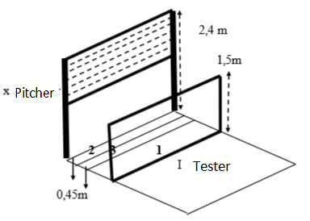
Fig 1. Instrument Forearm Passing Ability Test
- Hand-Eye Coordination test
The purpose of this test was to measure hand-eye coordination. Subjects were first instructed with test objectives. The equipment consists of walls, tennis balls, target boards, gauges, ribbons for making lines and stationery. The procedure was the ball thrown with one hand and caught with the other hand. Each throw which hit target and was caught by hand earned a score of one. The ball must be thrown from the bottom. The ball must hit the target. The ball should be able to be instantly caught without the previous hitch. Participants did not move beyond the boundary line to catch the ball. Participants threw for 20 times.
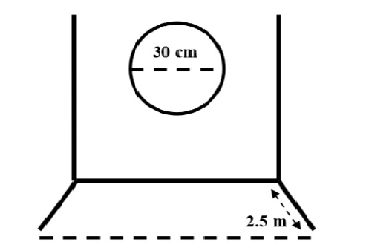
Fig 2. Instrument Hand-Eye Coordination test

Statistical Method
Metode analisis statistik menggunakan Analysis Of Varians (ANOVA) untuk mengevaluasi perbedaan antara kelompok metode latihan whole part dan kelompok metode latihan mini games dalam pretest dan posttest. Levene test digunakan untuk melihat apakah data homogen , sedangkan kolmogorov smirnov digunakan untuk melihat apakah data normal.analysis. This template already sets the style and formatting for the paper, so you can use it by choosing the style name on the style box as shown in Figure 1.

- Results

Table 1. Pretest and Posttest Results of Forearm Passing in Volleyball.
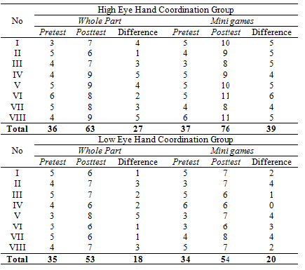

Table 1 shows the significant differences between pretest and posttest in both whole-part and mini-game groups.

Table 2. Results of ANOVA Experiment Group UsingWhole Part and Mini Games Training Method
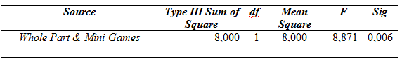
A significant difference (p<0.05) is found in Table 2 because the significance value of p is 0.006<0.05. Thus there is a significant difference of influence between the whole part and mini games training method on the forearm passing ability in volleyball in the junior high school school extracurricular students. Based on the results of the analysis, it turns out the mini games training method is better with the average value of posttest of 9.50 compared with the whole part practice method with the average posttest score of 7.88.

Table 3. Differences of Analysis of Influence between High Hand-Eye and Low Hand-Eye Coordination.
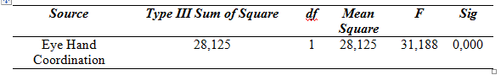
A significant difference (p<0.05) is found in Table 3 because the significance value of p is 0.000<0.05. This means that there are significant differences in influence on extracurricular students who have high hand-eye coordination and the ones with low hand-eye coordination on forearm passing ability in volleyball. Students with high hand-eye coordination are better than those with low hand-eye coordination.

Table 4. Interaction Analysis between Training Method (Whole Part and Mini Games) and Hand-Eye Coordination (High and Low)
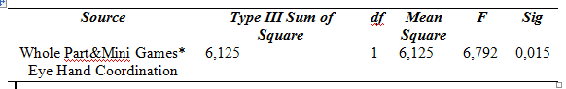
A significant difference (p<0.05) is also found in Table 3 because the significance value of p is 0.015 <0.05. This means that there is a significant interaction between the training methods (whole part and mini games) and hand-eye coordination (high and low) on forearm passing ability in volleyball.
7.88
9.50
6.63
6.75
4.38
4.50
4.63
4.25

Fig 3. Pretest and Postest Forearm Passing Ability Bar Chart

Discussion
The results also show that in the forearm passing test in volleyball, the four groups received the same training time in 6 weeks. The whole part and mini games training methods may have influenced the the improvement in forearm passing positively. In Table 1 the average of group with high hand-eye coordination and mini games training method got increased by 39 points more than the group with high hand-eye coordination and whole part training method which got 27 points on the Forearm Passing Ability Test.
The reason for this difference is that mini game training method may be easier to understand and more fun so participants will be motivated to do the training. Research shows evidence that games can improve skills, abilities, and knowledge related to sports [22]. It is different from the whole part training method that is more directed to the technique of doing the right so it may make the participants bored or lack of excitement in doing the training. So, when compared to the whole part training method, mini games training method is more appropriate to improve the forearm passing ability in volleyball. Mini game trainings will make students more motivated as there are competitive games in the training so that students will concentrate on the training. Equally important, hand-eye coordination plays an important role in improving a skill. Hand-eye coordination is a skill that can be trained and can contribute to increasing the player's motor potential. It can also influence the movement efficiency and thereby improve player performance in competitive situations [23]. Hand-eye coordination is especially needed in individual sports games, especially in handball, basketball, volleyball, racket sports, which require hand skill motor.

- Conclusion
This research shows that the application of whole part and mini games training methods has significant influence on the of forearm passing ability in volleyball of junior high school curricular students. This shows that in the forearm passing ability in volleyball, the application of mini games method is more appropriate in improving the forearm passing ability and mini game training method has proven to be able to give a significant influence in improving the forearm passing ability in volleyball. However both training methods have positive impact on the increase in forearm passing in volleyball. This research has also been limited by the physical and mental state of the subject during the tests such as fatigue factors, and motivational factors. During the training process, the researcher cannot fully control what the sample (student) was doing outside the exercise. This indirectly influenced the results of research. Other limitations are based on a sample of students who are all male. The situation can be different if the sample is to be formed, for example only female students. There are lots of things that can be learned from the results of this research, as it provides useful information for trainers in developing their training strategies or programs.
References
- Gortsila, E., Theos, A., Nesic, G., & Maridaki, M. (2013). Effect of Training Surface on Agility and Passing Skills of Prepubescent Female Volleyball Players. J Sports Med Doping Studies. Vol. 3. p. 1-5.
- Zhang, Y. (2010). An investigation on the anthropometry profile and its relationship with physical performance of elite Chinese women volleyball players. ePublications@SCU, Southern Cross University. Lismore.
- Dina, G., Dina, L., & Popescu, G. (2013). Perceptual models in voleyball players training. Social and Behavioral Sciences. Vol. 93. p. 2114 – 2119.
- Busko, K., Michalski, R., Mazur, J.,Gajewski, J. (2012). Jumpin Abilities In Elite Female Volley Ball Players. Department of Biomechanics Instytute of Sport, 24, 317-319.
- Dincer, O., Korkut, H., Yenigun, N., Turkay, I.K., Dincer, E. (2013). Stars and Little Girls Volleyball Team Force Talon Comparison of Athletes. International Journal of Science Culture and Sport, 4, 40-46.
- Singh, C. & Singh, J. (2014). Mental Skills between High and Low Performing Volleyball Players: An Analysis. Research Journal of Physical Education Sciences, 2, 5-7.
- Pereira, F. R. M., Mesquita, I. M. R.,& Graca, A. B. (2010). Relating content and nature of information when teaching volleyball in youth volleyball training settings. International Journal of Physical Education. Vol. 42. p. 121-131.
- Tennyson, E. (2012). Volleyball Tips Bite-Size Techniques To Boost Your Game. United States Of America: AVCA.
- Altaeib, M., A., Halaweh, R. M,.& Ay, K. M. (2013). The effect of movement imagery training on learning forearm pass in volleyball. Journal of Physical Education. Vol. 134. p. 227-236.
- Bain, S.,& McGown. C. (2010). Motor learning principles and the superiority of whole training in volleyball. Researchgate. University of Washington. Washington.
- Bokums, R., Massa. M., Neiva. M., Maia, J. F., Marques, M. T.,& Meira Júnior, C. M. (2013). Part and whole techniques for the volleyball spike from the perspective of Physical Education teachers. Pensar a Prática. Vol.16, No. 3 pp.731-744.
- Chan, A., Singh, S., Dubrowski, A., Pratt, D. D., Zalunardo, N., Nair, P., & McLaughlin, K. (2015). Part versus whole: a randomized trial of central venous catheterization education. Health Sciences Education. Vol. 20. p. 1061-1071.
- Lim, J. & Park, S. (2012). An Instructional Method for Competency-based e-Learning: A Whole-task Approach. In P. Resta (Ed.), Proceedings of SITE 2012--Society for Information Technology & Teacher Education International Conference. Austin, Texas, USA: Association for the Advancement of Computing in Education (AACE). p. 580-585.
- Hooper, T. (2011). Game-as-teacher: Modification by adaptation in learning through game-play. University of Victoria, British Columbia.
- Dunwell. I., Dixon, R., Bul, K. C. M., Hendrix, M., Kato, P. M.,& Ascolese, A. (2016). Translating open data to educational minigames. Semantic and Social Media Adaptation and Personalization. Thessaloniki, Greece.
- Richardson, K.P. (2016). Reflecting on Student Learning: Using the iPad to Collect GPAI Data. Research Quarterly for Exercise and Sport, Vol. 87 p. 117.
- Hastie, P., Mesquita, I. (2016). Sport Based Physical Education. Routledge Handbook of Physical Education Pedagogies. United State America.
- Clara, W. K. T., Chow, J. Y.,& Davids, K. (2012). ‘How does TGfU work?’: examining the relationship between learning design in TGfU and a nonlinear pedagogy. Physical Education and Sport Pedagogy. Vol. 17. p. 331-338.
- Alexandra, B. M., Roberto, C. (2018). Parieto-frontal networks for eye–hand coordination and movements. Handbook of Clinical Neurology. Vol. 151. p. 499-524.
- Alan. C.,& Williams, M. (2018). Measurement And Evaluation In Physical Education And Exercise Science. Roudledge. New York.
- Halewyck, F. V., Lavrysen, A., Levin, O., Boisgontier, M. P., Elliott, D., & Helsen, W. F. (2014). Both age and physical activity level impact on eye-hand coordination. Human Movement Science.Vol. 36. p. 80-96.
- Wiemeyer, Josef. & Tremper, L.L. (2016). Handbook of Digital Games and Entertainment Technologies. Edutainment in Sport and Health, pp 883-908.
- Pawel, L., Krzysztof, P., Maciej, S., Gabriel, B., & Justyna, L. (2017). The impact of exercises with a reaction ball on the eye-hand coordination of basketball players. Pilot study. University of Rzeszow, Faculty of Physical Education. 347-358.

