EDUCATIONAL MANAGEMENT MODEL AND NUTRITIONAL TRAINING SOCIETY-BASED FOR PRODUCTIVE AGE WOMEN AT BANARAN VILLAGE, GUNUNGPATI, SEMARANG
Atiek Zahrulianingdyah¹, Wahyuningsih², Musdalifah³, and Sita Nurmasitah⁴
^{1,2,3,4} Family Welfare Vocational Education, Faculty of Engineering, Universitas Negeri Semarang
1atiekzain_unnes@mail.unnes.ac.id, 2wahyuningsih@mail.unnes.ac.id, 3musdalifahpkk@mail.unnes.ac.id, 4sita_nurmasitah@mail.unnes.ac.id
Abstract
Family is the spearhead in establishing a good quality human resource, both physically, socially, emotionally and spiritually. Up to now, mother plays an important role, especially in the procurement and distribution of food in the family. It is assumed that if the mother has knowledge and good nutrition, then the daily nutritional of the family will be fulfilled. However, the phenomenon faced in developing countries today remains the same, low level of health, especially in productive age women. This is one of the reasons for the high mortality rate of pregnant women and childbirth in developing countries including in Indonesia. The question is how to overcome the problem? The aims of the study are to: (1) describe and analyze nutritional knowledge, (2) describe and analyze the knowledge of foodstuff, (3) describe and analyze the food processing technique, (4) describe and analyze knowledge about anemia, (5) build model of education and nutrition training to overcome anemia, and (6) produce teaching material of nutrition training. The sample in this research are productive age women who live in Banaran Gunungpati Village. Methods of data collection are using questionnaires, structured interviews, documentation and practice. The results of research show that the level of knowledge of nutrition: 19 women (79.16%) in good category, 2 (8.33%) in medium category and 2 (8.33%) in less category. Knowledge of food ingredients: 13 women (54.15%) in good category, 9 women (37.5%) in moderate category, 2 women (8.33%) in the less category. Food processing technique: 17 women (70.83%) in good category, 5 women (20.83%) in medium category, 2 women (8.33%) in less category. Knowledge of anemia of 13 women (54%) in either category, 7 women (29.16%) in moderate category, 2 women (8.33%) in the less category. The results indicate an increase but the ability and skills of preparing the menu and cooking still need to be improved and need assistance to change behavior and better nutritional attitude.
Keywords: management model, nutritional education and training, anemia

- Introduction
The issue of anemia in Indonesia is still one of the main problems of the four nutritional problems in Indonesia and has been a common concern, thus an intensive solution is needed. In addition, it is also to support one of the programs of the Sustainable Development Goals (SDGs) agreed by the nations of the world, which is to improve maternal health and to reduce the risk of maternal mortality. One of the death causes of pregnant women and childbirth is due to anemia of iron nutritional. Maternal mortality and childbirth rates in Indonesia are still quite high. The latest national data for 2007 showed that it was 228 mortality cases per 100,000 live births. The target agreed upon by MDGs (prior to SDGs) was 102 mortality per 100,000 live births by 2015. The issue of iron nutritional anemia in productive age women, by the research results, positively correlated to the high mortality rates in pregnant and maternal mothers and babies born with weight low.
Efforts to improve health using a promotion in the form of health socialization or education, dissemination of health information has not been done strategically. As stated by the 2010-2014 Community Nutritional Development Action Plan (Rencana Aksi Pembinaan Gizi Masyarakat/RAPGM) program, the main activity of nutritional education is to improve the knowledge, understanding and skills of the officers in providing qualified nutritional services and provide information and education to the community related to nutrition improvement through community empowerment. Law No. 36 of 2009 on Health, article 141, paragraph 1 states that efforts to improve the nutrition of the community aimed at improving the quality of individual and community nutrition. The vision and mission of the nutrition program is the Nutritionally Conscious Family (Keluarga Sadar Gizi/KADARZI), where each family member must know the nutritional problems that occur within the family and can take steps to solve the problem using existing resources. According to Azwar, family empowerment can be implemented through the revitalization of family nutrition improvement efforts (Upaya Perbaikan Gizi Keluarga/UPGK) in the form of an improvement of nutritionally conscious families, improvement of malnutrition early detection, improvement and utilization of income, utilization of yard and surrounding land as well as improvement of family meal variety, (Azwar, 2004: 108)
This research has a close relationship with Renstra Universitas Negeri Semarang, where one of them is Resources and quality of life improvement. The results or outcome of this research are "Model of Education and Nutrition Training to Overcome Nutritional Anemia" and Pocket Book of Nutritional Education to improve nutritional status as well as to improve eating behavior which in turn will improve health status and decrease the number of anemia in productive age mothers in Banaran Village.

  - Education and Training
According to Rothwell, (1996: 26), training is an activity that focuses on identifying, assuring, and helping to enable a person to display work at this time and in the future. The main emphasis of training is on the role of individual work. The main intervention of training is the planned learning for the individual. Training is framed to increase the extent to which individuals play a role based on their need to know or demonstrate their working abilities.
Training management refers to Hersey and Blanchard's opinion in their book, Management of Organizational Behavior: Utilizing Human Resources (1992: 482), which suggests that training management is the activity of the training organizers together or through others, both individuals and groups, in achieving the goals of organizational or training organizers. Training management is conducted through the training program management functions, based on non-formal education management. According to Sudjana (2004: 107-108), the recommended out-of-school education functions to be used in the training management programs are: (1) Planning, (2) organizing, (3) motivating, (4) conforming with sub-functions of supervision, observation, and monitoring, (5) evaluating, and (6) developing.

  - Model
A model, according to Knezevich, is a conceptual framework used as a guide in conducting an activity. (Zahrulianingdyah, 2013) states that a model is a bridge between intellectual activity of pure abstract and practical performance. The synthesis between theory and practice focuses more on the general things of particular dimension. The development of the model begins when the incorporation of significant concepts and facts to the understanding of the situation and conclusions on the study of an interrelated pattern is useful in conducting the situation better. Therefore, a model is the abstract intellectual configuration of a relationship and interactive that enables an interpretation, explanation, or forecasting of interrelationships tendencies that occur in the real world or some such dimensions (Zahrulianingdyah in Rachman, 2016). A model deals with a particular object, both physically and conceptually. A model is a physical or conceptual representation of an object that unifies component parts of the model. Models can be schemas, figures, charts, tables or diagrams. A model explains the interrelationships of various components of an integrated pattern of thoughts, so that we can see the clarity of the overall and consistent linkages. Therefore, a model must be arranged concretely by paying attention to abstract things, so by looking at the model, we can read the contents contained in the model.

  - Anemia
Anemia is a term used in situations of decreased hemoglobin concentration in the blood due to iron deficiency which is required in the formation of the hemoglobin. Hemoglobin is a red substance, in the form of a solution in red blood cells, which the main function is to transport oxygen to all parts of the body. Hemoglobin plays an important role in oxygen transport. According to Arisman, the limits of anemia are (1) a decrease in hemoglobin, hematocrit, and red blood cell counts below normal values set for individuals, (2) nutritional anemia is a condition where hemoglobin, hematocrit and red blood cells are lower than normal, as a result of the deficiency of one or more essential elements of the food that may affect the occurrence of the deficiency.
Iron, folic acid, vitamins and other mineral elements are needed for the formation of hemoglobin formed in the bone marrow. These substances come from animal-based foods (liver, meat, intestines, egg yolks), vegetable-based foods (green vegetables and staple foods, whole grains). In developing countries, anemia is measured by measuring hemoglobin or hematocrit levels.
- Method
The design of this study uses procedural development, because this study begins with describing initial studies, theoretical studies and relevant research results, then finding analysis of community needs, which is used to develop a conceptual model design. As the population and the samples are all productive age women who live in Banaran village, Gunungpati Sub-district, Semarang City, which are members and activators of Family Welfare Team in Banaran Village, as many as 24 women.

  - Conceptual Model Design
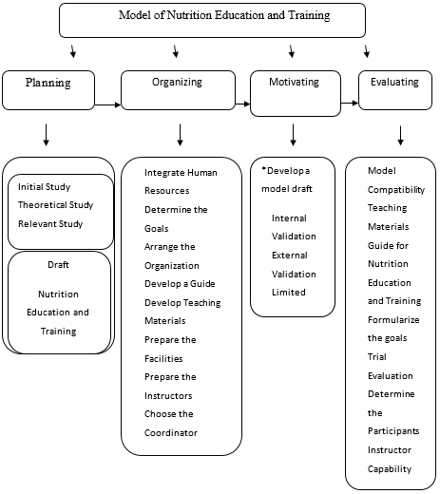

Figure 1. Conceptual Model Design

- Result
  - Nutritional Knowledge
The recapitulation result of nutritional knowledge data of productive age women in Banaran Village, Gunungpati Sub-district, Semarang City is summarized as follows: Nutrition knowledge before education and nutrition training, 18 women (75%) in good category, 4 women (16.6%) in medium category and 2 women (8.4%) in less category. After nutrition education and training, the results are as follows: 19 women (79.16%) in good category, 2 (8.33%) in medium category and 2 (8.33%) in less category.
  - Knowledge of Foodstuff
The recapitulation results of food knowledge data prior to the implementation of nutrition education and training are as follows: 10 women (41.6%) in good category, 9 women (37.5%) in medium category, 5 women (20, 83). The result after the implementation of nutrition education and training are as follows: 13 women (54.15%) in good category, 9 women (37.5%) in medium category, and 2 women (8.33%) in less category.
  - Food Processing Technique
The recapitulation results of food processing technique data prior to the implementation of nutrition education and training are as follow: 13 women (54%) in good category, 7 women (29.16%) in medium category, and 2 women (8.33%) in less category. The result after nutrition education and training were carried out are as follow: 17 women (70.83%) in good category, 5 women (20.83%) in medium category, and 2 women (8.33%) in less category.
  - Knowledge about Anemia
The recapitulation results of anemia knowledge data before the implementation of nutrition education and training are as follows: 19 women (79.2%) in good category, 5 women in medium category, (20.8%). The result after nutrition education and training were conducted are: 14 women (58.3%) in good category, 8 women (33.3%) in medium category and 2 women (8.3%) in less category.
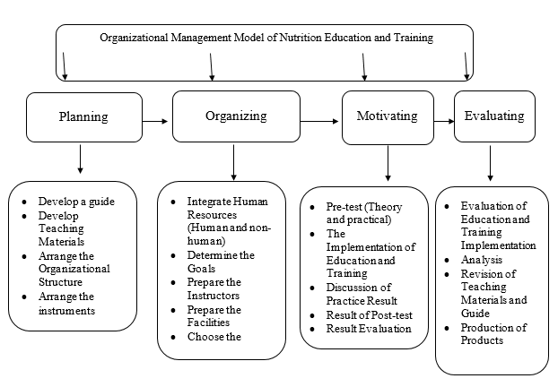
  - The result Model of Education and Nutrition Training

Figure 2. Final Model of Organizational Management of Community-Based Nutrition Education and Training to Overcome Anemia on Mothers
Based on the results of the description and analysis of each variable, the preparation of textbooks distributed to them is accompanied by samples of menus that can be made, ranging from simple menu, middle type menu and a fancy menu, all of which refers to the balanced nutrition menu. The teaching materials also include recipes, whether they are already practiced or not, and accompanied by photos of the cuisines to make them clear and descriptions of the various dishes that they can practice every day in the family. The textbooks are made in the form of pocket books that are practical for everyday use by mothers.
- Conclusion and Suggestion
Here are the conclusions and suggestions:
- The result of nutrition knowledge before the nutrition education and training: 18 women (75%) in good category, 4 women (16.6%) in medium category and 2 women (8.4%) in less category. After nutrition education and training, the results are as follows: 19 women (79.16%) in good category, 2 (8.33%) in medium category and 2 (8.33%) in less category.
- The result of food knowledge before nutrition education and training: 10 women (41.6%) in good category, 9 women (37.5%) in medium category, 5 women (20.83%) in less category. The result after nutrition education and training were conducted are: 13 women (54.15%) in good category, 9 women (37.5%) in medium category, and 2 women (8.33%) in less category.
- The result of food processing techniques prior to the implementation of nutrition education and training are as follows: 13 women (54%) in good category, 7 women (29.16%) in medium category, and 2 women (8.33%) in less category. The result after nutrition education and training were carried out are: 17 women (70.83%) in good category, 5 women (20.83%) in medium category, and 2 women (8.33%) in less category.
- The result of anemia knowledge before nutrition education and training were carried out are as follows: 19 women (79.2%) in good category, 5 women in medium category (20.8%). The result after nutrition education and training were carried out are: 14 women (58.3%) in good category, 8 women (33.3%) in medium category and 2 medium (8.3%) in less category.
- The built nutrition education and training model is presented in the table.
- The produced textbooks are arranged separately as a handy, compelling and easy-to-use pocket book.

Based on the results of the research, it is suggested that there should be strengthening or mentoring of nutrition education and training for productive age women in Banaran village, Gunungpati, Semarang, in order to have the proper nutrition attitude or behaviour about the implementation of the family diet that refers to balanced nutrition. This can be followed up in community service activities in the next activity.
References
- Arisman. 2004. Gizi dalam Daur Kehidupan. Jakarta: Penerbit Buku Kedokteran EGC.
- Azwar, Azrul. 2004. Aspek Kesehatan dan Gizi dalam Ketahanan Pangan. Makalah. dalam Prosiding Widyakarya Nasional Pangan dan Gizi VIII. Jakarta: LIPI
- Hersey, P. Blancard, H. 1992. Manajemen of Organizational Behavior. Alih Bahasa Agus Dharma. Jakarta: Penerbit Erlangga.
- Rothwell. W. J. 1996. Beyond Training and Development: State of the Art Strategies For Enhancing Human Performance. New York: AMACOM (American Management Association)
- Sudjana, D. 2004. Manajemen Program Pendidikan. Bandung: Falah Production
- Zahrulianingdyah, Atiek. 2013. Model Pengorganisasian Pendidikan & Latihan (DIKLAT) Gizi Berbasis Masyarakat. Jurnal Ilmu Pendidikan, 19 (2) 129-135.
- Zahrulianingdyah, Atiek. 2016. The Contribution of Indonesian Women’s Eating Habit to Iron Deficiency Anemia. Pakistan Journal of Nutrition. DOI: 10.3923/pjn.2016

