**DEVELOPMENT OF BLENDED LEARNING MODEL BASED ON STUDENT LEARNING STYLE IN VOCATIONAL HIGH SCHOOL LATHE MACHINING PRACTICE**

Ayub Budhi Anggoro1, Herman Dwi Surjono2

1,2 Yogyakarta State University

1ayub.budhi2016@student.uny.ac.id, 2hermansurjono@uny.ac.id

Abstract

Geometric quality of products of lathe machining practice of Vocational High School students is ever decreasing and presently included in low category, due to the low learning quality. This research is aimed to: (1) develop a blended learning model accommodating students’ learning style in accordance with VARK model; (2) reveal the feasibility of a developed blended model to be applied; (3) reveal the teaching with the developed blended learning model; (4) reveal the effectiveness of developed blended learning model in practice of the lathe machining in Yogyakarta Special Region. It used research and development approach. The research was conducted by following ADDIE model procedure by Branch, namely: (1) analysis; (2) design; (3) development; (4) implementation; (5) evaluation. Relevant data were obtained by using observation, interviews, documentation, and measurement. In obtaining the data, observation and assessment sheets were used. The results of this research are as follows. (1) the developed blended learning model that accommodates student learning style of VARK model consists of a syllabus, lesson plan, and learning modules with visual type, auditory, read/write, and kinesthetic in print and/or digital form. (2) the developed model is feasible to be applied (3) the result of implementation of teaching using the developed model a whole was in a very good category, and included in the blended learning category (4) The result of the effectiveness test show that the teaching with the developed blended learning model proved effective, in term of student learning outcomes using blended learning model.

**Keywords**: blended learning, learning model, learning style, lathe machining practice.

1. Introduction

Product quality is an important thing for products of lathe machining. A good product quality will raise the product’s price, and so did the opposite; a low product quality will lower its price as well. The quality of products of lathe machining practice is in general determined by their geometric quality, covering precision in dimension, the good level of surface roughness or performance, and the idealness of product shape. The ideals geometric is influenced by correct lathe process, covering adjustment of machine tools, precise measurements, machine tool movements, cutting tool wear, temperature changes, and force of cutting forces. Student often do not pay attention to the factors that enable the achievement of the ideal geometric quality in the learning of lathe machining practices, so that the quality of the resulting product is low, this can be caused by learning model that does not accommodate a student’s learning style, so students are reluctant to learn and ultimately incompetent student in lathe practice, as well as learning that does not facilitate student to learn. Education as a medium for improving students’ competence can pursue various action, namely by developing an effective learning model to be used in the learning process. Blended learning is learning can improve the effectiveness and efficiency of learning, providing opportunities for students to learn more quality, and can facilitate students to learn directly using the machine.

Students of Vocational High School in Yogyakarta Special Region are producing low quality products in their lathe machining practice results. The product quality in Student Competence Championship of Vocational High School in Yogyakarta experienced a degeneration [1]. It is strengthened by Utomo, Sukardi, and Munadi [2] which on their research stated that the products resulted from lathe machining practice of Vocational High School students tend to have a low quality.

The results of pre-survey conducted shows several causes of the geometric quality decrease of vocational high school students’ result of lathe machining practice, which counted the low number of student practice hours because of the lack of lathes available, the students’ respective learning styles which are not accommodated by the school, and the low learning quality.

One of the steps to solve the problems aforementioned is to make learning innovation. Conventional learning cannot accommodate the varied learning styles of students [3], while online learning or the utilization of Information and Communication Technology (ICT) has more advantage in raising learning effectiveness and efficiency, and through this method students can get more opportunity to quality learning. However, in doing practical learning, one cannot only use online learning, since the students need to learn to operate and use machines and machining tools directly.

Blended learning model is the alternative to answer the problems arising from the needs detailed before. Blended learning is a combination of online learning with face-to-face (F2F) learning [4]. The blended learning model integrates best elements of F2F and online learning [5]; so that both learning’s best factors can be combined into one and applied [6].

This research aims to develop a blended learning model accommodating students’ learning style in accordance with VARK model (visual, auditory, read/write, kinesthetic), in learning practice of lathe machining of the students of Vocational High School in Yogyakarta Special Region. Reveal the feasibility of a developed blended model to be applied, reveal the teaching with the developed blended learning model, and reveal the effectiveness of developed blended learning model in practice of the lathe machining.

1. Method
2. **Research Design**

The research was conducted by using research and development (R&D) method. It comprises of five stages: analysis, design, development, implementation, and evaluation. analysis stage cover analysis of needs. Design stage cover planning of learning tools such as syllabus, lesson plan (*Rencana Pelaksanaan Pembelajaran*, RPP), and learning modules. Development stage cover making of prototype. Implementation stage covers prelimanary field testing and main field testing. Evaluation stage was conducted by doing formative evaluation of planning and implementation stages, covering validation of blended learning model by experts of learning model and learning material, analysis of blended learning model implementation, analysis of online and F2F learning ratio, and analysis of blended learning model effectiveness.

1. **Participants**

The subject of the preliminary field testing in this study were 12 students. The sample of preliminary field testing is conducted in 1 to 3 schools using 6 to 12 subjects [7].

The subject of the main field testing were 47 students, based on the opinion of Wagiran who said that for the purposes of experimental research, a minimum sample of 15 subjects per group [8], and Sugiyono who said that for testing sample main field of 30-100 subjects [7].

1. **Data Collection and Analysis**

The data relevant to this research were obtained by using some techniques such as interviews, documentation, observations, and measurement. Interviews were used in analyzing the need, while documentation, observation, and assessment were used in implementation stage. Instruments used in the research were observation and assessment sheets.

Analysis of validation of blended learning model tools’ components is shown in (1)

$Final score=\frac{Obtained Score}{41 x 3} x 100\%$ (1)

Key validation analysis of blended learning model, basis of consideration in choosing blended learning model, learning system component, and preliminary field testing result as pursuant to Sudijono [9] is shown in (2).

P = f/N x 100% (2)

P, f, and N are percentage of scoring results, obtained score, and total score, respectively.

Analysis of online and F2F learning ratio is shown in (3) as follows.

*F2F or Online= $\frac{a}{n}$ x 100%* (3)

a is F2F or online total number, and n is total number of learning activity.

Analysis of blended learning model effectiveness was conducted by using one sample t-test to test hypotheses. Tests of hypotheses were conducted by comparing scores of lathe machining practice with minimum passing score (*Kriteria Ketuntasan Minimal*, KKM), in which H0 is accepted under condition of *tcount* < *ttable* vice versa, or which can be seen from probability score in which sig>0.05. It was conducted by using SPSS (*Statistical Package for the Social Sciences*).

1. **Research Framework**

The blended learning model which accommodates student learning styles was developed following the ADDIE model (analyze, design, development, implementation, evaluation), presented in Figure 1 [10].

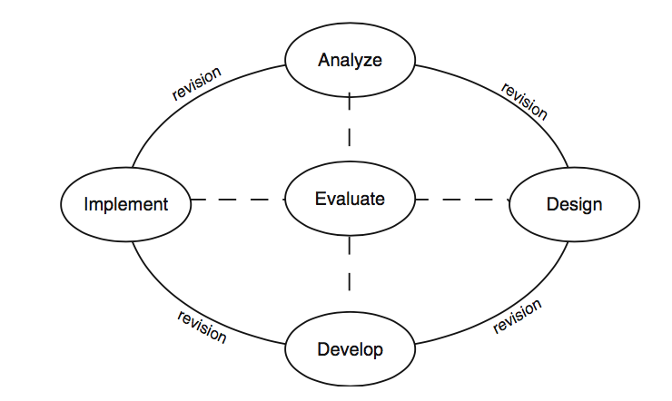

Figure 1. ADDIE model concept

Analyze is the process to identify the probable causes for a performance gap. Design is the process to verify the desired performances and appropriate testing methods. Develop is the process to generate and validate the learning resources. Implement is the process to prepare the learning environment and to engage with the students. Evaluate is the process to assess the quality of the instructional products and processes, both before and after implementation.

Based on the ADDIE development concept model, research framework was established, as shown in Figure 2.

Design

* Blended learning model design

Development

* Making of prototype

Analysis

* Analysis of needs

Implementation

* Preliminary field testing
* Main field testing

Evaluation

* Validation by experts
* Evaluation of the model’s implementation
* Evaluation of online and face-to-face (F2F) learning ratio
* Evaluation of the model’s effectiveness

Figure 2. Research framework

1. Results and Discussion

In this section, results of analyze stage, design stage, development stage, implementation stage, and formative evaluation of analyze, design, development, and implementation stages, as shown in figure 2, are reported.

1. **Analysis**

The analysis stage was initiated by analyzing the needs by obtaining information about learning model and learning materials of lathe machining practice in Vocational High School. The data were gathered by conducting field and literature study related to the competence of graduates needed and obstacles in lathe machining practice.

From field and literature study, some results were obtained: (1) the lack of lathe available, which resulted in some lathe practice materials being not practiced by students, and the lack of time for students to practice using lathe; (2) students’ respective learning styles were not accommodated; (3) the quality decrease of products of student lathe machining practice covering precise dimension, good level of surface roughness or performance, and ideal shape, or commonly known as geometric quality; (4) the unsuitable learning model employed in learning process.

1. **Design**

The next step is the blended learning model design. The design was initiated by establishing basic competencies (*Kompetensi Dasar*, KD); analysis of relation between graduate competency standards (SKL), core competencies (KI), and KD; translation of KD into competence achievement indicator (*Indikator Pencapaian Kompetensi*, IPK), learning objectives, and learning materials; and assessment planning.

The basic competencies established in this research are (1) basic competency of knowledge (KD3), which is application of operational procedures of general machinery, and (2) basic competency of skill (KD4) which is operation of general machinery.

The result of analysis of relation between SKL, KI, and KD shows that (1) KD-3, if viewed from the knowledge KDs had met cognitive dimension of KI-3 demands, which saw students applying their knowledge (C3). (2) The form of knowledge in this KD had been met, which is procedural knowledge. (3) KD-4, if viewed from the skill KDs had met taxonomy level of KI-4 demands in concrete domain, which saw students operating certain things pursuant to their obtained knowledge (P3).

The result of KD translation to IPK is explained as follows: (1) to describe various types of lathe and their functions; (2) to explain main parts of lathe; (3) to explain various types of cutting tools used in lathe; (4) to apply parameter of cutting and geometric quality of work object; (5) to apply procedure of operation with lathe; (6) to operate lathe to make simple object.

The result of KD translation to the learning objective is explained as follows: (1) through investigation and self-learning, students are able to describe various types of lathe and their functions in accordance with the printed or digital module in a polite way; (2) through self-learning and discussion, students are able to explain main parts of lathe in accordance with the printed or digital module in a polite way; (3) through self-learning, discussion, and information digging, students are able to to explain various types of cutting tools used in lathe in accordance with the printed or digital module in a polite way; (4) through self-learning, discussion, and information digging, students are able to to apply parameter of cutting and geometric quality of work object in accordance with the printed or digital module in a responsible way; (5) provided with lathe practice equipment and measurement tools, to apply procedure of operation with lathe in accordance with the printed or digital module in a true and responsible way; (6) through lathe practice, students are able to operate lathe to make simple object in accordance with the printed or digital module in a disciplined and responsible way.

The result of KD translation to learning materials is explained as follows: (1) various types of lathe and their functions; (2) main parts of lathe; (3) various types of cutting tools used in lathe; (4) parameter of cutting and geometric quality of work object; (5) practice of operating lathe.

The subsequent step is to plan the assessment. The result of assessment planning in this research is shown in Table 1.

Table 1. Result of assessment planning

|  |  |  |  |
| --- | --- | --- | --- |
| Basic Competences (KD) | Knowledge | Skill | |
| Essay test | Performance | Observation |
| 3.6 to apply procedure of general machinery operation | √ |  |  |
| 4.6 to operate general machinery |  | √ | √ |

1. **Development**

After the stage of assessment planning, the making of prototype was commenced. **Firstly,** the syllabus was designed as a reference in developing learning framework to each study material of the learning materials developed based on SKL and SI for education unit. The syllabus contained identity of education unit, KI (knowledge, attitude, and skills), KD, IPK, main materials, learning activities, assessment, time allocation, and learning sources.

**Secondly,** The RPP was designed as a guide for teachers to conduct learning activities. It was designed referring to syllabus containing KI and KD, IPK, learning objectives, learning materials, approach, strategy, methods, tools, media, and sources. The RPP was also equipped with learning scenario ought to be conducted by teachers and students.

The learning module was designed in a way that students are able to conduct self-learning by using available modules in accordance with their learning styles. It was developed in four types: visual, auditory, read/write, and kinesthetic, in form of printed and/or digital forms. It was designed in order for students to be able to apply operational procedure and to be able to operate lathe. To know the learning style of students, then developed a learning style test. The sample screen shot in Figure 3 is display of learning style test for student.



Figure 3. Sample learning style test

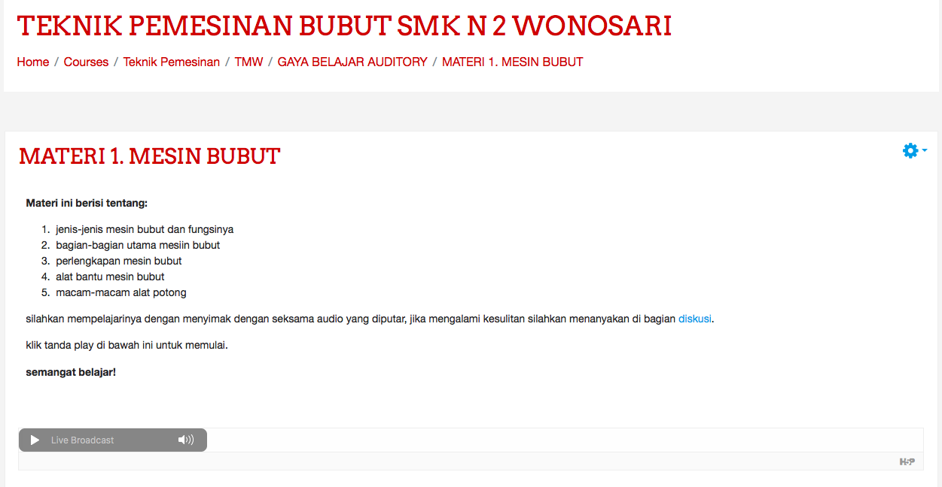

Figure 4. Auditory module

There were four modules made for this research. The first module contains the introduction of various types of lathe and their functions, main parts, and various types of cutting tools. It was designed so that the students have a summarized base of knowledge about types of lathe and their functions to for various types of work, and the workings and functions of each part of lathe. It was also designed so that the students can operate lathe cutting tools precisely as the job requires to.

The second module talks about geometric quality of work object, which contains the level of product quality as seen from its precision of dimension, its ideal shape, and its smooth surface. It is continued with the third module about cutting parameter, covering all factors influencing the cutting and slicing.

The last module talks about lathing techniques, covering procedures of lathing from the preparation until lathing process. After students master the knowledge of various types of lathe and their functions, the main parts, and cutting tools, continued with the formation of knowledge and skills about cutting parameters and geometric quality of work object, and lathing techniques, the students were then given a job to practice operating lathe to make simple objects. The sample screenshot in Figure 4 is display of VARK types module.

Therefore, the prototype of blended learning model developed had specifications in form of syllabus and RPP, equipped with learning modules of visual, auditory, read/write, and kinesthetic type in printed and/or digital forms.

After the prototype was developed, validations from experts of learning model and learning material were conducted. The result is shown in Table 2 and Table 3.

|  |  |  |  |  |
| --- | --- | --- | --- | --- |
| Variable | Maximum score | Obtained score | Percentage | NB |
| Component of learning equipment with blended learning model | 123 | 118 | 95,9% | Very Feasible |
| Blended learning model key | 40 | 39 | 97,5% | Very Feasible |

Table 2. Result of validation by learning module expert

Table 3. Result of validation by learning material experts

|  |  |  |  |  |  |  |  |
| --- | --- | --- | --- | --- | --- | --- | --- |
| Variable | Maximum score | Result score | | Percentages | | NB | |
| 1 | 2 | 1 | 2 | 1 | 2 |
| Basis of consideration of learning model choice | 40 | 32 | 32 | 80% | 80% | Feasible | Feasible |
| Learning system components | 40 | 33 | 31 | 82.5% | 77.5% | Very Feasible | Feasible |

Table 4. Result of observation of blended learning model implementation

|  |  |  |  |  |  |  |  |  |  |  |  |
| --- | --- | --- | --- | --- | --- | --- | --- | --- | --- | --- | --- |
| Variabel | Maximum score | Scoring result of observation of teacher-student meetings | | | Observation result  (%) | | | Average of each meeting (%) | | | Average meeting (%) |
| 1 | 2 | 3 | 1 | 2 | 3 | 1 | 2 | 3 |
| Preliminary activities | 24 | 23 | 24 | 24 | 95,8 | 100 | 100 | 91,5 | 91,6 | 95,1 | 92,7  (Very Good) |
| Core activities | 68 | 57 | 61 | 58 | 83,8 | 89,7 | 85,3 |
| Closing activities | 20 | 19 | 17 | 20 | 95 | 85 | 100 |

Table 2 can further be presented in Figure 5.

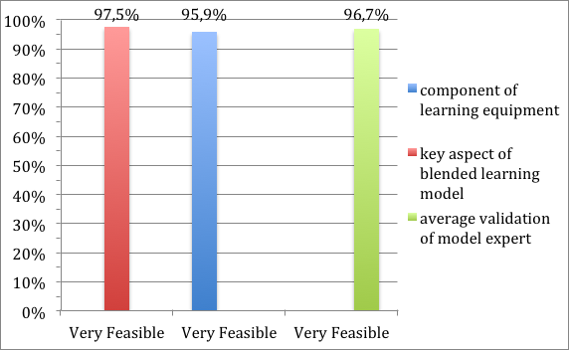

Figure 5. Percentage of validation result from learning model expert

It can be understood that from table 2 and figure 8 above, the learning model expert assessed the blended learning model as very feasible from the aspect of component of learning equipment, with the percentage of 95.9%, and very feasible from the key aspect of blended learning model, with the percentage of 97.5%. Average validation of model expert was categorized as very feasible, with the percentage of 97.6%.

Table 3 can further be presented in Figure 5.

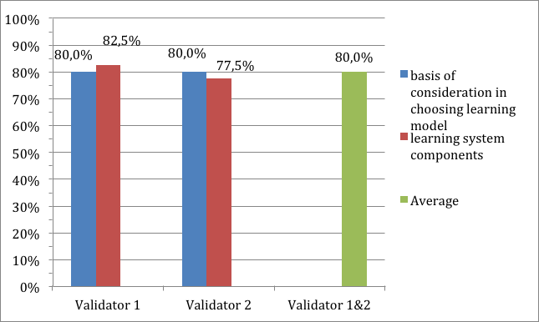

Figure 6. Percentage of validation result from learning material experts

It can be understood that from table 3 and Figure 9, there existed differences between first expert and second expert of learning material. The first expert assessed that from the aspect of basis of consideration in choosing learning model, the blended learning model material was categorized as feasible, with 80% percentage, and very feasible from the aspect of learning system components, with 82.5% percentage. However, the second expert assessed that from the aspect of basis of consideration in choosing learning model, the blended learning model material was categorized as feasible, with 80% percentage, and also feasible from the aspect of learning system components, with 77.5% percentage. The average validation by learning material experts was categorized as feasible with 80% percentage.

If the average score given by two experts is looked, then the aspects of basis of consideration in choosing learning model and component of learning system with blended learning model are categorized as feasible, amounting to 80%.

1. **Implementation**

The testing stage was conducted in two steps: preliminary field testing and main field testing. Preliminary field testing is the testing of blended learning model with its equipment in small scope real learning process situation. The test was conducted to 12 students as research subjects. The observation of learning process observation was then conducted, with the result as shown in Table 4.

Table 4 is also presented in figure 7.

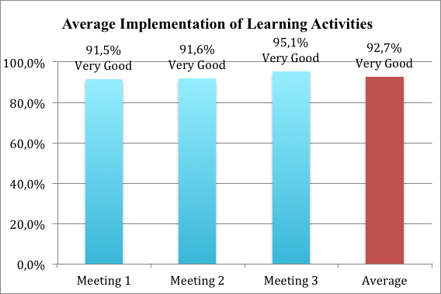

Figure 7. Diagram of the implementation of learning activities at each meeting and overall

It can be seen from table 4 and figure 7 that the percentage of learning implementation in first meeting amounted to 91.5%, second meeting amounted to 91.6%, and third meeting amounted to 95.1%. It shows that at the first, second and third meetings all activities of preliminary, core, and closing activities were categorized as very good. Average results of the implementation of learning activities was categorized as very good, with the percentage of 92.7%.

The ratio of F2F and online learning in the developed model will show whether the developed model had met criteria for blended learning model. The result of learning implementation during 3 teacher-student meetings is as follows.

Table 5. Ratio of F2F and online learning

|  |  |  |  |
| --- | --- | --- | --- |
| No | Learning | Percentage | Criteria |
| 1 | F2F | 60.71% | In accordance with the proportion |
| 2 | Online | 32.29% | In accordance with the proportion |

The data on Table 5 can further be presented in Figure 8.

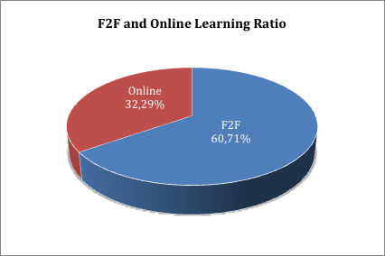

Figure 8. Diagram of face-to-face and online learning ratio

It can be seen from table 5 and figure 8 that F2F learning activity was conducted for 17 times, amounting to 60.17% of total activity, while online learning activity was conducted for 11 times, amounting to 32.29% of total activity. In this ratio, it can be assumed that blended learning model had been used. It is in tune with Allen, Seaman, & Garret [11] which stated that blended learning is a learning which has online learning activity portioned around 30-79% of total activity, combined with face-to-face learning activity.

Main field testing was a continuation of preliminary field testing. In this experiment, the learning model tested earlier was tested to a broader group of students. In this research, there are 47 students acting as informants, taken from two sample schools.

To meet the requirements of analysis, normality test was conducted to determine if the data was distributed normally. The hypotheses of normality test were as follows:

H0 : Data distributed not normally.

Ha : Data distributed normally.

The result of normality test of lathe machining practice score is shown in Table 6.

Table 6. Normality test of one-sample Kolmogorov-Smirnov test

|  |  |  |  |  |
| --- | --- | --- | --- | --- |
| Variable | Kolmogorov-Smirnov | Sig. | Std. Dev | NB |
| Practice result score | 1.327 | 0.059 | 0.00832 | Normal |

Table 6 shows the normality test result of one-sample Kolmogorov-Smirnov testwith lathe machining practice result as variable, with 0.059 significance. The test result was categorized as normal.

Subsequently, one-sample t-test (*one-shot case study*) was conducted to understand the effectiveness of the model being developed. The t-test hypotheses were as follows:

H0 : The group learning by using blended learning modelscores ≤ 75

Ha : The group learning by using blended learning modelscores > 75

The hypotheses test result is presented in Table 7.

Table 7. Hypothesis test result of average practice result score

|  |  |  |  |  |
| --- | --- | --- | --- | --- |
| Variable | *Tcount* | *ttable* | Sig. | T-test result |
| Practice result score | 31.139 | 1.671 | 0.000 | Since *tcount*> *ttable* and significance < 0.05, then Ha was accepted, meaning that the score of lathe machining practice learning by using blended learning model > 75 |

Table 7 shows that in the variable of score of lathe machining practice result, *tcount* = 31.139 and *ttable* = 1.671 with 0.000 significance, therefore *Ha*, stating that the score of lathe machining practice by using blended learning model > 75 was accepted. This shows that the score obtained from learning by using blended learning model was higher than the minimum passing score and are declared effective for improving the geometric quality of students' practice results. İt is in tune with the various formulations Stein & Graham [12], Bath & Bourke [13], and Husamah [3] stating that blended learning can improve learning, access, management of learning, support the provision of information for students, and facilitating student learning styles.

1. Conclusion

Based on ADDIE model, the development of blended learning model which accommodates student learning styles to improve geometric quality of lathe machining practice result was conducted in five stages: analyze, design, development, implementation, and formative evaluation.

The developed blended learning model that accommodates student learning style of VARK model consists of a syllabus, lesson plan, and learning modules with visual type, auditory, read/write, and kinesthetic in print and/or digital form.

The result of the feasibility assessment of the developed blended learning model by the expert of the learning model is included in the very feasible category with the average percentage of 96.7%, and by the learning material expert included in the feasible category with the average percentage of 80%.

Blended learning model can be implemented in accordance with the lesson plan which covers preliminary activities, main activities (observing, giving questions, exploring, associating, and communicating), and closing activities. The result of implementation of teaching using the developed model a whole was in very good category with the percentage equal to 92.7%. the percentage of teaching implementation at the first meeting was 95.1%, second meeting was 91.6%, and third meeting was 95.1%. The proportion of face-to-face teaching activities is 60.71% or conducted as many as 17 activities, while the online activity is 32.29% or conducted as many as 11 activities, in this ratio teaching is said as blended or hybrid type of teaching.

The blended learning model is proven to be effective, based on the score result of lathe machining practice > 75 (minimum passing score).

References

[1] Winarno P. *Analisis Hasil Lomba Kompetensi Siswa Sekolah Menengah Kejuruan Bidang Las Provinsi Daerah Istimewa Yogyakarta*. Other, UNY, http://eprints.uny.ac.id/21009/ (2015, accessed 23 July 2018).

[2] Utomo PD, Sukardi T, Munadi S. Analisis Kualitas Geometris Hasil Praktik Pemesinan Bubut Siswa SMK Jurusan Teknik Pemesinan. *J Din VOKASIONAL Tek MESIN* 2017; 2: 1.

[3] Husamah. *Pembelajaran Bauran*. Prestasi Pustaka Jaya, 2014.

[4] Al-Azawei A, kadhim Al-Bermani A, Lundqvist K. Evaluating the Effect of Arabic Engineering Students’ Learning Styles in Blended Programming Courses. *J Inf Technol Educ Res* 2016; 15: 109–130.

[5] Clark I, James P. Blended learning: an approach to delivering science courses on-line. *Proc Aust Conf Sci Math Educ Former UniServe Sci Conf*; 11, https://openjournals.library.sydney.edu.au/index.php/IISME/article/view/6430 (2012, accessed 23 July 2018).

[6] Vernadakis N, Giannousi M, Derri V, et al. The impact of blended and traditional instruction in students’ performance. *Procedia Technol* 2012; 1: 439–443.

[7] Sugiyono. *Metode Penelitian Kuantitatif Kualitatif dan R&D*. Bandung: Alfabeta, 2012.

[8] Wagiran. *Metodologi Penelitian Pendidikan: Teori dan Implementasi*. Yogyakarta: Deepublish, 2015.

[9] Sudijono A. *Pengantar Statistik Pendidikan*. Jakarta: PT. Raja Garfindo Persada, 2011.

[10] Branch RM. *Instructional Design: The ADDIE Approach*. Boston, MA: Springer US. Epub ahead of print 2009. DOI: 10.1007/978-0-387-09506-6.

[11] Allen IE, Seamen J, Garret R. *Blending in: The extent and promise of blended education in the United States*. USA: The Sloan Consortium, 2007.

[12] Stein J, Graham CR. *Essentials for Blended Learning : A Standards-Based Guide*. Routledge. Epub ahead of print 3 January 2014. DOI: 10.4324/9780203075258.

[13] Bath D, Bourke J. *Getting Started With Blended Learning*. Australia: Griffith University, www.griffith.edu.au/gihe (2010).