THE WORK PERFORMANCE OF THE GRADUATES OF 3-YP VOCATIONAL HIGH SCHOOLS AND ITS FOLLOW-UP

Badrun Kartowagiran¹, Djemari Mardapi², Amat Jaedun³, Edi Istiyono⁴, Faridl Musyadad⁵
^{1,2,3,4,5}Universitas Negeri Yogyakarta
¹kartowagiran@uny.ac.id, ²djemari@uny.ac.id, ³amatjaedun@uny.ac.id, ⁴edi_istiyono@uny.ac.id, ⁵faridl.musyadad@gmail.com

Abstract [1]

The fourth industrial revolution and globalization have led to the strong intention to improve the performance quality of three-year vocational high school graduates (3-YP VHS). The improvement can be made precisely if it is initiated with research on graduate work performance. Therefore, this research aims to describe the work performance of the 3-YP VHS graduates and ways to follow it up. This research was conducted at

11 3-YP VHS’s, 13 business sectors and industrial sectors with the respondents consisting of school principals, teachers, students, and alumni of vocational high schools working in industries. The data were collected through a questionnaire, observation, and interviews, and analyzed using the descriptive technique completed with the qualitative one. The result of this research shows that in general the work performance of 3-YP VHS graduates is in a high category, except for the ethics which needs improvement. In addition, there are skills needed by industries but not developed in school, including a special skill to accomplish a task and managerial and public speaking skills. On the other hand, there are subject matters not directly needed by industries but developed in school, including social science, arts, electric installation, heavy instrument operation, introductory test analysis, and map measurement. Based on this result, there is a need to revise the curriculum, i.e. by including materials on special trainings which are interesting to students and relevant to the development of job market. It is also necessary to improve classroom instruction and evaluation by integrating character aspects in teaching and evaluation.
Keywords: work performance, graduate, 3-YP VHS follow up

INTRODUCTION
Evidence suggests that the fourth industrial revolution and globalization are the two main challenges faced by the Indonesian people nowadays (Tim Penyusun Buku Revitalisasi Kemendikbud, 2016) [2]. A key issue with the fourth industrial revolution is that both machine and information technology are predicted to replace human workforces. All mechanisms are connected with others on the basis of a cyber physical system which will change people’s way of life, work, and communication radically. The jobs available now will gradually be in extinction in 10 years. Approximately 35% basic skills will change in 2020 and two billion workers are likely to lose their jobs (Tim Penyusun Buku Revitalisasi Kemendikbud, 2016) [2].
In light of the beginning of the Globalization Era, especially ASEAN Economic Community (AEC) on December 31, 2015 [3], everything in one ASEAN country will flow smoothly to other ASEAN countries. This means that in this era, whatever is produced by ASEAN countries can be sold in Indonesia easily. Besides, an influx of workers from neighboring countries will enter Indonesia very easily. There will be many high quality goods and high quality labors with high work ethos fluxing Indonesia very easily.
AEC has a variety of implications related to human resources development. Structural changes related to AEC brings about growing needs for skilled workers and decreasing needs for manual workers. AEC is expected to be a stimulus to be more skill intensive economies because many members of ASEAN have move to the products and export whose process and technology need high skills and productivity. It is forecasted that from 2015 to 2025 the demand for skilled workers in ASEAN countries will increase approximately 41% or 14 million workers. Half of them are needed by Indonesia, followed by the Philippines, which needs 4.4 million workers [2].
Based on the above description, there must be efforts to improve the quality of labors who can adapt themselves to the job market of the 2020’s. These efforts are done through the improvement of the quality of vocational education and trainings. For the medium technical workers, it is the quality of the 3-YP VHS education that needs improvement. There must be serious efforts made so that 3-YP VHS graduates are able to achieve graduate competency standard and to adapt themselves to the development of job market needs.
According to the Decree of Minister of Education and Culture Number 54 Year 2013, for the 3-year program vocational high school and vocational Islamic high school (3-Y VHS/VIHS, the graduate competency standard includes three dimensions: attitude, knowledge, and skill. The attitude competence includes: having the character that reflects the character of a person who is devoted to God, has good character, and who is knowledgeable, self-confident, and responsible in interacting effectively with social environment and nature as well as putting himself as the reflection of the nation in global interaction.
The second qualification, i.e., cognitive competence is concerned with factual, conceptual, procedural, and metacognitive. This competence is manifested in science, technology, art, and culture. In turn, this competence is expected to sharpen the insights of humanity, nationality, citizenship, and civilization. The last competence, i.e., the qualification of skill competence deals with having effective and creative thinking and action in the abstract and concrete. This is a development of what is learned at school independently.
Considering the vital role of the competency standards in preparing vocational education students to face the fourth industrial revolution and globalization, there is an urgent need to improve the high graduate competency standards of 3-YP VHS. In order to have a precise quality improvement of 3-YP VHS, it is necessary to analyze 3-YP VHS graduates’ work performance. Therefore, this study aims to describe the work performance of the 3-YP VHS graduates and ways to follow it up.

RESEARCH METHOD
This research was a survey with the cross sectional survey design. The data were collected through a survey, observation, and interviews using a questionnaire, observation sheet, and interview guide. The questionnaire, observation sheet, and interview guide had good face validity. The questionnaire and observation sheet also had good Cronbach Alpha reliability. This research was conducted at 11 vocational high schools with informants consisting of 11 principals, 44 vice principals, 11 coordinators of special job market, 65 teachers, 65 students, and 39 school alumni. It was also conducted at business and industry sectors with informants consisting of 13 supervisors and 65 employees of business and industry sectors who were alumni of vocational high schools. The data were analyzed using the descriptive-quantitative statistics and descriptive-qualitative one.

RESEARCH FINDINGS
The data on the graduates’ work performance were collected from 39 sample alumni who have worked, and it consisted of all skill competencies. The work performance was viewed from job waiting time, experience in current position, income, needed skill, and work ability in industry. Based on the document in the sample schools, the job waiting time of 3-YP VHS alumni can be seen in Figure 1.

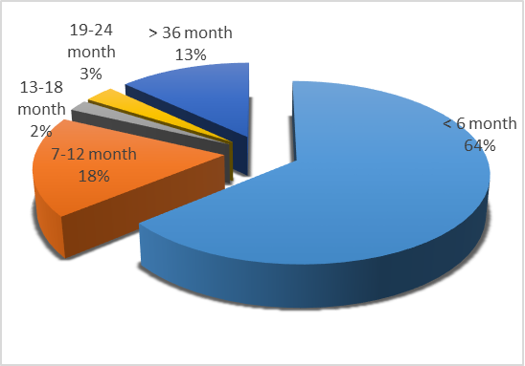
Figure 1. Chart of waiting Time of 3-YP VHS Alumni

Figure 1 shows that most alumni of state vocational high schools in several areas in Indonesia got a job right away upon the completion of their study. One of them even got a job when he was still studying, although there is also one who has not got a job because he continued his study in university. The data were the responses from 39 alumni of state vocational high schools which become the benchmark in Indonesia. The short job waiting time shows that until 2016 the 3-YP VHS graduates were still competitive. There were 3-YP VHS graduates working in small scale and large scale industries. Table 1 shows the distribution of 3-YP VHS graduates who are the research sample.

Table 1. Number and workers’ average length of service
No | Name of Industries | Prov. | Expertise | Num-ber of VHS Alumni workers | Length of Service  (Year)
1 | PT. Smart T.U | Jabar | Building Drawing Engineering | 11 | 5
2 | PT. Ligna | Jabar | Mechanical Engineering | 140 | 3
3 | Klop Mitra Solusi | DIY | Computer & Network Engineering | 4 | 2
4 | Prama Sanur Beach Hotel | Bali | Hotel Accommo-  dation | 20 | 1
5 | PT BPRS Bangun Drajat Warga | DIY | Accounting | 2 | 3
6 | PT. Duta Tour Jumantara | Sulsel | Travel Unit | 3 | 6
7 | CV. Ariesta Adhitama Eng. | Jateng | Electrical Installation Engineering | 12 | 8
8 | Padepokan Seni Sarotama | Jateng | Handycraft | 5 | 3
9 | CV. Saptani karya mandiri | Jateng | Food Vegetation and Holticulture | 2 | 1
10 | DPC. Pelra Makasar | Sulsel | Nautika Fishing Vessel | - | 1
11 | PT. Graha Service Indonesia | Jatim | Audio-Visual Technology | - | 1
12 | UPT. Pengujian Energi dan Sumber Daya Mineral | Jabar | Chemistry Analyst | 10 | 20
13 | Balai Besar Plup dan Kertas | Jabar | Industrial Chemist | 6 | 20
Total |  |  |  | 140

Table 1 shows that 3-YP VHS graduates can also work for large scale industries like PT. Ligna. It also shows there are six industries employing 3-YP VHS graduates for one to seven years, some have worked for 30 years, and there are even industries employing 3-YP VHS graduates until their retirement. The length of service of the 3-YP VHS graduates, which is relatively long in some industries shows their very good working performance so that industries keep employing them.
Upon working in industries, the 3-YP VHS graduates improve very fast. This is indicated by their income growth. The proportion of those whose income grows can be seen in Figure 2.

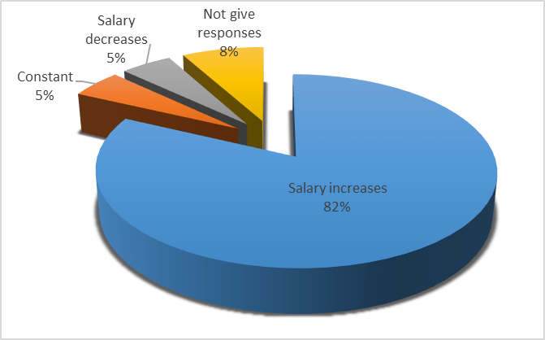
Figure 2. Chart of percentage of Alumni whose Income Grows

Figure 2 shows the percentage of 39 3-YP VHS alumni whose income increases compared to their initial income. There are 82% alumni whose salary increases, but there are 5% alumni whose income does not change, and there are even 5% alumni whose income is constant, while the rest 8% did not give responses. The increase of salary is varied from the lowest Rp. 200,000.- to the highest Rp. 14,000,000.- which is averagely Rp. 1,739,510.-. This indicates that industries appreciate 3-YP VHS graduates by giving them rewards in the form of pay increase. According to the employers, the competence of 3-YP VHS graduates is in a good/high category, and this can be seen in Figure 3.

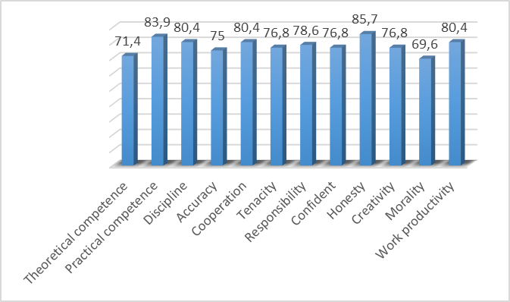
Figure 3. Competence of 3-YP VHS graduates (according to industries)

Figure 3 shows industries recognition of 3-YP VHS graduates in a high category because generally it exceeds the minimum requirement of 75. Nevertheless, if looked more carefully, it turns out that two competencies need a special attention, i.e. ethics/morality whose score is 69.6 and theoretical competence with a score of 71.4. The finding of this research also shows that there is a competency needed by industries but is not taught in school. The aforementioned competency can be seen in Figure 4.

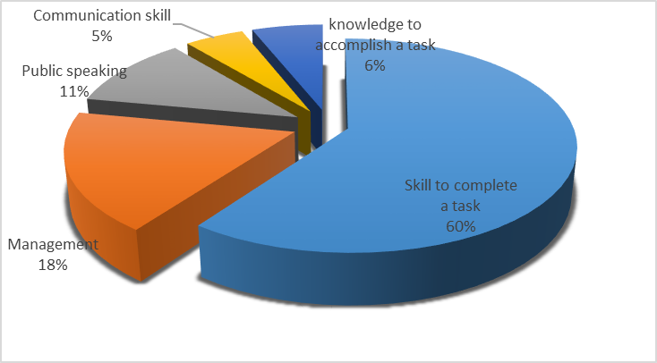
Figure 4. Chart of competencies needed by industries but not developed in school

Figure 4 shows there are 39 3-YP VHS alumni who become the respondents of this research saying that there are some competencies needed by industries but not developed in school. There are respectively 60%, 18%, 11%, 6%, and 5% respondents saying that: special competency/skill to complete a task, management, public speaking, supporting knowledge to accomplish a task and communication skill is not taught in school. This shows that the sample schools have not yet developed the competence and skill needed and/or relevant to the needs of industries in Indonesia, but develop the competence which is not needed.
On the other hand, the respondents also said that there were some school subjects not directly needed in the job, for instance natural ncience, arts, electric installation, heavy equipment handling, introductory testing analysis, network making, and map measurement. Some of those skills are general skills which are really used in their workplace.

DISCUSSION
The short waiting time of 3-YP VHS graduates who are the sample of this research is really rejoicing, but it must be noted that the alumni who are the respondents in this research graduated several years ago, when the digital era had not begun. The digital era is marked by the rapid change of information and communication technology (ICT) and literacy in ICT media in the rapid and wide scope of the spread and exchange of information. The era of openness and free competition is marked by the borderless of countries of the world, including the making of free regional market in a variety of sizes of territorial scopes from groups of countries of the same neighborhood, continent, and inter-continent such as AEC, AFTA, and APEC.
In the digital era, someone’s job changes rapidly in line with job market needs and more global labor supply and more sophisticated science and technology. The work which used to be done manually heavily relying on man power is replaced by machines and information technology. Several kinds of jobs available at present will disappear in 10 years. It is estimated that 35% of basic skills in the world of jobs will change in 2020, and almost two billion workers are at the risk of losing their jobs. For this reason, education and training should be done by providing students with many choices of skills in accordance with their interests and the development of job market needs so that it enables life-long learning to happen (Tim Penyusun Buku Revitalisasi Kemendikbud, 2016) [2].
In addition to providing workers to be with many choices of skills in accordance with their interests and the development of job needs, teaching must also integrate characters’ aspects. This is done with the aim to make them adapted to the digital era and at the same time to solve the research result as shown in Figure 3, i.e. the low moral ethics.
In line with the above description, Heusdens et al (2018) research, which explored vocational student knowledge, show that the framework provides a structure to gain insight into nature and meaning of vocational knowledge, and is valuable to describe charachteristics in term of knowledge component such as technical procedures or the social and occupational environment, and qualities such as richness, complexity and specificity. [4]
The tasks in vocational education must be complex but should not be too high. Fjellstorm’s research (2014) show that the project’s high complexity affects the students’ learning ability to take own decision in the learning environment [5]. This also affect the students’ motivation and ability to develop competences required to fulfill goals in course sylabuses. So, if the students’ are supposed to be able to be apart of their own learning the complexity in the task should not be too high. Hence, if the task is too easy the students will not be challenge enough in order to develop vocational competences.
Terminologically, the meaning of character is put forward by Thomas Lickona, one of proponents of character education from the USA. According to Lickona, character is “…. a reliable inner disposition to respond to situations in a morally good way.” He furthermore says, “Character so conceived has three interrelated parts: moral knowing, moral feeling, and moral behavior”[6]. According to him, good character includes virtual knowledge, resulting in commitment to doing virtues, and eventually doing good deed. Thus, the realization of character is through a long process starting from process of cognition, affection, and behaviors which has become habits
Character is like the most precious treasure in one’s life. One’s identity, as a perfect human, lies on his character building. One’s character building is successful if one can develop different potentials that one has. Those potentials are thinking potentials, religion and common sense, desire, and sensory perception. Developing the thinking potential will result in scientific competence; developing heart will result in belief and good moral or character; developing life energy will result in the spirit to solve life problems.
The Curriculum Center of Ministry of National Education has formulated 18 main character traits to be implemented in teaching, including religiosity, honesty, tolerance, discipline, perseverance, creativity, independence, democracy, curiosity, patriotism, love of the country, achievement-orientation, hospitality and communicativeness, peace-lover, reading mindedness, environment caring, social caring, and responsibility [7]. Meanwhile, UNESCO mentions that there are six character values: trustworthiness, respect, responsibility, fairness, caring, and citizenship. McElmeel offers 17 character values to be inculcated to students: caring, confidence, courage, curiosity, flexibility, frienship, goalsetting, humility, humor, initiative, integrity, patience, perseverance, positive attitude, problem solving, self-discipline, and teamwork [8].
In the era of President Joko Widodo’s administration now (2017) character building is very much emphasized to be conducted in all aspects of life. Schools run a special program called Penguatan Pendidikan Karakter (Character Education Reinforcement). There five basic values targeted at students to achieve: religiosity, nationalism, independence, cooperativeness, and integrity [9]. In line with the government’s policy, in this research character is focused on five principal values: religiosity, responsibility, independence, cooperativeness, and integrity.
From the explanation above, it can be understood that character is identical with moral, so that character is the values of man’s universal behavior which includes all of a person’s activities, in order to interact with God, himself, other people, and the environment [10], which is realized in thought, attitude, feeling, words, and behavior based on religious, legal, etiquette, cultural, and traditional norms. From this concept of character emerges the concept of character education.
Character education is value education, moral education, personality education, or education which aims at developing the students’ ability to distinguish good deed from bad deed, to maintain the good deed, and to realize the good deed in everyday life full-heartedly. Psychologically, the content of character education covers the dimension of moral reasoning, moral feeling, and moral action [6]. Meanwhile, Frye defines character education as “A national movement creating schools that foster ethical, responsible, and caring young people by modeling and teaching good character through an emphasis on universal values that we all share” [11]. Thus, character education, according to Frye, must become a national movement which makes school the agent to cultivate good character values through teaching and modelling. Through character education, schools have to make students have good character values such as respect and care for others, responsibility, cooperativeness, integrity, and discipline. Character education must also be able to prevent students from disgraceful and prohibited behavior.
The character education process includes at least four principles. First, it gives rational information, including the consequence of doing or not doing an act. Students need to have critical understanding of an action to be done or to be undone. Second, it is necessary to formulate a policy or regulation, such as ethics code, students’ contract, teacher or lecturer’s contract, and standard of behavior to be obeyed by all (for example, No Smoking in campus/school area, No Jeans). Third, it communicates continually the content and target of character education to all school or campus community members. The content and target must be clear and not ambivalent or cast doubt and must be delivered strictly. This communication is also done to inspire school or campus community with the message brought by character education. This is in line with the research by Kartowagiran and Maddini who reported that attitudinal competence developed in the classroom and exemplified by teachers will affect students’ behavior [12]. Fourth, the process of character building needs a model, example, and consistent concrete example, especially from those who are the students’ leader, i.e. their teacher or lecturer [13].
The process of character education consisting of four principles described above is in line with the result of the research done by Zamroni, et al This research described that multicultural education covered four factors as follows. (1) Factor 1: informing and socializing multicultural principles to all academic elements at school directly or indirectly; (2) Factor 2: giving examples or becoming a role model, and showing behaviours which are in line with the multicultural principles; (3) Factor 3: organizing or giving permissions to organize activities to promote multicultural education; and (4) Factor 4: strengthening and giving sanctions to all academic components at school who do not obey or violate the multicultural education principles [14].
The study by Zamroni, et al (2017) is similar to Grill and colleagues’ research which was conducted in Sweden and Denmark (Grill, et al, 2017). The study, which involved 1907 vocational education students, show that the empowering implicit leadership theories (ILT) of the vocational education and training (VET) students was found to increase during VET. The leadership of supervisors’but of teachers’, was found to be positively related to be improving ILT of the VET-students. [15]
In his book, 100 Ways to Enhance Values and Morality in Schools and Youth Settings, Howard Kirschenbaum explains 100 ways to improve values and morality (character) in school, which can be classified into five methods: 1) inculcating values and morality, 2) modeling values and morality, 3) facilitating values and morality, 4) skills for value development and moral literacy, dan 5) developing a values education program [16]. Kirschenbaum’s opinion suggests that the model of character education can be designed through five educational processes based on those five programs. Kirschenbaum’s proposal needs to be completed with the basis of spiritual competence development, because it has been admitted as a condition which enables character education to be managed easily with relatively good result.. Moreover, Esmond (2017) found that questions of access, knowledge and pedagogy remain to be addressed if plans for ‘technical education’ in England are to provide meaningful learning opportunities and support transitions to fulfilling work. [17]
Inculcating good character needs to be done in order to realize good character which is the end product of an educational process. The culture in an institution, at a school or other places, plays an important role in building a good character among civitas academica and the workers. Therefore, an educational institution has a duty and responsibility to implement character education for the students, which is supported by providing conducive environment in the classroom, school, students’ home, and society.
Habituation as the initial steps of culture growth can be done in schools in a varieties of ways and involving many things such as time discipline, dressing ethics, etiquette in personal relation, student’s attitude towards employees, lecturers, and authorities, and vice versa. Habituation by lecturers, students, workers, and authorities in discipline of an institution is a very strategic step toward character building in groups.
At the same time, a concrete example is needed because very often abstract values cannot be understood, and even cannot show their beauty and use to most people. Abstract values can be seen through concrete and visible examples. That is also the reason for concrete examples to have a very big role and function in transferring one’s character. In everyday life, a concrete example shown by someone can spread very quickly in the society. In school or campus life, moral values containing character building can be realized though concrete examples.
Furthermore, the inculcation of good character into students needs ‘healthy’ environment so that they can appreciate life experience. Therefore, in addition to hard work from the faculty or campus in creating the atmosphere of leadership, service, and teaching which is conducive to good campus culture, the surrounding community is expected to support and control this endeavor. Good character should always be improved and guarded through the three aforementioned components: family, campus, and community, because character building is a never ending process.

CONCLUSION
Based on the result of the data analysis, available regulation analysis, and discussion, the following conclusions can be drawn.
- Generally, the 3-YP VHS graduates’ work performance is in a high category, although there is one important thing that needs serious attention, i.e. the etiquette of the alumni who work in industries needs improvement.
- On the one hand, there are also competencies required by industries but not developed in school, for example a special competency at accomplishing work, management, and public speaking.
- On the other hand, there are school subjects not directly required in industries but are taught in school. The subjects include Natural Science, Arts, Electric Installation, Heavy Equipment Operation, Introductory Test Analysis, and Map Measurement.

RECOMMENDATION
- Based on the result of this research, vocational high school curriculum has to be modified by supplementing materials on special trainings which attract students’ interest and are relevant to the development of job market needs.
- There needs to be improvement in teaching and evaluation by integrating the aspects of character in teaching and evaluation processes.
- There needs to be learning environment so conducive to learning that the integration of character education can run well.
REFERENCES
[1] Kartowagiran, B; Mardapi, D; Jaedun, A Istiyono, E & Musyadad, F . (2017). Evaluasi tata kelola kelembagaan dan pembelajaran SMK 3 tahun. Laporan Hasil Penelitian Kerjasama Universitas Negeri Yogyakarta dan Direktorat Pembinaan SMK
[2] Kemendikbud. (2016). Revitalisasi pendidikan vokasi. Jakarta: Kementerian Pendidikan dan Kebudayaan.
[3] Chia, S. Y. (2013). The ASEAN economic community: progress, challenges, and propspects. Tokyo: Asian Development Bank Institute
[4] Heusdens, W T., Liesbeth K. J. Baartman & Elly de Bruijn (2018). Knowing everything from soup to dessert:an exploratory study to describe what characterises students’ vocational knowledge, Journal of Vocational Education & Training, DOI: 10.1080/13636820.2018.1437065
[5] Fjellstrom, M (2014). Vocational education in practice: a study of work-based learning in a construction programme at a Swedish upper secondary school. Emerical Research in Vocational Education and Training. http://doi.org/10.1186/1877-6345-6-2
[6] Lickona, T. (1991). Educating for character: how our school can teach respect and responsibility. Aucland: Bantam books
[7] Pusat Kurikulum Kemdiknas. (2009). Pengembangan dan Pendidikan Budaya dan Karakter Bangsa: Pedoman Sekolah. Jakarta: Pusat Kurikulum Balitbang Kemdiknas
[8] McElmeel, S.L. (2002). Character education. a book guide for teachers, librarians, and parents. Colorado: Libraries Unlimited.
[9] Kemdikbud. (2017). Konsep dan pedoman penguatan pendidikan karakter tingkat sekolah dasar dan sekolah menengah pertama. Jakarta: Kementerian Pendidikan dan Kebudayaan.
[10] Marzuki. (2009). Prinsip dasar akhlak mulia: pengantar studi konsep-konsep dasar etika dalam islam. Yogyakarta: Debut Wahana Press-FISE UNY.
[11] Frye, M et al. (Eds.). (2002). Character education: informational handbook and guide for support and implementation of the student citizent act of 2001. North Carolina: Public Schools of North Carolina.
[12] Kartowagiran, B & Maddini, H. (2015). ”Evaluation model for islamic education learning in junior high school and its significance to students’ behaviours “. American Journal of Educational Research, 2015, Vol. 3, No. 8, 990-995
[13] Zamroni. (2011). Strategi dan model implementasi pendidikan karakter di sekolah. Dalam Darmiyati Zuchdi (Ed.). Pendidikan karakter dalam perspektif teori dan praktik. yogyakarta: UNY Press
[14] Zamroni, Kartowagiran, B; Dwiningrum, S.I.A & Sudartinah, T. (2017). Development of cultural competence in multicultural education in indonesia and new zealand. Laporan Hasil Penelitian Hibah Pascasarjana.
[15] Grill, M. Pousette, A. Nielsen, K, Grytnes, G & Torner, M (2017). “Supervisors and teachers’ influence on expectation on empowering leadership among students in vocational education and training”. Emerical Research in Vocational Education and Training. http://doi.org/10.1186/s40461-017-0046-3
[16] Howard K. (1995). 100 ways to enhance values and morality in schools and youth settings. New York: Allyn & Bacon
[17] Esmond, B (2017) ‘They get aqualification at the end of it, I think’ : incidental workplace learning and technical education in England, Journal of Vocational Education & Training, 70: 2, 193-211, DOI: 10,1080/13636820.2017.1393000

