**Redesign of Technological Pedagogical Science Knowledge (TPSK) Based on Local Culture**

**Febrina Siska Widyaningtyas1,Ummi Kalsum2**

1Yogyakarta State University, 2 Riau Islamic University

[1siska_vtyas@yahoo.co.id](mailto:1siska_vtyas@yahoo.co.id), [2ummibio@edu.uir.ac.id](mailto:2ummibio@edu.uir.ac.id)

**Abstract**

# This research is a literature study and the method used is Systematic Literature Review (SLR). The advancement of the educational world demands a renewal of knowledge and skills in accordance with the demands of the development of 21st century education. Teachers must be able to integrate between content, pedagogy, and technology by lifting culture local in classroom learning practices. Local culture-based learning is used by teachers who must be adapted to the subject matter presented under the curriculum. The important thing here is how students are able to understand and master the concept of science through local culture using current technology. The design of the learning model begins with a redesign of TPSK integration indicators. Redesign of Technological Pedagogical Science Knowledge (TPSK) Based on existing Local Culture can be used by teachers as a reference in developing learning model that integrates technology, pedagogy, knowledge. TPSK in science learning should be tailored to the needs and facilities available in schools.

# Keyword: Redesign, TPSK, Local Culture.

1. **Background**

Currently the demands in the world of education, students must be equipped with the science in accordance with the development of 21st century education. This becomes one of the teachers task that is part of the professionalism of a teacher. Kohler, Mishra, & Yahya (2007) stated that the teacher's professional ability implies the content, pedagogy, and technology he possesses. The use of technology in science learning is emphasized to science teachers who are adapted to meaningful pedagogical frameworks in learning materials (Barak, 2017) and are expected to assist students in learning science (Subramaniam, 2016).

The integration of content, pedagogy, and technology is packaged in Technological Pedagogical Content Knowledge (TPACK). TPACK is currently regarded as an essential framework for promoting instructional competence of 21st century teachers (Niwat Srisawasdi, 2012). One of the challenges of 21st century education is finding and developing efficient tools for learning. Therefore, a teacher needs to know the foundation in utilizing computer technology to be used in teaching. Teachers need to apply local culture-based learning using technology. Technology as a powerful tool for changing classroom teaching practices that are considered effective. In line with Awolaju's (2015) opinion, Abdu-Raheem (2012), Musa & Agwagah (2006) which states that projected learning using media will be better than without projected using instructional media.

Effective learning practices contribute to the quality of learning. According to Chen, Hendricks, & Archibald (2011), quality teaching practices need to apply appropriate strategies, make use of comprehensible language, encourage learners' engagement, and be responsive to the needs of learners. Teachers and learners can use new technologies to collect, organize, and evaluate information to solve problems and innovate practical ideas in the real world (Edelson, 2001; Jimoyiannis, 2010). According to Jimoyiannis (2010) Information and Communication Technology (ICT) is deemed inherent to the educational reform effort needed for 21st century society that can produce fundamental changes. Particularly in ICT-based science learning is potentially and highly effective as they provide opportunities for active learning, enabling learners to have higher cognitive levels, support constructive learning, and promote scientific inquiry and conceptual change. TPACK for science teachers according to Angeli & Valanides (2009) and Jimoyiannis (2010) includes knowledge of representation, science curriculum, learners' understanding of science, various educational contexts, ICT tools capabilities, etc.

Implementation of education according to what the 21st century education aspires is not as easy as imagined. There are still some things that 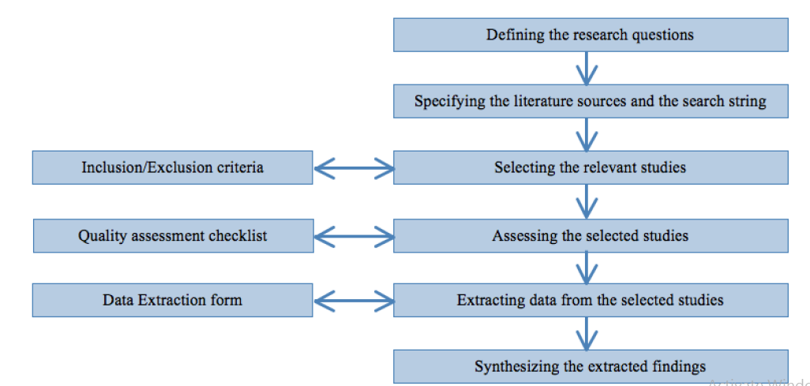become obstacles in practice in the world of education today. In general, teachers recognize the importance of introducing ICTs in the learning process, but teachers tend to be less in applying ICT in the classroom and less sure of their potential to improve the learning process (Jimoyiannis & Komis, 2006; Russell, Bebell, O'Dwyer, & O'Connor, 2003). This is in line with the views of Mumtaz (2000) and Afshari, Bakar, Luan, Samah, & Fooi (2009) which state that teachers' lack of knowledge and trust in the use of ineffective technology in the classroom, along with common problems such as lack of good technological tools .

Teachers tend to use ICTs for the sake of academic tasks such as searching for information on the internet or for administrative purposes eg looking for examples of learning tools, etc. rather than being used as a classroom learning tool (Russel et al., 2003; Waite, 2004). ICT development tends to focus on the technological aspects of how to use various tools in learning while pedagogical and instructional problems are why and how the tools can be used to enhance learning are often considered ordinary or under-noticed.

1. **Method**

The method used in this research is Systematic Literature Review (SLR) which according to Mulrow (1994) is one of scientific activities. This research is conducted by conducting systematic literature review by taking and integrating existing information. The resulting information integration results are then used to provide direction for the study effectively. A systematic literature review is used to (a) define, rationalize, and revise predetermined hypotheses, (b) understand and minimize previous assignments, (c) obtain estimates of numbers, and (d) identify important confounding effects and necessary covariates considered in future studies (Mulrow, 1994). Literature can be analyzed in six components of interest ie the database is used to retrieve articles, theoretical perspectives used to conduct systematic integrated literature review, quality assessment tools, integration tables and contents, methods used to categorize articles, and methods used to synthesize findings which is obtained.

**Ficture 1. Systematic Literature Review Sceme**

1. **Results and Discussion**

TPACK in Local Science-Based Science Learning

Learning of the 21st century has launched significant changes in learning methods by involving students in every learning activity. In an effort to create sophisticated learning today, teachers should be able to act as facilitators who provide the greatest opportunities for students to express themselves in the learning process. TPACK is an integration of content, pedagogy, and technology. According to Rosenberg & Koehler (2015) there are still most who do not fully understand about TPACK. Koehler found an interest in something unique: the overlap between technology, pedagogical, content, and knowledge. The uniqueness is the inclusion to provide a unified experience in which a teacher can combine their knowledge with more specific content and then how to effectively teach the content (pedagogy) as well as what technology is used to provide an effective learning experience to learners .

According to the results of the survey proposed by O'Bannon & Thomas (2015) found that preservice teachers recognize and use more features of smartphone, but they are not enthusiastic about using smartphones in learning. Further development, not limited to here but the use of technology must be integrated in learning between technology, pedagogic, content and knowledge. The purpose of this integration for future teacher education. This is in line with the opinion of Tsung Hau Jen (2016) which suggests that not only how well teachers can teach with technology, but also a constructive direction for future teacher education. Niess et al. (2009) argues that TPACK development of teachers usually begins by recognizing technology in learning and shaping attitudes and beliefs in accepting their values, especially when teachers motivate learners by providing technically supported instruction or properly guided in learning with using a particular technology.

Research on TPACK has previously been done focusing on content coverage and grade level with respect to practice (Harris and Hofer, 2011), development of instrument measurement (Abbitt, 2011), teacher inservice (Jang and Tsai, 2012), focusing on theory (Olofson, et al., 2016), and research was undertaken at higher education (Jang and Chang, 2016), as well as further research into the processes and products of TPACK's leadership diagnostic tool (Kevin, et al., 2017). Currently seven TPACK construction components namely TK, PK, CK, TPK, TCK, PCK, and TPACK have been studied by educational technology researchers such as Angeli, Valanides, & Christodoulou, 2016; Brantley-Dias & Ertmer, 2013; Voogt, Fisser, Pareja Roblin, Tondeur, & van Braak, 2013. They do research on TPACK by dividing it into seven components which then inter-component integrate into TPACK.

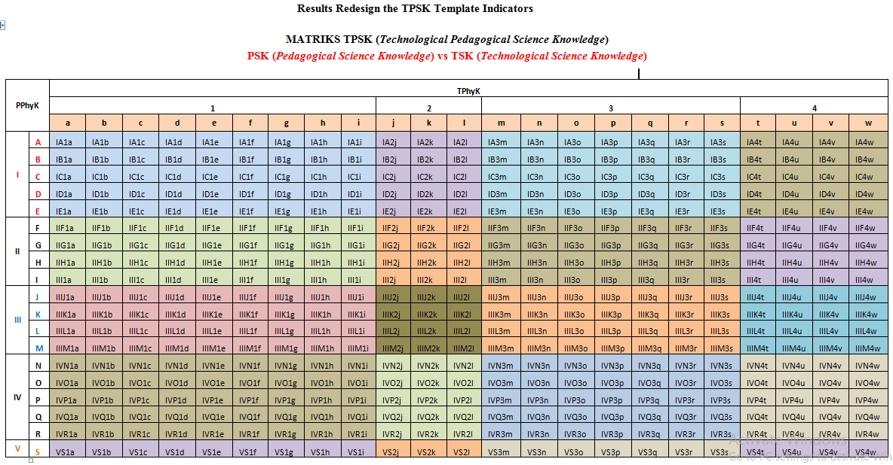In addition, previous research has been done by Elif Aktas & Serap Uzuner Yurt (2017) which is about the influence of learning using digital story which gives effect of positive influence to the level of academic achievement of learners. This is also in line with many studies in the literature which show that digital storytelling in learning can increase the academic achievement level of learners because it allows them to conduct individual research, actively participate in learning and learning processes through experience (Burmark, 2004, Barret, 2005, Robin, 2006; Jenkins & Lonsdale, 2007; Ohler, 2008; Figg & McCartney, 2010; Yang & Wu, 2012; Hung, Hwang & Huangi 2012; Yoon, 2013; Demirer, 2013). This proves that many have done research related to TPACK and success.

Research conducted by Takahiro Sato and Justin A. Haegele (2017) on the involvement of educators in the online physical adaptation of professional development graduate education resulted that with the presence of instructors online, it can change their teaching style (pedagogical orientation). This suggests that instructions given online can be understood and performed by observers. Local science-based science learning is the creation of a learning environment and the design of a science-learning experience that integrates local culture as part of the learning process of science. In the process of learning based on local culture, it means that culture is integrated as a tool in the learning process.

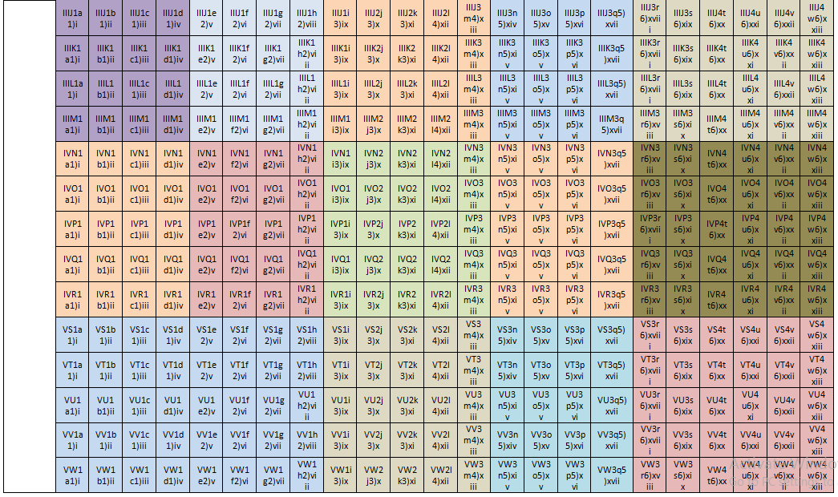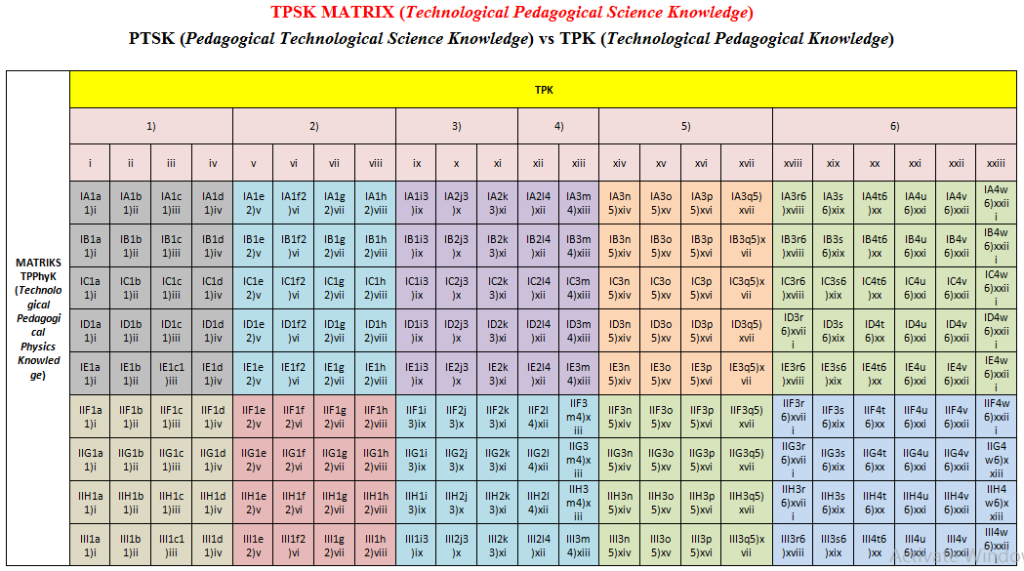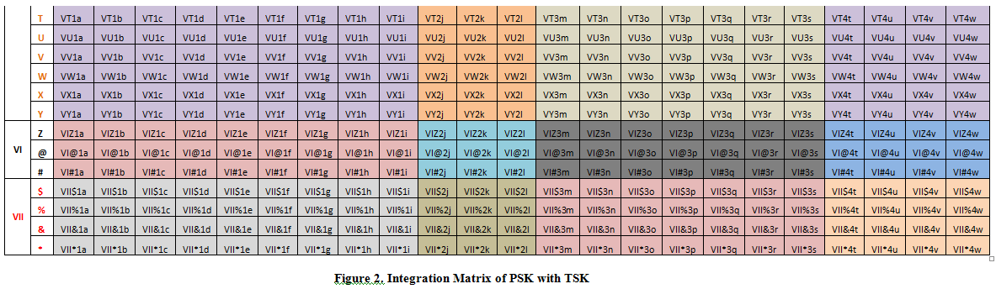

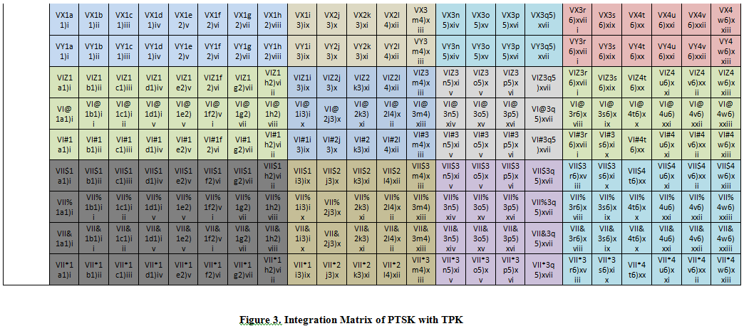

Information:

PSK (Pedagogical Science Knowledge)

1. Scientific Knowledge
   1. Structure of Science
   2. Facts, Theories, and Practices
   3. History and Philosophy / Paragdigma of Science
   4. Nature of Science
   5. Relationship between Science, Technology, and Society
2. Science Curriculum
   1. General Purpose of Science Education
   2. Special Learning Objectives for Various Units
   3. Philosophy of Science Education Curriculum
   4. Available Resources
3. Transformation of Scientific Knowledge
   1. Organizing Scientific Knowledge (facts, theories, practices)
   2. Representation of Scientific Knowledge (images, graphics, vectors, mathematics)
   3. Teaches Nature of Science
   4. Teaches Science, Technology and Society
4. Difficulty Learning Students about Certain Fields
   1. Early Knowledge of Students
   2. Student Misconception
   3. Student Cognitive Barriers
   4. Skill of Scientific Method of Student
   5. Student Learning Profile
5. Learning Strategy
   1. Promote student motivation and involvement
   2. Using practical / experimental work
   3. Use of Scientific Inquiries
   4. Use of Scientific Explanations
   5. The Use of Constructivism Approach
   6. Use of Cognitive Conflict Situations
   7. Use of a Conceptual Change Strategy
6. Common Pedagogic
   1. Knowing Basic Pedagogy
   2. Developing a Pedagogical Philosophy
   3. Knowing the Pedagogical Strategy
7. Education Context
   1. Educational Objectives
   2. School Culture
   3. Practical Knowledge
   4. Knowledge of Class Organizations

TSK (Technological Science Knowledge)

* + 1. Resources and Tools Available for Science Subjects
  1. Simulation
  2. Props
  3. Spreadsheets
  4. Concept maps
  5. MBL settings
  6. Multimedia
  7. Web app
  8. Source Wb Scientific
  9. Web 2.0 Application
     1. Operational and Technical Skills Associated with Scientific Knowledge
  10. Use of an effective simulation to model material
  11. Use of an effective concept map to model material
  12. Use of MBL settings to support specific material experiments
      1. Transformation of Scientific Knowledge
  13. Dynamic representations of specific scientific knowledge
  14. Simulations of specific scientific knowledge (macroscopic and microscopic)
  15. Virtual experimentation
  16. Experimentation using MBL
  17. Conceptual mapping in specific areas
  18. Geospatial technologies in Geography (e.g. Google Earth)
  19. Changes in Nature of Science
      1. Transformation of scientific processes
  20. ICT-based problem solving approaches in science
  21. New methods used to solve problems in science (e.g. using spreadsheets or modeling tools in physics)
  22. New methods used to analyze experimental data
  23. Modeling and simulation methods of specific content in physics, chemistry, biology (e.g. concepts, processes, principles)

TPK (Technological Pedagogical Knowledge)

* + 1. Affordances of ICT tools
  1. Knowledge of the pedagogical affordances of ICT
  2. Knowledge and skills to identify the pedagogical properties of specific software
  3. Knowledge and skills to evaluate educational software
  4. Ability to select tools supporting specific learning approaches
     1. Learning strategies supported by ICT
  5. Supporting experimental-practical work
  6. Use of constructivist approaches
  7. Promoting student motivation
  8. Fostering collaborative learning
     1. Fostering scientific inquiry with ICT
  9. Use of scientific inquiry
  10. Use of scientific explanation
  11. Learning how to learn (autonomous learning)
      1. Information skills
  12. Search and access of information in digital media (e.g. Web)
  13. Analyze and evaluate scientific content in digital media
      1. Student scaffolding
  14. Revealing and handling students' learning difficulties
  15. Supporting students in conceptual change processes
  16. Developing cognitive conflict situations for the students
  17. Supporting students to develop information skills
      1. Students' technical difficulties
  18. Supporting students to develop technical and operational skills for specific ICT applications
  19. Supporting students to use software modeling in specific content
  20. Supporting students to develop creative thinking
  21. Supporting students to develop critical thinking
  22. Supporting students to develop open ended
  23. Supporting students to use local culture in specific content

1. **Conclusion**

Redesign of Technological Pedagogical Science Knowledge (TPSK) Based on existing Local Culture can be used by teachers as a reference in developing learning model that integrates technology, pedagogy, knowledge. TPSK in science learning should be tailored to the needs and facilities available in schools.

1. **References**

Abbitt, J. T. (2011). Measuring technological pedagogical content knowledge in preservice teacher education: a review of current methods and instruments. *Journal of Research on Technology in Education*, 43(4), 281–300.

Abdu-Raheem, B. O. (2012). The influence of gender on secondary school students’ academic performance in south-west, Nigeria. *Journal of Social Science,* 31(1):93-98.

Afshari, M., Bakar, K. A., Luan, W. S., Samah, B. A., & Fooi, F. S. (2009). Factors affecting teachers’ use of information and communication technology. *Online Submission*, *2*(1), 77-104.

Angeli, C., & Valanides, N. (2009). Epistemological and methodological issues for the conceptualization, development, and assessment of ICT-TPCK: Advances in technological pedagogical content knowledge (TPCK). *Computers & Education*, *52*(1), 154–168.

Angeli, C., Valanides, N., & Christodoulou, A. (2016). Theoretical considerations of technological pedagogical content knowledge. In M. C. Herring, M. J. Koehler, & P. Mishra (Eds.), *Handbook of technological pedagogical content knowledge (TPACK) for educators* (2nd ed., pp. 11–32). New York, NY: Routledge.

Awolaju, B. A. (2015). Instructional materials as correlates of students’ academic performance in biology in senior secondary schools in Osun State. *International Journal of Information and Education Technology, 6*(9).

Barak. M. (2017) Science Teacher Education in the Twenty-First Century: a Pedagogical Framework for Technology-Integrated Social Constructivis. *Research in Science Education* . 47(2) 283–303.

Barrett, H. (2005). Researching and evaluating digital storytelling as a deep learning tool. [Online]: <http://electronicportfolios.org/portfolios/SITEStorytelling2006.pdf>.

Brantley-Dias, L., & Ertmer, P. A. (2013). Goldilocks and TPACK: Is the construct “just right?” *Journal of Research on Technology and Education, 46*(2), 103–128. doi:10.1080/15391523.2013.10782615.

Burmark, L. (2004). Visual presentations that prompt, flash & transform. *Media and Methods*, 40(6), 4–5.

Chen, W., Hendricks, K., & Archibald, K. (2011). Assessing pre-service teachers' quality teaching practices. *Educational Research and Evaluation*,*17*(1), 13-32.

Demirer, V. (2013). İlköğretimde e-öyküleme kullanımı ve etkileri. [Use of e-storytelling in primary education and its effects] . Unpublished doctoral dissertation. Necmettin Erbakan University, Institute of Education Sciences, Konya.

Edelson, D. C. (2001). Learning-for-use: A framework for the design of technology- supported inquiry activities. *Journal of Research in Science Teaching*, 38(3), 355-385.

Elif Aktas & Serap Uzuner Yurt. (2017). Effects of Digital Story on Academic Achievement, Learning Motivation and Retention among University Students. *International Journal of Higher Education Vol. 6, No. 1*

Figg, C. & McCartney, R. (2010). Impacting academic achievement with student learners teaching digital storytelling to others: The ATTTCSE digital video project. *Contemporary Issues in Technology and Teacher Education, 10*(1), 38-79.

Harris, J. B., & Hofer, M. J. (2011). Technological pedagogical content knowledge (TPACK) in action: a descriptive study of secondary teachers’ curriculum-based, technology-related instructional planning. *Journal of Research on Technology in Education*, 43(3), 211–229.

Hung, C.M., Hwang, G.J. & Huang, I. (2012). A project-based digital storytelling approach for improving students’ learning motivation, problem-solving competence and learning achievement. *Educational Technology & Society, 15*(4), 368-379.

Jang, S. J., & Tsai, M. F. (2012). Exploring the TPACK of Taiwanese elementary mathematics and science teachers with respect to use of interactive whiteboards. *Computers & Education*, 59(2), 327–338.

Jang, S. J.,&Chang,Y. (2016). Exploring the technological pedagogical and content knowledge (TPACK) of Taiwanese university physics instructors. *Australasian Journal of Educational Technology*, 32(1), 107–122.

Jenkins, M. & Lonsdale, J. (2007). Evaluating the effectiveness of digital storytelling for student reflection. In ICT: Providing choices for learners and learning. *Proceedings ASCILITE Singapore.*

Jimoyiannis, A., & Komis, V. (2006). Exploring secondary education teachers’ attitudes and beliefs towards ICT in education. *THEMES in Education*, 7(2), 181–204.

Jimoyiannis A. (2010). Designing and implementing an integrated technological pedagogical science knowledge framework for science teacherprofesional development. *Computer & Education*, 55, 1259-1269.

Kevin J. Graziano, et al. ((2017). A TPACK Diagnostic Tool for Teacher Education Leaders. *TechTrends*, 61(4), 372-379.

Koehler, M.J., Mishra, P., & Yahya, K. (2007). Tracing the development of teacher knowledge in a design seminar: Integrating content,pedagogy, and technology. *Computers & Education, 49*(3), 740-762.

Mulrow, C.D. (1994). Rationale for systematic reviews. BMJ, 309, 597-599.

Mumtaz, S. (2000). Factors affecting teachers’ use of information and communications technology: A review of the literature. *Journal of Information Technology for Teacher Education*, *9*(3), 319-342.

Musa, D.C. & Agwagah, U.N.V. (2006). Effect of incorporating practical into Mathematical evaluation on senior secondary school students’ achievement in Mathematics. Abacus: *Journal of Mathematical Association of Nigeria, 3*(1), 55 – 56.

Niess, M. L., Ronau, R. N., Shafer, K. G., Driskell, S. O., Harper, S. R., Johnston, C. … Kersaint, G. (2009). Mathematics teacher TPACK standards and development model. *Contemporary Issues in Technology and Teacher Education, 9*(1), 4–24.

Niwat Srisawasdi. (2012). The role of TPACK in physics classroom: case studies of preservice physics teachers. *SciVerse ScienceDirect Social and Behavioral Sciences*, 46, 3235 – 3243.

Ohler, J. (2008). *Digital storytelling in the classroom: New media pathways to literacy, learning, and creativity.* Thousand Oaks, CA: Corwin Press.

Olofson, M.W., Swallow,M. J., & Neumann, M. D. (2016). TPACKing: a constructivist framing of TPACK to analyze teachers’ construction of knowledge. *Computers & Education*, 95, 188–201.

O'Bannon, B. W., & Thomas, K. M. (2015). Mobile phones in the classroom: Preservice teachers answer the call. *Computers & Education*, *85*, 110-122.

Robin, B. R. (2006). The educational uses of digital storytelling. In C. Crawford et al. (Eds.), *Proceedings of Society for Information Technology & Teacher Education International Conference 2006* (pp. 709-716). Chesapeake, VA: AACE.

Rosenberg, J. M., & Koehler, M. J. (2015). Context and technological pedagogical content knowledge (TPACK): A systematic review. *Journal of Research on Technology in Education, 47*(3), 186–210. doi:10.1080/15391523.2015.1052663.

Russel, M., Bebell, D., O’ Dwyer, L., & O’ Connor, K. (2003). Examining teacher technology use: implications for preservice and inservice teacher preparation. *Journal of Teacher Education*, 54(4), 297–310.

Subramaniam. K. (2016). Teachers’ Organization of Participation Structures for Teaching Science with Computer Technology. *Journal of Science Education and Technology* 25(4) 527–540.

Takahiro Sato & Justin A. Haegele. (2017). Physical Educators’ Engagement In Online Adapted Physical Education Graduate Professional Development. *Professional Development in Education*. <http://dx.doi.org/10.1080/19415257.2017.1288651>.

Tsung-Hau Jen, et.all. (2016). Science Teachers’ TPACK-Practical: Standard Setting Using an Evidence-Based Approach. *Computers & Education, 95*(3), 45-62.

Voogt, J., Fisser, P., Pareja Roblin, N. P., Tondeur, J., & Van Braak, J. (2013). Technological pedagogical content knowledge—A review of the literature. *Journal of Computer Assisted Learning, 29*, 109–121. doi:10.1111/j.1365-2729.2012.00487.x

Waite, S. (2004). Tools for the job: a report of two surveys of information and communications technology training and use for literacy in primary schools in the West of England. *Journal of Computer Assisted Learning*, 20, 11–20.

Yang, Y. T. C. & Wu, W. C. I. (2012). Digital storytelling for enhancing student academic achievement, critical thinking, and learning motivation: A year-long experimental study. *Computers & Education, 59*(2), 339-352. <https://doi.org/10.1016/j.compedu.2011.12.012>

Yoon, T. (2013). Are you digitized? Ways to provide motivation for ELL’s using digital storytelling. *International Journal of Research Studies in Educational Technology, 2*(1), 25-34. <https://doi.org/10.5861/ijrset.2012.204>.