ESP FOR VOCATIONAL HIGH SCHOOL STUDENTS OF ELECTRICITY INSTALLATION ENGINEERING STUDY PROGRAM: A NEEDS ANALYSIS

Ika Kurniawati Khasanah¹, Suwarsih Madya²
^{1,2} English Education Study Program, Graduate School, Yogyakarta State University
1 ikakurniawatikhasanah@gmail.com, 2 suwarsihm@yahoo.com
Abstract
In the global industrialization era, ESP has obtained much attention in English language teaching in vocational high school. ESP is considered as one factor to facilitate vocational high school students so that they become competent and are able to compete in their global working lives. This study is a part of research and development under the issue of developing English reading materials by applying English for Specific Purposes (ESP) for students of vocational high school. It aims at finding out the needs of vocational high school students of electricity installation engineering study program in developing the English reading materials. This is based on evidence that a great number of the existing English textbooks for vocational high school students, specifically reading materials, do not meet their needs and do not apply ESP thoroughly. This leads to students’ disinterest in reading and failure at understanding texts. To achieve the objective, there were 31 eleventh graders in Batang Regency of Central Java involved as the sample of this study. A survey with questionnaire and interviews were administered to gather the data. The gathered data were analyzed both quantitatively and qualitatively. In reference to the data analysis, two findings are documented. First, the students’ necessity towards ESP materials was reflected on their response which is expecting the reading materials with the topic relevant to their study program. Second, the reading materials should help the students to tackle their difficulties in reading through various reading activities.
Keywords: ESP, reading materials, vocational high school, needs analysis

- Introduction
Nowadays ESP has obtained much attention in English language teaching in vocational high school. Much research has been conducted under the issue of ESP. As the name suggests, ESP is an approach to English language teaching in which all decisions regarding to content and method are based on the learner’s reasons for learning [1]. In other words, ESP facilitates students to learn English based on their specific reasons for learning which means the content and method for learning are adjusted to the students’ field.
In reference to this, it is inevitable that ESP is essential for vocational high school which implements vocational education. It is known that vocational education currently has an important role to face a global industrialization era due to its benefit in economic and social dimensions which cover individual, enterprise and labor market and affect to stability of a country [2]. In relation to this, vocational education aims at preparing the students to face their working lives after graduating. As Billet [3] asserts, vocational education refers to “provision of education that occurs prior to individuals or groups commencing their working lives, and which prepares them for it”. Thus, it is better if English teaching and learning is made specific and real for the students’ working environment. In this case, ESP plays its role in vocational education to make the students function effectively in work life communication in order to meet the demand of this era.
In regard to this, English language teaching and learning in vocational high school should apply ESP in the teaching and learning process. One way is by the provision of appropriate English materials. As has been stated by Tomlinson [4], materials refer to anything which teachers or learners use to help them in language learning. This means that the English materials in the form of a textbook is one of important aspects in the teaching and learning process of a language since it provides learning sources for students and teaching materials for teachers. Moreover, Hutchinson and Torres [5] have stated that a teaching and learning process can be considered as complete when it includes relevant textbooks. In other words, the relevant textbooks refer to those which meet vocational high school students’ needs. As a consequence, ESP should be reflected in the textbook used to teach vocational high school students.
The provision of English textbooks for vocational high school in Indonesia, however, is still far from applying ESP. As a matter of fact, the English textbooks which are provided either by government, serving as the main textbooks in the teaching and learning process, or by private publishers are generalized to all study programs and even equalized to the textbooks for senior high school which apply General English. Besides, senior high school has a different goal from vocational high school for graduates, as has been set in Law number 20 in 2003 about National Education System. Nevertheless, the English textbooks for vocational high school have not been completely developed based on the students’ needs towards ESP.
Based on the researcher’s preliminary observation on Electricity Installation Engineering study program, it is evident that most reading materials in the English textbooks used are not particularly in accordance with the needs of the students. In addition, the textbooks do not provide enough vocabulary exposure in terms of difficult vocabulary list equipped with correct pronunciation and intonation, and vocabulary exercises. This leads to the students’ disinterest in reading learning. Besides, through reading the students can obtain any information they need. This is in line with Linse and Nunan [6] who state that there are two prime purposes to do reading: for pleasure and for information. In relation to the nature of the students of Electricity Installation Engineering study program which is often dealt with English texts such as reading manuals of electrical tools, reading becomes an important skill for them to be master.
To fulfill the absence of the needs of the students towards ESP in the English textbooks, in particular in the reading materials, many English teachers of vocational high school are supposed to take the initiative to develop their ESP materials to encourage their students in reading learning. In contrast, they teach their students with the available materials which do not completely apply ESP. The reason is that the teachers do not have enough time, power, and even fund to develop their own materials. Their businesses in carrying out administrative duties become one of factors causing the condition. Therefore, supplementary reading materials, which apply ESP, are urgently needed to assist both teachers and students in order to have an interesting and successful teaching and learning specifically reading teaching and learning.
In response to this, the development of English reading materials for Electricity Installation Engineering study program is important to do. As an initial step to develop the materials, a needs analysis, therefore, needs to be administered to find out the needs of the eleventh grade students of Electricity Installation Engineering study program as the follow up of the issue having been mentioned previously.
- Method
In order to find out the students’ needs, a needs analysis as an initial part of research and development was conducted in February 2016. The respondents were the eleventh grade students of Electricity Installation Engineering study program in Batang Regency of Central Java, Indonesia. The needs analysis data were gathered through survey and interview. The data of the needs analysis were further analyzed by using a quantitative method in the form of percentage and using a descriptive qualitative method.
There were 31 students who participated as respondents in the survey. The respondents were asked to answer a multiple-choice questionnaire with two types of answer in which the respondents can answer either one choice or more than one. There were 20 questions to obtain the data related to the target needs and learning needs. The interview guidelines were used for interviewing the respondents to get deeper their point of view. The interview was attended by six interviewees.

3.Results
The data of the needs analysis were analyzed in order to determine the students’ needs. The needs cover the students’ necessities, lacks, wants, and learning needs. The data analysis resulted in the following findings.
Almost all students argued that reading skill is important in learning English. Only few students (6.5%) did not consider it important because of their lack of interest in learning English. Further, as shown in Figure 1, the majority of the students considered they would use English when reading the manuals of electrical tools (90.3%) and reading English texts to improve knowledge and ability in electrical field (74.2%). The data are supported by the result of the interview in which five students agreed that reading is important to their study program which frequently deals with English manuals of electrical tools and sometimes other English texts. They also expected to have vocabulary exposure inserted to the materials. Furthermore, it was confirmed 100% of the students choosing electricity as the main topic for the materials.
In terms of the students’ current reading ability which is shown in Figure 2, more than a half of the number of the students has not been able to understand various English texts maximally. They (48.4%) were only able to understand few kinds of English text, even some of them (35.5%) were not able to understand English text. Furthermore, most students (58.1%) expected to master vocabulary related to electrical field through reading.
Input is inevitably one of crucial aspects in the teaching and learning process. In the survey, the result shows that a great number of students expected texts about electricity (74.2%) and text with pictures or illustrations (58.1%) as their inputs in reading.
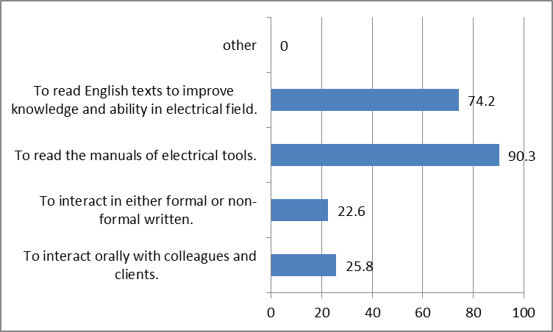
Figure 1. Students’ current reading ability
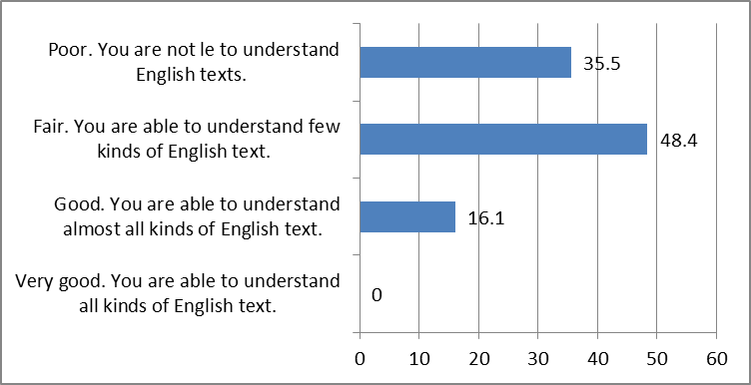
Figure 2. Students’ current reading ability
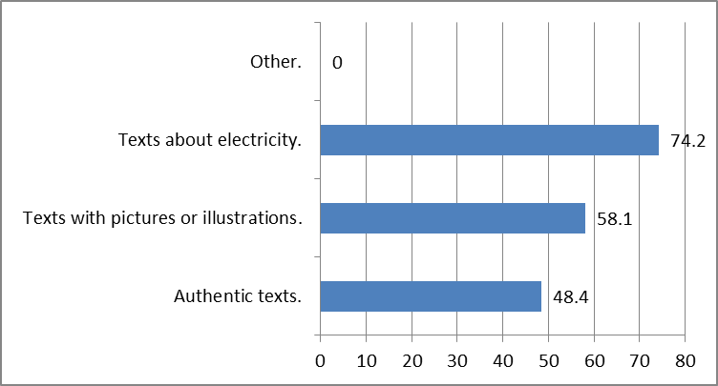
Figure 3. Kinds of texts
However, 48.4% of them considered authentic texts important as their input. It is in line with the interview result in which all the interviewees conveyed that during this time the texts used in the teaching and learning process have not been related to their major. The data can be seen in Figure 3.
Beside the input, how the students prefer to perform in the learning process needs to take into account. Related to media for learning reading, 58.1% did not need any media in reading learning except the textbook. Additionally, the reading activities should also be adjusted to the students’ needs in which the majority of the students expected to answer questions after reading (80.6%) and find the meaning of vocabulary in a text (54.8%). The reading activities were also supposed to let the students do their tasks either individually or in groups as conveyed by the students during the
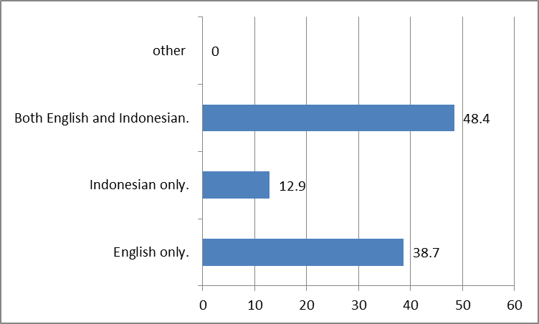
Figure 4. Language used in the materials
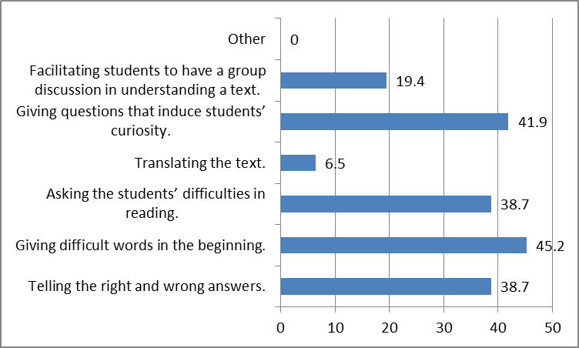
Figure 5. Teacher’s roles
interview in which they gave various responses related to this issue.
Figure 4 shows that 48.4% of the students expected the use of both English and Indonesian for the languages of the material explanations and instructions. This was more than the amount of the students (38.7%) who expected English only as the language used in the materials.
In developing the materials, the students’ and teachers’ roles are also important. The result shows that 50.0% of the students preferred to have discussion with friends and the teacher to understand the text well in reading learning. Meanwhile, the two largest percentages of the teacher’s role result, as presented in Figure 5, show that the students expected the teacher to give difficult words in the beginning (45.2%) and questions that induce their curiosity (41.9%).
- Discussion
In reference to the finding mentioned previously, there are important issues to discuss. The data related to the important of reading skill show that the students consider reading important for their study program. This means that reading becomes Electricity Installation Engineering students’ necessity in learning English. It has been known that reading is a receptive skill, in addition to listening, which naturally enable the readers obtain a message or meaning from a text [7]. In other words, reading provides an opportunity for the students to manage the inputs in the form of texts they obtain to extract information from the them.
This issue is supported by the data of the use of English in the students’ work environment. The students admitted that their reasons of learning English are to be able to read manuals of electrical tools which they often meet in their work environment and English texts to improve knowledge and ability in electrical matters since most sources of information about electricity are presented in English. It is in accordance with the result of the study conducted by Chostelidou [8] which conclude that the needs-based materials lead to the students’ better achievement. In response to this, therefore, it is evident that it is significant to develop supplementary reading materials for Electricity Installation Engineering study program in order to fulfill the students’ needs in reading.
Regarding to the topics for the reading materials, all the students agreed that electricity must be the main topic in the materials developed since their study program is related to electricity. This indicates that the students expected ESP materials to be present in their learning. As has been mentioned previously, the implementation of ESP can be seen in the content of the materials [1]. This brings to a conclusion that the reading materials should mostly contain the materials about electricity, in particular electricity installation, to embody ESP in the language learning for vocational high school.
Further, the students’ lacks are reflected in the students’ current reading ability. The data show that the students are still lack of reading ability. Only few of them are able to understand English texts maximally. Compared to the reading provided by Common European Framework of Reference for Languages, their proficiency in reading has not met the required level B1/B2 in which the students should be able to understand texts that consist mainly of high frequency every day or job-related language with ease. Nevertheless, many vocational high school students are not able to understand such texts, even a short text. This gave the researcher enlightenment on the students’ current reading ability which then became a deep concern in developing the reading materials.
Concerning the previous issue, the mastery of vocabulary can be one factor causing it. The students felt uneasy in reading since they have limitation on vocabulary. Thus, they expected to master vocabularies, in particular those which are related to their field, through reading learning. Considering the students’ wants in developing materials can motivate them in reading. This can encourage the students in reading which definitely improves the students’ vocabulary [9]. In other words, reading provides vocabulary exposure which is very needed by the students in their learning. This leads to difficult vocabulary list and vocabulary exercises to be present in the reading materials in order to facilitate the students to be successful in reading learning.
In reading learning, the input presented in written texts plays an important role. The data shows that to develop the appropriate reading ESP materials, the texts included in the materials should be related to electricity and accompanied by pictures or illustrations. However, the authenticity of the texts also becomes an important aspect to take into consideration in selecting the texts for the materials. The reason is that in learning a foreign language the students should be directed to the exposure of the nature of the language learned which is reflected in its authenticity. This is to avoid misunderstanding in interpreting the language and to facilitate the students to learn English successfully [10]. As a consequence, in the reading materials the texts should be not only related to electricity and accompanied by pictures or illustrations but also authentic in order to make the students interested and have better understanding of the texts.
As has been mentioned previously, the focus of ESP is not on the product but the approach of learning which is presented in the content and the method used in learning [1]. Therefore, how the students prefer to perform in the learning process also needs to take into account. Beside the input, media play their role in learning. In contrast, however, most students did not expect any media in learning except textbook. This issue brings on an implication that the reading materials developed should be well-developed in order to fulfil the students’ expectation. In response to this, various reading activities should be adjusted to meet the quality. It is related not only to the activities with the texts but also to the condition to complete the activities. Therefore, the reading activities in the materials should let the students do their tasks either individually or in groups. This setting can also minimalize the students’ boredom in learning.
Furthermore, regarding to the language used in the explanations and instructions of the reading materials, the data show that more students expected to use both Indonesian and English in the material. It is inevitably caused by the students’ current English proficiency. However, in order to achieve the objective of learning English that is the students are able to function effectively in communication with English, the language used in the materials should be completely in English. In this case, the role of the teacher will help the students in their learning.
Last but not least, the data of the students’ role and the teacher’s role should reflect in the reading activities of the materials. This means the activities should allow the students to be active during the learning process. Moreover, the students’ expectation of the teacher’s role can be presented through the arrangement of the reading activities which can guide the students to complete every task.
This study reveals that the students of Electricity Installation Engineering study program were in need of ESP in their learning. The result shows that the students expected relevant materials related to electricity as the content of the materials for learning. This supports the finding of the research proposed by Musikhin [11]. Further, their expectations towards the process of learning were also important to take into account in producing the appropriate reading materials which apply ESP thoroughly.
- Conclusion
The research finding leads to a conclusion that the students’ needs towards ESP to be present in the reading materials for Electricity Installation Engineering Study Program are a significant aspect to take into a consideration. This relies on the evidence that the students expect to have the materials content for their learning related to their study program that is electricity. In addition, the students expect to perform better in learning through the development of the reading activities in the materials. It is relevant to the nature of ESP which does not focus on the product but the approach for learning in which all decisions to do are based of the students’ reasons for learning which reflect on the students’ needs. Furthermore, it is recommended for vocational English teachers and English textbook developers to consider the significance of the students’ needs as an aspect in developing ESP materials for other study programs in vocational high school. Finally, the finding of the research is expected to trigger the researcher and other researchers to conduct similar studies in other skill of English.
Acknowledgment
I would like to express my deepest gratitude to God the Almighty. I would like to express my deepest appreciation to all those who provided me the possibility to complete this paper. A special gratitude I give to Bhakti Praja vocational high school students and teachers, whose contribution in helping me to conduct the needs analysis.

References
- T. Hutchinson, and A. Waters, English for specific purposes: A learning-centered approach, Cambridge: Cambridge University Press, 1987.
- European Centre for the Development of Vocational Training (Cedefop), The benefits of vocational education and training, Luxemburg: Publications Office of the European Union, 2011.
- S. Billet, Vocational education: Purposes, traditions, and prospects, London: Springer, 2011.
- B. Tomlinson, Materials Development in Language Teaching, Cambridge: Cambridge University Press, 1998.
- T. Hutchinson, and E. Torres, “The textbook as agent of change”, ELT Journal, vol. 48 (4), 1994, pp. 315-328.
- C.T. Linse, and D. Nunan, Practical English language teaching: Young leaarners, NY: The McGraw-Hill Companies Inc, 2005.
- C. Nuttall, Teaching reading skills in a foreign language, Oxford: Macmilan Publisher Ltd, 2000.
- D. Chostelidou, “Needs-based course design: The impact of general english knowledge on the effectiveness of an ESP teaching intervention”, Social and Behavioral Sciences, vol. 15, 2011, pp. 403-409.
- K. Cho, and S. D. Krashen, “Acquisition of vocabulary from the Sweet Valley Kids series: Adult ESL acquisition”, Journal of Reading, vo. l37 (8), 1994, pp. 662-667.
- R.H. Al Azri, and M. H. Al-Rashdi, “The effect of using authentic materials in teaching”, International Journal of Scientific and Technology Research, vo. L 3 (10), 2014, pp. 249-254.
- I. A. Musikhin, “English for Spesific Purposes: teaching English for science and technology”, ISPRS Annals of the Photogrammetry, Remote Sensing and Spatial Information Sciences Research, vol. 3 (6), 2016, pp. 29-35.

