A NEEDS ANALYSIS OF DEVELOPING HOTS-BASED INTERACTIVE MULTIMEDIA
¹Wiji Kurnia Asih, ² Agus Widyantoro
¹ Student of English Education Program Graduate Study Yogyakarta State University
² Lecturer of English Education Program Graduate Study Yogyakarta State University
1wiji.kurnia@student.uny.ac.id, 2agus_wiwied@yahoo.com
Abstract
This article is a part of Reserach and Development research under the issue of Developing Interactive Learning Multimedia to Promote Higher Order Thinking Skills to teach Reading for Senior High Schools in Science Major. The product is developed due to the nonexistance of appropriate learning media that promote Higher Order Thinking Skills (HOTS). Needs analysis is a step in the research which aims to obtain the information in used to design the developed media. This information obtained from the needs analysis are used as data to develop the media. A questionaire was written as the instrument to collect the data. The participants of this research are senior high schools students. The result of the research are valuable implications for interactive multimedia development that romotes higher order thinking skills. In relation to the Educational Research and Innovation in Best Practices to improve quality in the 21st century, the value of this study is to give addition in the form of interactive multimedia which promote higher order thinking skills.
Keywords: Higher Order Thinking Skills, HOTS, Interactive Multimedia, Needs Analysis.

- Introduction
As a lingua fanca, English is widely used as a medium of communiation. It is used both in spoken and written communication. As a global language, English is used by the outer English speaking countries as a second language or as a foreign language. In respond to the growing demand of appropriate communication, English widely taught all over the world.
Reading as one of four language skills of English has contribution of absorbing written information. In educational context, reading as a receptive skill is usually used as students mostly interact with written texts, such as textbooks, newspaper, and internet. Without ignoring other language skills, reading has an significant role to shape the future generations. Because of its importance, the ministry of education all around the world tried their best to develop and improve their educational system.
Peraturan Menteri Pendidikan dan Kebudayaan Nomor 67 tahun 2013 stated that education roots in the culture of the nation and directed for a better development of present and future lives. Curriculum is the basic framework in education. In response of the curriculum change in Indonesia, 2013 Curriculum is believed to be able to contribute to the advancement of society.
An important aspect changed in 2013 Curriculum is to make students being a critical thinker. Thinking critically means being able to make a wise judgement and giving a reasonable reasons (Brookhart, 2010: 5). Some researcher stated that the term “critical thinking” and “higher order thinking” are interchangebly while others said that critical thinking is part of higher order thinking (King et al, 2013). Higher order thinking is abased on the concept of Bloom’s Taxonomy involving cognitive activity to make complex judgmental skills and evaluation. (King et al, 2013). Being critical thinker in learning process is quite a new concept for students in which some of them are failed to apply.
It is belived that the government has provide appropriate textbooks to support them with the new curriculum. However, the content of the materials are failed to meet the expectation. of the 2013 Curriculum in which the content of the materials should encourage the students in creative thinking. Moreover, the content of the materials is not based on the actual needs of the students. With the diversity of students in Indonesia, it is hard to design for a specific purpose which covers the students’ need unless the teachers develop their own learning materials as supplementary. Schools must provide students with supplementary materials to thrieve in a rapidly evolving, saturated world (Jerald, 2009: 1). In addition, the topics in the textbook is not designed for a specifi study program in senior high school. As a result, English materials which covers the students needs and also compatible with the current curriculum are needed.
The new development in technology gives contribution in learning process to make students more engaged in their learning. The use of on computer-based interactive multimedia as learning media is expected to improve students interest in learning English as it provides multiple sources of materials that can be explored by students.
- Remember–retrieve relevant knowledge from long term memory.
  - Recognizing (identifying)
  - Recalling (retrieving)
- Understand–construct meaning from instructional messages, including oral, written, and graphic communication.
  - Interpreting (clarifying, paraphrasing, representing, translating)
  - Exemplifying (illustrating, instantiating)
  - Classifying (categorizing, subsuming)
  - Summarizing (abstracting, generalizing)
  - Interfering (concluding, extrapolating, interpolating, predicting)
  - Comparing (contrasting, mapping, matching)
  - Explaining (constructing model)
- Apply–carry out or use a procedure in a given situation.
  - Executing (carrying out)
  - Implementing (using)
- Analyze–break material into its constituent parts and determine how the parts relate to one another and to an overall structure or purpose.
  - Differentiating (discriminating, distinguishing, focusing, selecting)
  - Organizing (finding, coherence, integrating, outlining, parsing, structuring)
  - Attributing (deconstructing)
- Evaluate–make judgement based on criteria and standards.
  - Checking (coordinating, detecting, monitoring, testing)
  - Critiquing (judging)
- Create–put elements together to form a coherent or functional whole, reorganize element into a new pattern or structure.
  - Generating (hypothesizing)
  - Planning (designing)
  - Producing (constructing)

Higher order thinking skills (HOTS)

Higher order thinking skills is an American terms that is used to refer to cognitive ability to make a complex judgement rather than obtaining simple knowledge (definition by experts)
In the Blooms’ Taxonomy, the cognitive domain is divided into 6 levels, they are knowledge, comprehension, application, analysis, syntesis and evaluation. Those six level of thinking aims to encourage the students think critically, as the highest the level is the more difficult and complex it is (Huitt, 2011:1, Brookhart, 2010),

The revision of Bloom’s Taxonomy was done in 1990 and they are called the Revised Blooms’ Taxonomy (Krathwohl et al, 2001). Figure 1 displays the original Bloom’s Taxonomy and the revised blooms’ Taxonomy.

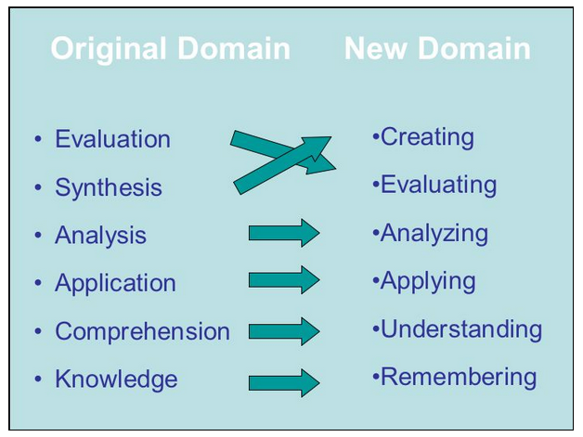
Figure 1. The Original Bloom’s Taxonomy and Revised Bloom’s Taxonomy

As it is seen in Figure 1 the changes in Blooms’ Taxonomy are the change of terms in the first thee level. Figure 2 explains the Revised Blooms’ Taxonomy.

Figure 2. The Revised Blooms’ Taxonomy

The aims of Revised Blooms’ Taxonomy is to promote higher thinking skill in learning process. Rather than remembering facts, the students are engage to analyze and make a complicated judgement in creative way. That creative thinking will be activated when they encounter unfamiliar probllems or questions. Successful application of the skills result in explanation, analysis, performance and product to solve the problem.
Brookhart [9] defines higher-order thinking into three categories, they are: (1) higher-order thinking in terms of transfer, (2) those that define it in terms of critical thinking, and (3) those that define it in terms of problem solving. According to Krathwohl [2] higher order thinking skills in the terms of transfer means students require not only to memorize but also make sense of the information and be able to use what they have learned. Higher order thinking skills in term of critical thinking means students can apply wise judgment or produce a reasonable reason.
Higher order thinking skills in the problem-solving category means the skill that enables a person to find a solution for a problem that cannot be solved simply by memorizing. Brookhart [9] argues that if teachers think of higher-order thinking as problem solving they can set lesson goals to teach students how to identify and solve problems at school and in life.

Interactive Multimedia
Interactive multimedia can be defined as the use of more than one media i.e. texts, pictures, videos, animations, and audios in a way that the user has the control over the choice of progress of the program. Lohr and Gall in Spector [] define interactive learning multimedia as the use of more than one form of media such as texts, visuals, videos, animations, and audios in a way which a user has a great deal of control over the choice of progress of the program. The user has a control to lead the learning process as they choice.
In line with the above definition, Richard and Schmidt [] add that a multimedia presentation can be categorized interactive when they involve a question on the computer, a response from the students and a feedback from the computer telling the students whether the answer is correct. Moreover, Morton et al. in Zhang [] tells that interactive multimedia provides learners with opportunities to receive comprehensible input and feedback. Interactive learning multimedia provides the users to learn by their own. They input the data to a question and then the computer will give a feedback as the respond of the data whether it is correct or incorrect.
Considering the definition above, it can be concluded that interactive multimedia in learning context is the combination of well-arranged audio and visual media in the form of texts, graphics, animations, sounds and videos to present the learning materials that provide learners with opportunities to promote meaningful learning then receive comprehensible input and feedback.
Wolfgram (1994 in Mohler. 2001: 294) states that people only remember 15 percent of what they hear and 25 percent of what they see, but remember 60 percent of what they interact with. Interactive multimedia is an effective and appropriate as the learning tools. Learners will enjoy learning using computers and they are motivated to learn. By using it as a learning tool, learners can interact with them because it provides audio-visual stimuli.
The advantages of using interactive multimedia are supporting interactive learning by presenting text, image, sound, video, and animation, reducing learning time, flexibility (potential for anytime and anyplace), increasing students’ motivation in learning, and accommodating individual learning style.
There are two roles of interactive learning multimedia in the teaching and learning process. They are interactive learning multimedia as a tool and as a tutor. Interactive learning multimedia as a tool is that it is used by the teacher to present the materials and by the students to understand the materials and do the exercises. Meanwhile as a tutor is that it presents the materials to the students and guides them step by step to learn.

Needs Analysis
Needs analysis related to to the development of materials for a specific audience can be defined as a process of determinating the needs for certain group of learners required a language and arranging the needs in order to find out the determine and prioritize the needs for which students required (Hutchinson & Waters (1987), Jordan (1997), Flowerdew & Peacock (2001), and Basturkmen (2006)). The needs analysis helps in establishing the needs for introducing a change that the needs of students and acceptable for teachers. Richards 2001
In this case, needs analysis is a part of research and developement study. The aims of research and development research is to develop a certain product which is suitable for a certain group because the data used to develop are based on their needs. The needs analysis is required to obtain data that will be useful in the development of the product.
The data required in needs analysis can be divided into two, they are target needs and lerning needs. In the target needs, there are three aspects that should be covered necessities, lacks and want. In the learning needs, there are learner’s and teacher’s role, input, activities and setting.
The purpose of this study is to needs analysis data that will be interpret to develop interactive multimedia based on higher order thinking skills.
- Method
The participants are 30 students of senior high school in Yogyakarta. They were Science major students in 11th grade. The students are already taught by using 2013 Curriculum.
This research is a part of reaseach and development model. The needs analysis aims to obain the information that is used to develop the interactive multimedia. Questionaires are delivered to ask the actual needs in learning. There were 20 items of questions in the form of multimple choice asking about target needs and learning needs. The data were analyzed by looking into the frequency of responses and the result were presented in percentage. The two items that received the highest percentage of response will be taken into consideration in the development of interactive multimedia.

3. Results
Based on the needs analysis questionaire, there are target needs and learning needs. Target needs refers to what the learners needs to do in the target situation [6][8][10]. There are three aspects in this, they are necessities, lacks and wants.
Necessities refer to what the students has to know in the target situation. Figure 3 below shows that most students moslty only deal with English text only at school. Their purpose of reading English text mostly because they want to get information from the text. It is rare for them to read text outside academic purpose as in they are enjoying reading English in their leisure time. It is added that their goal in learning English is to proceed in higher education as displayed in Figure 4. As in the From this data, students prefer the developed interactive multimedia can provide them with activities in the academic purpose like in the classroom and daily life.
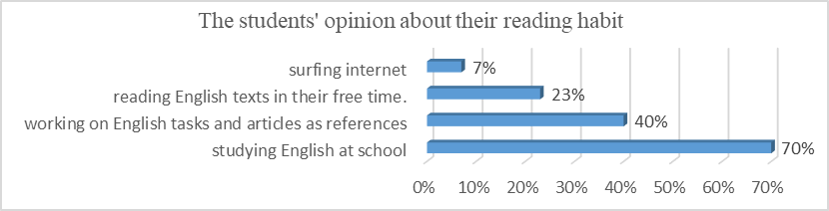
Figure 3. Target needs: Necessities

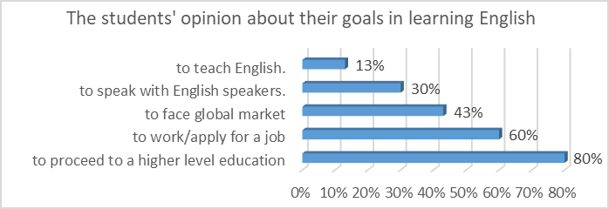
Figure 4 . Target needs: Necessities

Lacks in Target needs can be considered as what the students know already. In other words, lacks means their level of proficiency in English. In Figure 5, the result of the needs analysis shows that their level of proficiency is in the intermediate level. According to CEFR, students with English proficiency in B1 or Intermediate level can undertand basic English that is familiar and happens in daily life.
In addition to that, Figure 4 shows the students’ level of reading comprehension is mostly in B2 level. In this level they are able to understand factual texts in the range of their interest.
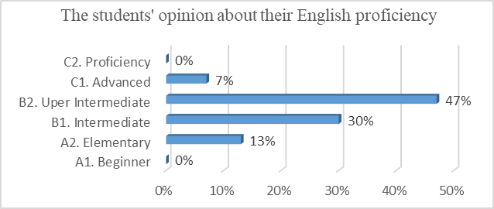
Figure 5. Target needs: Lacks

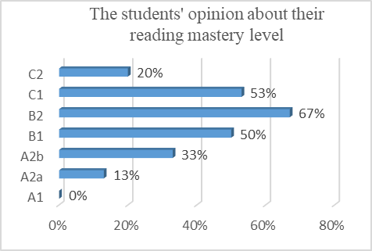
Figure 6. Target needs: Lacks

Related to their level of thinking skills, in figure 7 we can conclude that most students has mastered lower thinking skills i.e. remembering, understanding and applying. It can be concluded the devloped media adjust the level of difficulty according as stated above.

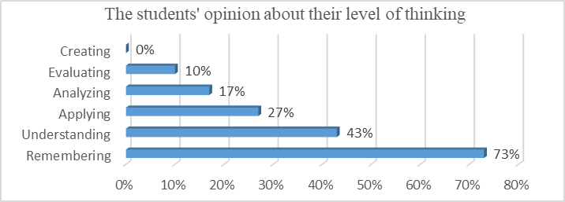
Figure 7. Target needs: Lacks

Wants in target needs means what the students want to do, to get, or to experience during learning activities. It can be refered as a personal preference of students. In the learning activities, the activities they prefer are identifying important poin the text and understanding text. It means that when they are dealing with text, they want to focus more in the text itsel i.e obtaining a certain information and identifying it.
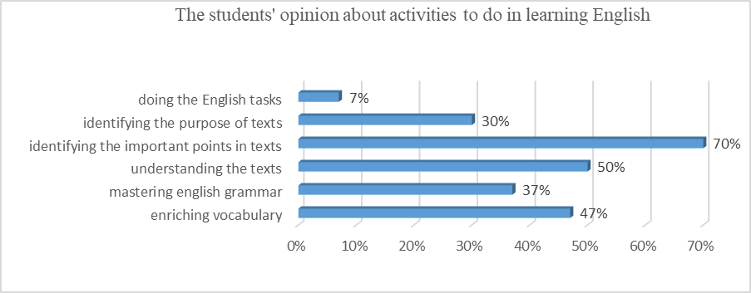
Figure 8. Target needs: Wants
Besides target needs, there is learning needs. Learning needs can be defined as what will the students get from the staring point to get their goal in learning. Figure shows shows topics the students want to discuss in their learning process are related to their study program which is science because they are familiar with the problem win it.
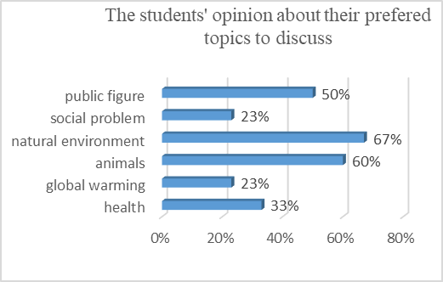
Figure 9. Learning needs
In relation to the media itself, they consider interactive multimedia is needed in learning process as a media in the classroom. In the previous learning process, thay have use textbooks, videos, internet, and picture as learnig media in the classroom. A lot of students knew about interactive multimedia but they never use it in the learning process.

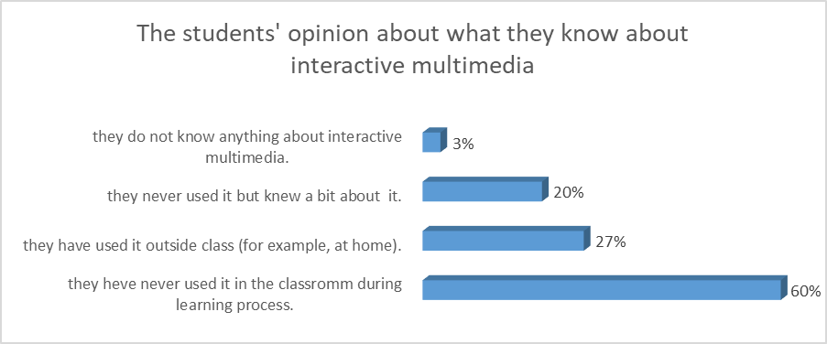
Figure 10. Learning needs

- Discussion
The students responses from the needs analysis provide intriguing insight to the media development. First, the content of materials in the interactive multimedia should be designed to provide them with learning activities in the classroom and to accustome them in English in daily life as their goal in learning English is to proceed in higher education.
Second, the difficulty level of the developed media should adjust the intermediate level. In this level, they are basically understand things that are familiar and happen in daily life. The content of materials in the interactive multimedia should be adjusted to fit this level of difficulty.
Third, most students has already mastered lower thinking skills such as remembering, understanding and applying. They still have difficulty in analyzing, evaluating and creating. The developed media should more emphasize on the higher thinking skills.
Fourth, some of the students are already familiar with interactive multimedia so their opinions about the appropriate media are an important information in the development process.

- References
- C.D. Jerald, Defining a 21st Century Education, Report of the Center of Public Education in America, 2009
- D.R. Krathwohl, “A revision of Bloom’s Taxonomy: in theory into practice,” vol. 41. Number 4, Autumn 2002, College of Education, Ohio State University. http://www.unco.edu/cetl/sir/stating_outcome/documents/Krathwohl.pdf
- J.C. Richard, & R. Schmidt, (Eds.), Longman Dictionary of Language Teaching and Applied Linguistics (3rd ed.). London: Longman, 2002.
- L.W. Anderson, and D. R. Krathwohl, A Taxonomy for Learning, Teaching, and Assessing: A Revision of Bloom’s Taxonomy of Educational Objectives. Allyn & Bacon. Boston, 2001 Pearson Education Group
- M. Roblyer, Integrating Educational Technology into Teaching. (3rd ed.) Upper Saddle River, NJ: Merrill Prentice Hall, 2003.
- R.E. Mayer, & R. Moreno, Aids to Computer-Based Multimedia Learning. Learning and instruction,” vol. 12, 2001, pp. 107–119,
- R.E. Mayer, The Cambridge Handbook of Multimedia Learning. Cambridge: Cambridge University Press, 2005.
- S. Mishra, & R. Sharma C. Interactive Multimedia in Education and Training, India: Idea Group Publishing, 2004
- S.M. Brookhart, How to Assess Higher Order Thinking Skills in your Classroom, United States of America, ASCD Member Book, 2010.
- T. Vaughan, “Multimedia: Making it work,” 7th ed, 2008.
- W. Huitt, Bloom’s et al.’s Taxonomy of the cognitive domain. Valdosta State University, Georgia, 2011, Retrieved on 20/7/2016 http://www.edpsycinteractive.org/topics/cognition/bloom.html [pdf]

