**INVENTIONS IN TECHNOLOGY AND EDUCATION**

**FROM PROFESSOR HARDJOSO PROJOPANGARSO:**

**A PHENOMENOLOGY RESEARCH**

**Yanto Sidik Pratiknyo1, Nining Dyah Ekaningsih2**

1[yantosp2013@gmail.com](mailto:yantosp2013@gmail.com), 2[dyah_ekaningsih@yhoo.com](mailto:dyah_ekaningsih@yhoo.com)

1Sekolah Tinggi Teknik PLN

2Traditional Technology Laboratory, University of Gajah Mada, Yogyakarta

**Abstract**

The deceased of Prof Hardjoso Prodjopangarso used traditional technology approach in inventing the apparatus or equipments to solve many problems especially in the rural society in term of water sanitation and its related that consist of shower, washing, toilet, drinking water and other water usage. Even the names of his inventions tend to mystics, such *Ki Panca Sihir* / Mr Five Magic (jets water purifier), *Nyi Bunga Sihir*/ Mrs Flower Magic (air bubbles water purifier), *Cak Kilang Sihir*/ Brother Refinery Magic (spray water purifier), *Ki Datuk Sihir*/Mr Progenitor Magic (uplift and rotating sprinkler) etc, all of the inventions are scientifically proven and can be replicated in his laboratory in University Gadjah Mada or other universities, by students as regular practicum as a way to disseminate his inventions. His inventions are also researched by other experts to be presented in local or international conference and journals. The urgency of this research is that inventions and especially of the process in inventing should be documented scientifically.

Key words: Hardjoso Prdjopangarso, Traditional Technology, Invention

1. **Introduction**

Some inventions of the late of Professor Hardjoso Prodjopangarso were stored in Gadjah Mada Museum together with property of Barrack Obama. Hardjoso also received award such as Satya Lencana Pembangunan (1974) and Science and Technology award from President Soeharto (1977) and Herman Johanes Award from Gajah Mada University (2018).

Hardjoso wanted his inventions can be used by anyone and could be useful for the Indonesian people, especially those under the poverty line. Not surprisingly, his inventions of technology are very useful especially for rural people. Hardjoso made a suitable technology needed by the people and applicable to the society. He did not want to be an Ivory Tower, but a person directly to the people. Hardjoso said that construction technologies that were used, building materials and also the tools must be simple, in accordance with the conditions of the existing local resources in the region, according to Hardjoso.

Hardjoso has many inventions for the development of the lowest classes of the society, especially in the village, such as Tripikon-S (septic tank for swamp area) in 1989, Subromarto (installation of waste incineration for producing steam and hot water) in 1990, Nalareksa (air analysis equipment) in 1992, Ki Panca Sihir / Mr Five Magic (jets water purifier), Nyi Bunga Sihir/ Mrs Flower Magic (air bubbles water purifier) and Cak Kilang Sihir/ Brother Refinery Magic (spray water purifier) in 2001-2003, Jumantara (small weather station) in 2004, Sikate (soil water reservation), Si Katak (inter peat soil reservoir), Ki Datuk Sihir/Mr Progenitor Magic (uplift and rotating sprinkler) etc, He gave many local content name of his inventions even tends to be mystic name, in order to easier to be remembered by the people and with the surrounding raw materials.

In the trustworthiness and validity of the study, Thomas (2002) explained in how trustworthy of qualitative data that consists of consistency checks in data analysis, stakeholder checks, triangulation of data sources, and independent replication of findings. Whereas, triangulation techniques may involve: two or more data-collection methods, two or more research frameworks or perspectives, two or more data sources (using the same method) and two or more data analysis techniques.

In phenomenology research, usually only related with small number of data. Application of multiple methods allows counterbalancing the strength of one another. Triangulation increases credibility of the results.

1. **Method**

Husserl states that phenomenology is understood as the careful description of experiences in the manner in which they are experienced by the subject, proposes to study, in words, the whole of life of consciousness that is to say, it includes not just explicit cognitive states and acts, such as judgments, but all the myriad acts and states of consciousness such as sensory awareness, perception, memory, imagination, feeling, emotion, mood, free will, time-consciousness, judgment, reasoning, symbolic thought, self-conscious awareness, as well as subconscious drives and desires.

Phenomenological research is an inductive, descriptive research approach that is developed from phenomenological philosophy; its aim is to describe an experience as it is actually lived by the person.

This research applied is a case study of the deceased of Professor Hardjoso Projopangarso, using a phenomenology research. Samples of the research are the inventions of Hardjoso. Data gathering are form the paper made by Hardjoso, research papers from other experts presented in Local and International Conference and Journals and observing physically of his inventions. Because this research is qualitative research, researcher is an instrument. Data analysis used is content analysis from his inventions.

The phenomenology research used consists of steps. 1. Define the research questions, 2. Conduct a pre-study, 3. Choose a theory as scheme of reference, 4. Study Constructs of the Inventions, 5. Check for Unintended Consequences, 6. Relate the evidence to the scientific literature and the empirical field of study

1. **Results**

Steps of the phenomenology researches are:

Step 1: Define the research questions

Prof Hardjoso used the traditional technology approach in inventing the apparatus to solve many problems especially in the rural society in term of water sanitation and its related that consist of shower, washing, toilet, drinking water and other water usage. The research question is, are there any patrons in inventions from Prof Hardjoso?

Step 2: Conduct a pre-study.

Pre study were done by interviews and reading the paper that wrote by Prof Hardjoso. Interviews with Prof Hardjoso Prodjopangarso and from the close relationship people with Prof Hardjoso were done as follow.

Prof Hardjoso Prodjopangarso said:

*“Ancient technology was proven and inherited from generation to generation, and frequently people said as a mystic, because cannot be explained logically, therefore the scientist should be analyzed deeply to clarify scientifically and modernly in order to solve the other problems, new problems emerge in the society, especially in the rural”.*

Anton Sujarwo, founder of the Dian Desa Foundation and Magsaysay Award 1995 Receiver told:

*“Prof Hardjoso can construct traditional technology even ancient to invent the new technology to solve the sanitation problems for the lowest classes of the society scientifically”.*

Hariyoto, formerly the Chief of The Health Technology Laboratory, Health Department and receiver of the Satya Lencana Award told:

*“Prof Hardjoso used the local wisdom intuitively to develop the technology; scientifically even many names of his inventions are tended to be mystical”.*

Step 3: Choosing a theory as scheme of reference

The new theory or inventions, it is not easy to be found. However to construct the steps of inventions from Prof Hardjoso or the theoretical frame work can be seen as follow in figure 1.

Identify need or gap of the lowest level of the society is an initial steps. Prof Hardjoso has many inventions for the development of the lowest classes of the society, especially in the village.

The important of the new invention is that invention can be replicated by others with the same result. Therefore, Prof Hardjoso established the Technology Traditional Laboratory for practicum that the students can replicate the invention of Prof Hardjoso with similar results.

Figure 1: Theoretical Frame Work

Step 4: Study Constructs of the Inventions

Prof Hardjoso did not give names for all his inventions. Partly only generic names and others have names. Local wisdom is significantly appeared in the name of his inventions, for instance: Nyi Bunga Sihir in English is Mrs. Magic Flower, Ki Panca Sihir in English is Mr. Five Magic, Ki Datuk Sihir in English is Mr. Magic Leader. Other names come from Sanskrit language such Tirto Gunandito, Subromarto, Nalareksa etc. However, all of his inventions is proof science, and can be replicated and taught to the student in his laboratory as practicum, in Technology Traditional Laboratory.

The list of some intentions from Prof Hardjoso that can be found as follow

1. Tripikon-S (Septic tank using three concentric pipes) in 1989,

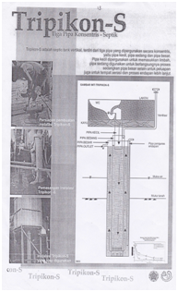

Figure 2: Tripikon S

1. Subromarto (installation of waste incineration for producing steam and hot water) in 1990,

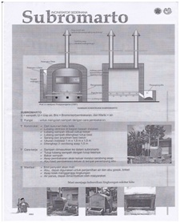

Figure 3: Subromarto

1. Nalareksa (air analysis equipment) in 1992,

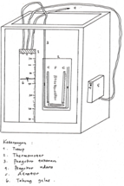

Figure 4: Nalareksa

1. Sikate (soil water reservation),

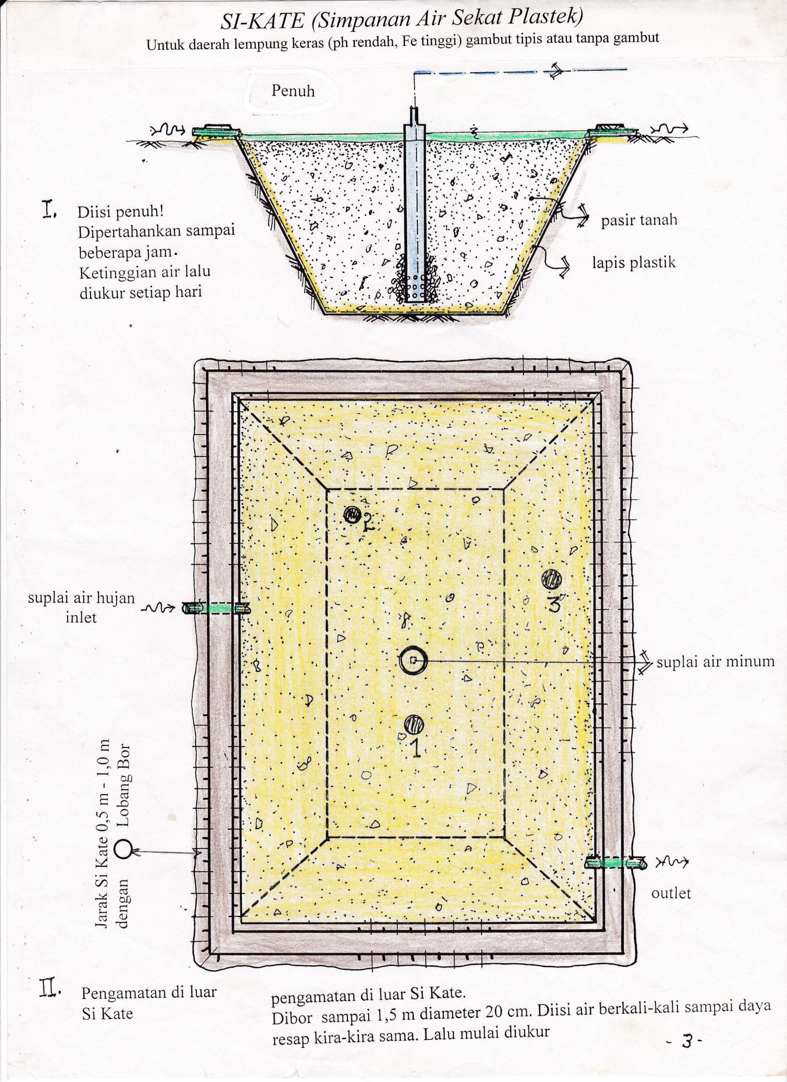

Figure 5: Si Kate

1. Cak Kilang Sihir (rotating sprinkler water purifier) in 2001-2003,
2. Jumantara (small weather station) in 2004,
3. Ki Panca Sihir (spray water purifier),
4. Nyi Bunga Sihir (air bubbles water purifier)
5. Si Katak (inter peat water reservoir),
6. Pinastik A (septic tank for swamp area) in 1989,
7. Pinastic U (general septic tank) in 1989
8. Tripikon (drinking water well)
9. Filiorasi (bio aerated filter)
10. Ki Datuk Sihir (uplift and rotating sprinkler),
11. Soil permeability meter
12. Field water analyzer
13. Bantala (avoid crash dam)
14. Bak Jantung (drinking water control box for bamboo pipes)
15. Tirto Gunandito (fairly water distribution)
16. Kang Fermansah (mixed composting waste organic waste).

Step 5: Check for Unintended Consequences

Prof Hardjoso experts in water and its related, therefore, all his inventions are in the water area that are, shower, washing, toilet, drinking water etc. However, still another invention that is not so close with water that is Kang Fermansah for making mixed composting organic waste, however this invention is still in the sanitation area. Perhaps, it is related to the former inventions, Subromarto (installation of waste incineration for producing steam and hot water)

Step 6: Relate the evidence to the scientific literature and the empirical field of study.

Inventions of the Prof Hardjoso are researched by many other experts and presented and published in local and international level both journals and conferences, that can be seen in bibliography.

1. **Discussion**

In order to disseminate his inventions, Hardjoso developed Traditional Technology Laboratory content of prototype of his inventions for the students practicum in University of Gajah Mada in Kuningan, Yogyakarta. The layout of Laboratory can be seen as follow:

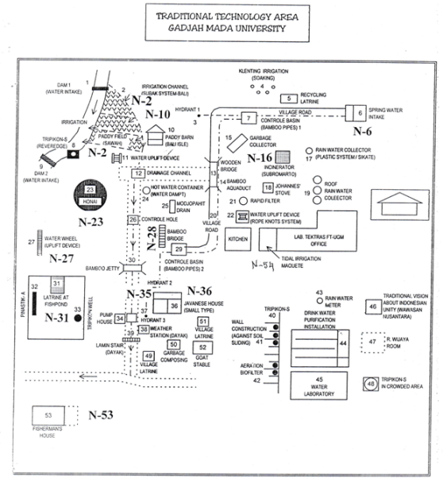

Figure 7: Traditional Technology Lab

Guests visited the Traditional Technology Laboratory come from overseas, from Japan, Europe, USA etc.

More over, his inventions are also used in other university such as Yanabadra University, Muhamadiah University, Atmajaya University, etc.

ACKNOWLEDGMENT

Thank for Traditional Laboratory for permitting to write this research. Special thank for Mrs Estiningrum and Mrs Ratnawati for helping the data collection.

REFERENCES

1. Achmad Nurmandi, Urban River Side Settlement in Yogyakarta City Indonesia Center for Public Management Studies Faculty of Social and Political Science Muhammadiyah University Jogyakarta Ringroad Barat Tamantirto, Jogyakarta Indonesia, Toward Community-based Wastewater Management 2013-220 <https://www.researchgate.net/publication/247769051> 7;50am, 3/5/2018
2. Aditya Wishnu Wijaya and Novi Paramita Dewi, Tripikon-S as Appropriate Technology for Sustainable Sanitation in Riverbank 109 Area in Tropical Developing Country, International Conference on Sustainable Future for Human Security (SustaiN'2010), 11-12 December, 2010, Inamori Foundation Memorial Building, Center for Southeast Asian Studies, Kyoto University. <https://www.google.co.id/url?sa=t&rct=j&q=&esrc=s&source=web&cd=13&cad=rja&uact=8&ved=0ahUKEwi4rKjloePaAhULvI8KHSeSAOYQFghYMAw&url=http%3A%2F%2Frepository.ipb.ac.id%2Fjspui%2Fbitstream%2F123456789%2F69565%2F1%2FSUSTAN_2010.pdf&usg=AOvVaw1bI_8uYOrvQ8M8li3nvzCP>
3. Aspers Patrick, An Approach for Qualitative Research, November 2004,London School of Economics and Political science, Methodology Institute Papers in Social Research Methods, Qualitative Series no 9, Empirical Phenomenology. <https://www.google.co.id/url?sa=t&rct=j&q=&esrc=s&source=web&cd=2&cad=rja&uact=8&ved=0ahUKEwil2dfR6ePaAhXEvY8KHfEjBfYQFgg1MAE&url=http%3A%2F%2Fwww.ipjp.org%2Fonline-issues%2Fsend%2F36-edition-2-october-2009%2F157-patrikaspers9e2&usg=AOvVaw12qy734uhuMd4H8xRs-Tjf>
4. Aspers, Patrik, Markets in Fashion, A Phenomenological Approach, London: Routledge, City University Press, First edition 2001. <https://www.google.co.id/url?sa=t&rct=j&q=&esrc=s&source=web&cd=1&cad=rja&uact=8&ved=0ahUKEwiwiovj6OPaAhXFPI8KHY1pCXwQFggnMAA&url=http%3A%2F%2Fciteseerx.ist.psu.edu%2Fviewdoc%2Fdownload%3Fdoi%3D10.1.1.461.5817%26rep%3Drep1%26type%3Dpdf&usg=AOvVaw1stM0fNDmBR6SDPzGbcGz_>
5. Dyah Wulandari Putri, Prayatni Soewondo, Agus Jatnika Effendi, Tjandra Setiadi, Sustainability Analysis of Domestic Wastewater Treatment Technology Applied in Human Settlements in Swamp Areas, International Journal of Scientific & Engineering Research, Volume 7, Issue 9, September-2016 284 ISSN 2229-5518 IJSER © 2016 <http://www.ijser.org>, <https://www.google.co.id/url?sa=t&rct=j&q=&esrc=s&source=web&cd=14&cad=rja&uact=8&ved=0ahUKEwi4rKjloePaAhULvI8KHSeSAOYQFghfMA0&url=https%3A%2F%2Fwww.ijser.org%2Fresearchpaper%2FSustainability-Analysis-of-Domestic-Wastewater-Treatment-Technology-Applied-in-Human-Settlements-in-Swamp-Areas.pdf&usg=AOvVaw0xiHlgwOKA2iVwD23t3GIm> , 1;25am, 5/1/2018.
6. Eka Rahayu Normasari, Banjarmasin Clean and Comfortable City of Banjarmasin, Indonesia, 8th East Asia Summit High Level Seminar on Sustainable Cities, 8-9 February 2017 Chiang Rai Thailand. <https://www.google.co.id/url?sa=t&rct=j&q=&esrc=s&source=web&cd=12&cad=rja&uact=8&ved=0ahUKEwjXy8PTo-PaAhVJpI8KHf3VDKI4ChAWCCswAQ&url=https%3A%2F%2Fhls-esc.org%2Fdocuments%2F8hlsesc%2Foutput%2FAnnex%2520C%2520-%25208HLS%2520_%2520Presentation.pdf&usg=AOvVaw15XP8UMiTLp_Zc1DHDrdpq> 10;25pm, 5/1/2018.
7. Hitchcock, L.: Methodology in computing education: a focus on experiences. Proceedings of the 19th Annual NACCQ Conference, 7-10 July, 2006, Wellington New Zealand. 2006. <https://www.google.co.id/url?sa=t&rct=j&q=&esrc=s&source=web&cd=1&cad=rja&uact=8&ved=0ahUKEwjkgoyB6OPaAhXK6Y8KHa_hCIAQFggnMAA&url=http%3A%2F%2Fciteseerx.ist.psu.edu%2Fviewdoc%2Fdownload%3Fdoi%3D10.1.1.679.2736%26rep%3Drep1%26type%3Dpdf&usg=AOvVaw0i5fvf_EA4A0PHrEcxvF5i> 2;25am, 5/1/2018.
8. Marton, F., Phenomenography: Describing conceptions of the world around us. Instructional Science, 10 (1981), 177-200. <https://link.springer.com/article/10.1007%2FBF00132516>
9. Moran, Dermot. Edmund Husserl and phenomenology , Philosophy of Mind: The Key Thinkers, , Bloomsbury, London,2013
10. <https://andreassiagian.wordpress.com/bio-prof-ir-hardjoso-projopangarso/> 11.08am, 2/28/2018
11. <https://ugm.ac.id/id/berita/8070-guru.besar.fakultas.teknik.prof.hardjoso.meninggal.dunia> 11.17am, 2/28/2018
12. <http://materi-kunci.blogspot.co.id/2015/12/analisa-udara-eks-air-nalareksa.html> 8;16pm, 3/1/2018
13. <http://edukasi.kompas.com/read/2009/01/11/11593224/mahasiswa.arkeologi.ugm.kecam.perusakan.situs> 5;46am, 2/24/2018
14. <http://edukasi.kompas.com/read/2009/01/11/11593224/mahasiswa.arkeologi.ugm.kecam.perusakan.situs>. 5,45am, 2/24/2018
15. <http://okvideofestival.org/web/id/nalareksa-0-7/> 5,35am, 2/24/2018
16. <http://okvideofestival.org/web/id/unduh/> 5,56am, 2/24/2018
17. <https://groups.yahoo.com/neo/groups/kagamaamrk/conversations/topics/20?var=1> 6,10am, 2/24/2018
18. <http://tsipil.ugm.ac.id/id/fasilitas/laboratorium-teknologi-tradisional/> 6;46am, 3/7/2018.
19. <https://www.thefreedictionary.com/examining> , 5;21am, 5/5/2018